HUNTER PLANT HIRE

HUNTER MINECAT SALES
M2054
MINELOADER

PARTS MANUAL

USE ONLY GENUINE
HUNTER MINECAT SALES PARTS

If service and repairs are needed, contact
HUNTER PLANT HIRE
phone +612 4964 9959
in order to receive the highest in quality and service.

When ordering spare parts contact
HUNTER MINECAT SALES
phone +612 4964 8777

MUSTANG MANUFACTURING COMPANY, INC., reserves the right to make changes or add improvements to its products at any time without any obligation to make such changes to products manufactured previously. MUSTANG MANUFACTURING COMPANY, INC., or its dealers, accept no responsibility for variations, which may be evident in actual products and the specification, pictures and descriptions contained in this publication.

TABLE OF CONTENTS
DESCRIPTION |  |  | PAGE
Frame & Lift Arm Components
 | Main frame | .............................................................................. | 6
 | Lift arm | .............................................................................. | 8
 | Foot pedal control & cabin panel | .............................................................................. | 12
 | Rops / fops | .............................................................................. | 14
 | Seat, seat mounting & restraint bar | .............................................................................. | 16
 | Rear door and engine cover | .............................................................................. | 20
Drive System
 | Brake system | .............................................................................. | 22
 | Hydrostatic mount linkage | .............................................................................. | 24
 | Steering controls | .............................................................................. | 28
 | Drive motor & parking brake | .............................................................................. | 30
 | Gear pump | .............................................................................. | 32
Hydraulics Plumbing System
 | Hydrostatic plumbing | .............................................................................. | 34
 | Auxiliary circuit plumbing | .............................................................................. | 36
 | Tilt circuit plumbing | .............................................................................. | 38
 | Lift circuit plumbing | .............................................................................. | 40
 | Lift cylinder | .............................................................................. | 42
 | Tilt cylinder | .............................................................................. | 44
 | Main control valve | .............................................................................. | 46
 | Self-levelling valve | .............................................................................. | 62
Decals & Tyres
 | Tyres | .............................................................................. | 64
 | Decals | .............................................................................. | 66
Other
 | Wheel drives | .............................................................................. | 68
 | Air cleaner | .............................................................................. | 72
 | Cooler water system | .............................................................................. | 74
 | Attachment system | .............................................................................. | 78
 | Tandem pump | .............................................................................. | 80

Kubota Diesel Engine
 | Crankcase | .............................................................................. | 84
 | Oil pan | .............................................................................. | 86
 | Cylinder head | .............................................................................. | 88
 | Gear case | .............................................................................. | 90
 | Head cover | .............................................................................. | 92
 | Oil filter | .............................................................................. | 94
 | Dipstick & guide | .............................................................................. | 96
 | Oil pump | .............................................................................. | 98
 | Main bearing case | .............................................................................. | 100
 | Camshaft & idle gear shaft | .............................................................................. | 102
 | Piston & crankshaft | .............................................................................. | 104
 | Flywheel | .............................................................................. | 108
 | Fuel camshaft & governor shaft | .............................................................................. | 110
 | Idle apparatus | .............................................................................. | 112
 | Engine stop lever S.No BK2999 | .............................................................................. | 114
 | Engine stop lever S.No BL0001 | .............................................................................. | 116
 | Injection pump | .............................................................................. | 118
 | Governor | .............................................................................. | 120
 | Speed control plate | .............................................................................. | 122
 | Nozzle holder and glow plug | .............................................................................. | 124
 | Fuel pump (mechanical) | .............................................................................. | 126
 | Cover | .............................................................................. | 128
 | Alternator pulley | .............................................................................. | 130
 | Starter | .............................................................................. | 132
 | Water pump | .............................................................................. | 134
 | Fan | .............................................................................. | 136
 | Valve & rocker arm | .............................................................................. | 138
 | Inlet manifold | .............................................................................. | 140
 | Gasket kit | .............................................................................. | 142
 | Lower gasket kit | .............................................................................. | 144

This page was intentionally left blank

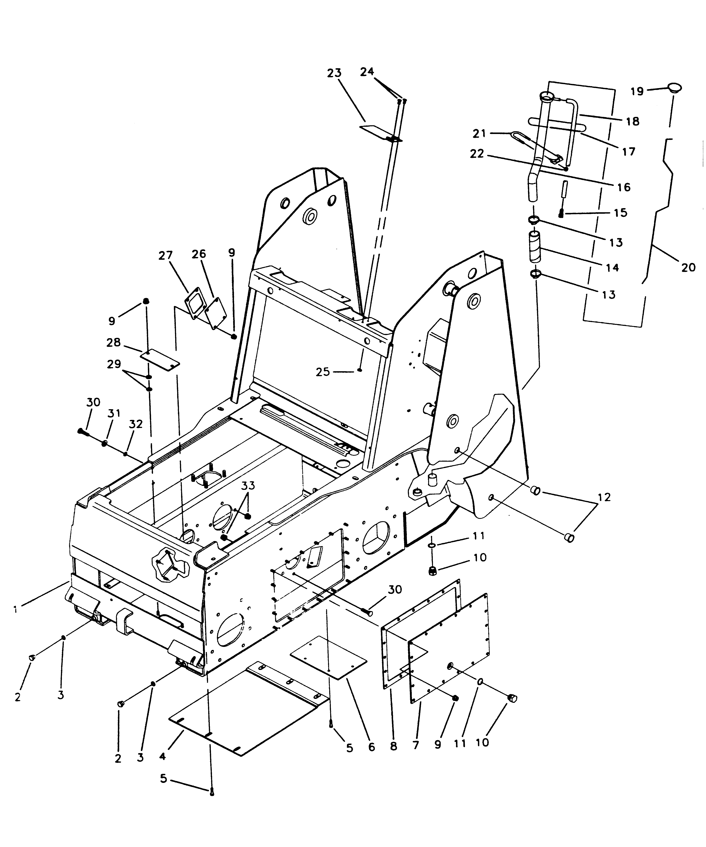
MAIN FRAME

REF | PART NUMBER | DESCRIPTION | QTY
1 | 1100 | MAINFRAME | 1
2 | 1101 | PLUG 3/4-16 SAE W/O-RING | 3
3 | 1102 | O-RING 3/4 | 3
4 | 1103 | PAN/BELLY | 1
5 | 1104 | SCREW/CAP WHIZLOCK 3/8-16NC X 3/4 | 10
6 | 1105 | COVER/FLOOR REAR BOTTOM | 1
7 | 1106 | COVER/CHAINCASE OUTSIDE | 2
8 | 1107 | GASKET/CHAINCASE COVER | 2
9 | 1108 | NUT/HEX WHIZLOCK 3/8-16NC | 44
10 | 1109 | PLUG/1-1/16-12 SAE | 2
11 | 1110 | O-RING 1-1/16 | 2
12 | 1111 | PLUG/COUNTERWEIGHT MOUNTING HOLE | 4
13 | 1112 | CLAMP/HOSE | 2
14 | 1113 | HOSE/TUBE TO TANK | 1
15 | 1114 | VENT/FILTER | 1
16 | 1115 | TUBE/FILL | 1
 | 1116 | TUBE/FILL (2054 HIGH FLOW MODELS) | 1
17 | 1117 | TIE/CABLE | 2
18 | 1118 | HOSE/FILL NECK DRAIN | 1
19 | 1119 | CAP/FILL TUBE | 1
20 | 1120 | DIPSTICK/HYDRAULIC RESERVOIR | 1
21 | 1121 | CLAMP/MUFFLER | 1
22 | 1122 | NUT/HEX CENTERLOCK 5/16-18NC | 2
23 | 1123 | DOOR/FUEL | 1
24 | 1124 | SCREW/TRUSS HEAD 5/16-18NC X 3/4 | 2
25 | 1125 | NUT/HEX WHIZLOCK 5/16-18NC | 2
26 | 1126 | COVER/CHAINCASE INSIDE | 2
27 | 1127 | GASKET | 2
28 | 1128 | MAGNET/CERAMIC | 2
29 | 1129 | NUT/HEX FLANGED LOCK 1/2-20NF | 20
30 | 1130 | BOLT/SERRATED 1/2-20NF X 1-15/16 | 20
31 | 1131 | O-RING | 8
32 | 1132 | BULB SEAL/SEAT PLATE | 1
33 | 1133 | PROTECTOR/WIRE HARNESS | 1
34 | 1134 | GROMMET/RUBBER 2-1/2 | 2
35 | 1135 | DECAL/RESERVOIR CAP | 1
36 | 1136 | COVER/FRONT | 1
 | 1104 | SCREW/CAP LOCKING 3/8 X 3/4 | 1

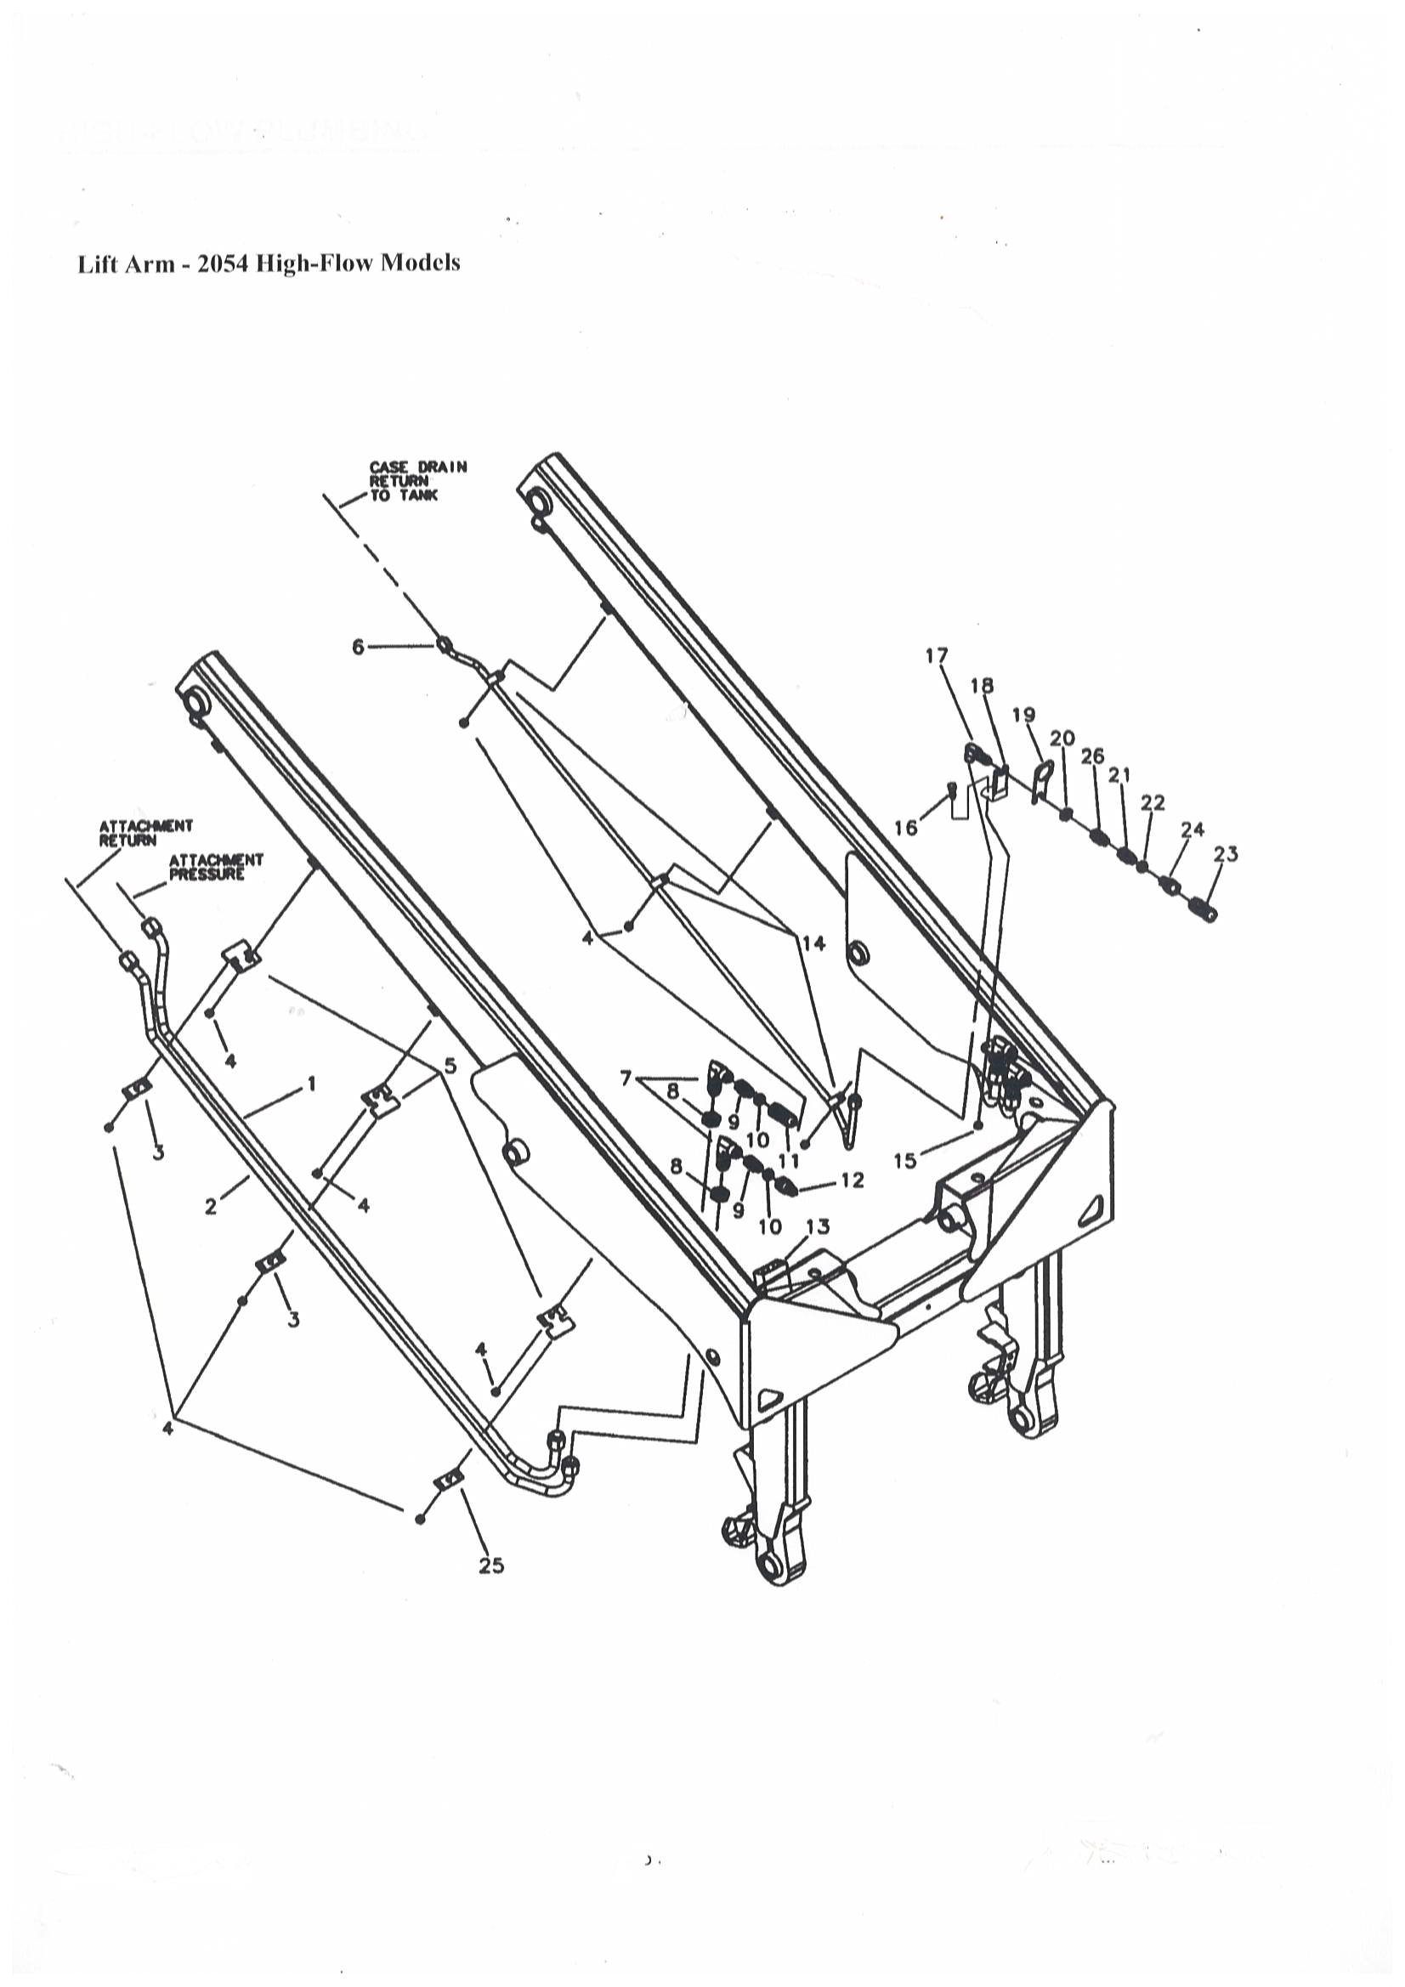

LIFT ARM

REF | PART NUMBER | DESCRIPTION | QTY
1 | 1200 | HYDRAULIC LINE/INNER | 1
2 | 1201 | HYDRAULIC LINE/OUTER | 1
3 | 1202 | CLAMP/HYDRAULIC LINE | 2
4 | 1203 | NUT/LOCK 3/8 | 3
5 | 1204 | CLIP/HYDRAULIC LINE | 3
6 | 1205 | HYDRAULIC LINE/CASE DRAIN | 1
7 | 1206 | ELBOW/90° BULKHEAD 1-1/16 | 2
8 | 1207 | NUT/LOCK 1-1/16 | 2
9 | 1208 | FITTING/STRAIGHT 1-1/16 | 2
10 | 1110 | O-RING 1-1/16 | 2
11 | 1209 | COUPLER/FEMALE | 1
12 | 1210 | COUPLER/MALE | 1
13 | 1211 | DECAL/AUX PORT/HIGH FLOW | 1
14 | 1212 | CLIP/INSULATED | 3
15 | 1108 | NUT/LOCK 3/8 | 1
16 | 1213 | SCREW/CAP 3/8 X 1 | 1
17 | 1214 | ELBOW/SWIVEL | 1
18 | 1215 | BRACKET/CASE DRAIN TUBE | 1
19 | 1216 | BRACKET/ELECTRICAL MOUNT | 1
20 | 1217 | NUT/LOCK 3/4 | 1
21 | 1218 | FITTING/STRAIGHT 3/4 | 1
22 | 1102 | O-RING 3/4 | 1
23 | 1219 | QUICK COUPLER/ FEMALE 3/4 | 1
24 | 1220 | QUICK COUPLER/MALE 3/4 | 1
25 | 1221 | STRAP | 1
26 | 1222 | FITTING/STRAIGHT JIC08 X JIC08 | 1

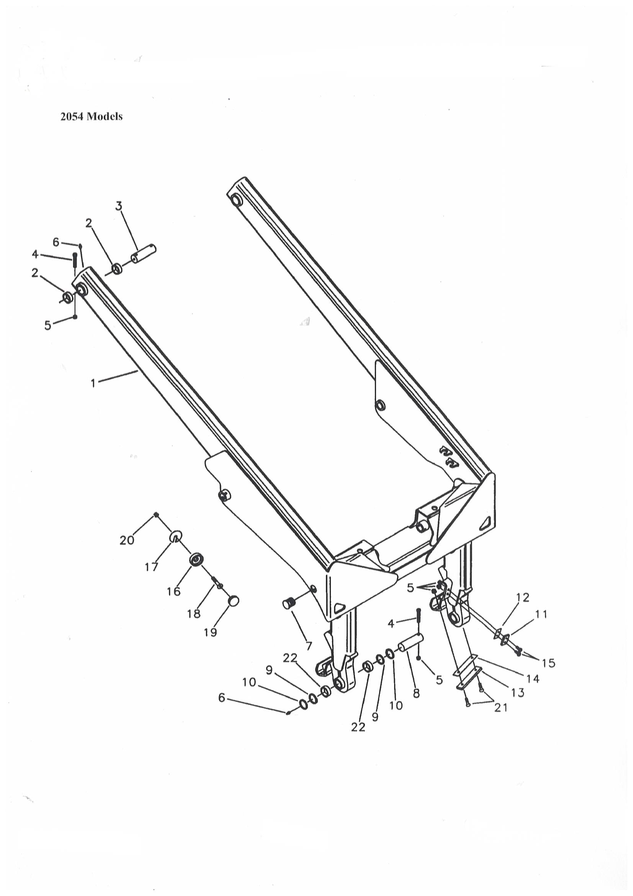
LIFT ARM
REF | PART NUMBER | DESCRIPTION | QTY
1 | 1223 | ARM/LIFT | 1
2 | 1224 | BUSHING/OILITE | 4
3 | 1225 | PIN/PIVOT | 2
4 | 1226 | SCREW/CAP 3/8-16NC X 2-1/2 | 4
5 | 1203 | NUT/HEX CENTERLOCK 38-16NC | 12
6 | 1228 | ZERK/GREASE | 4
7 | 1229 | PLUG | 2
8 | 1230 | PIN/PIVOT | 2
9 | 1231 | SEAL/PIN | 4
10 | 1232 | WASHER/SHIM | AR
11 | 1233 | PLATE/WEAR | 2
12 | 1234 | SHIM/ROLL BACK | AR
13 | 1235 | PLATE/WEAR | 2
14 | 1236 | SHIM/DOWN STOP | AR
15 | 1237 | SCREW/FLAT SOCKET HEAD 1/2-13NC X 1-1/4 | 4
16 | 1238 | STOP/DOWN | 2
 | 1239 | DOWN/STOP LIFTARM | 2
17 | 1240 | SHIM/DOWN STOP | AR
18 | 1241 | SCREW/FLAT SOCKET HEAD 1/2-13NC X 1-1/2 | 2
19 | 1239 | BUMPER/DOWN STOP | 2
20 | 1242 | NUT/HEX CENTERLOCK 1/2-13NC | 2
21 | 1243 | SCREW/FLAT SOCKET HEAD 3/8-16NC X 1-1/2 | 4
22 | 1244 | BUSHING/OILITE | 4
1 | 1223 | ARM/LIFT | 1
2 | 1224 | BUSHING/OILITE | 4
3 | 1225 | PIN/PIVOT | 2
4 | 1226 | SCREW/CAP 3/8-16NC X 2-1/2 | 4
5 | 1227 | NUT/HEX CENTERLOCK 38-16NC | 12
6 | 1228 | ZERK/GREASE | 4
7 | 1229 | PLUG | 2
8 | 1230 | PIN/PIVOT | 2
9 | 1231 | SEAL/PIN | 4
10 | 1232 | WASHER/SHIM | AR
11 | 1233 | PLATE/WEAR | 2
12 | 1234 | SHIM/ROLL BACK | AR
13 | 1235 | PLATE/WEAR | 2

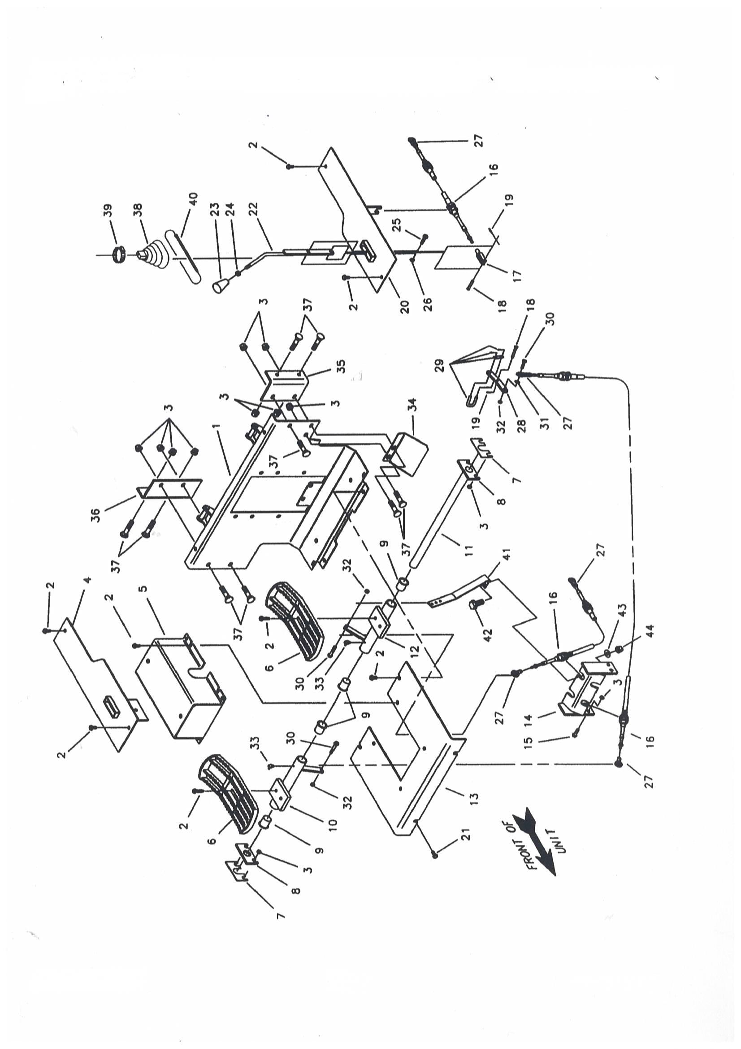
FOOT PEDAL CONTROL AND CABIN PANEL

REF | PART NUMBER | DESCRIPTION | QTY
1 | 1300 | PLATE/KICK | 1
2 | 1301 | SCREW/CAP WHIZLOCK 3/8-16NC X 3/4 | 8
3 | 1302 | NUT/HEX WHIZLOCK 38-16NC | 17
4 | 1303 | MOUNT/THROTTLE | 1
5 | 1304 | COVER/ACCESS FOOT PEDAL | 1
6 | 1305 | PEDAL/FOOT | 2
7 | 1306 | SHIM/PEDAL MOUNT | AR
8 | 1307 | PIVOT/PEDAL SHAFT | 2
9 | 1308 | BUSHING/FLANGED NYLON | 4
10 | 1309 | PEDAL PIVOT/RIGHT FOOT | 1
11 | 1310 | PIVOT SHAFT/PRESS ASSEMBLY | 1
12 | 1311 | PEDAL PIVOT/LEFT FOOT | 1
13 | 1312 | PLATE/FLOOR | 1
14 | 1313 | BRACKET/CABLE MOUNT (2054 MODELS ONLY) | 1
15 | 1314 | SCREW/CAP WHIZLOCK 3/8-16NC X 1 (2054 MODELS ONLY) | 4
16 | 1315 | CABLE/CONTROL (T-BAR) | 3
 | 1315 | CABLE/LIFT/TILT (DUAL LEVER FOOT CONTROL) 80.00 | 2
 | 1315 | CABLE/AUXILIARY (DUAL LEVER HAND CONTROL) 80.00 | 1
 | 1316 | CABLE/TILT (DUAL LEVER HAND CONTROL) 104.00 | 1
 | 1317 | CABLE/LIFT (DUAL LEVER HAND CONTROL) 104.00 | 1
17 | 1318 | CLEVIS | 1
18 | 1319 | PIN/CLEVIS 1/4 X 3/4 | 1
19 | 1320 | PIN/COTTER 1/16 X 3/4 | 1
20 | 1321 | MOUNT/LEVER AUXILIARY (T-BAR) | 1
 | 1322 | PANEL/SEAT LEFT (T-BAR W/OUT AUXILIARY) | 1
21 | 1323 | SCREW/CAP WHIZLOCK 3/8-16NC X 1/2 | 2
22 | 1324 | LEVER/AUXILIARY | 1
23 | 1325 | KNOB | 1
24 | 1326 | NUT/HEX 3/8-16NC | 1
25 | 1327 | SCREW/CAP 3/8-16NC X 1 | 1
26 | 1203 | NUT/HEX CENTERLOCK 3/8-16NC | 1
27 | 1328 | ROD END/FEMALE | 5
28 | 1329 | LINKAGE/VALVE | 3
29 | 1330 | ASSEMBLY/LOCK AND PIN | 3
30 | 1331 | SCREW/CAP 1/4-20NC X 1 | 5
31 | 1332 | WASHER/FLAT 3/16 | 3
32 | 1333 | NUT/HEX CENTERLOCK 1/4-20NC | 5
33 | 1334 | FITTING/GREASE | 2
34 | 1335 | COVER/BRAKE ACCESS | 1
35 | 1336 | BRACKET/KICK PLATE MOUNT LEFT | 1
36 | 1337 | BRACKET/KICK PLATE MOUNT RIGHT | 1
37 | 1338 | BOLT/CARRIAGE 3/8-16NC X 1 | 9
38 | 1339 | BOOT/AUXILIARY | 1
39 | 1340 | CLAMP/HOSE | 1
40 | 1341 | TIE/CABLE | 1
41 | 1342 | BRACKET/FOOT PEDAL (HANDS ONLY CONTROLS) | 1
42 | 1343 | SCREW/CAP 1/2-13NC X 1-1/4 | 1
43 | 1344 | WASHER/FLAT 1/2 | 1
44 | 1345 | NUT/HEX CENTERLOCK 1/2-13NC | 1
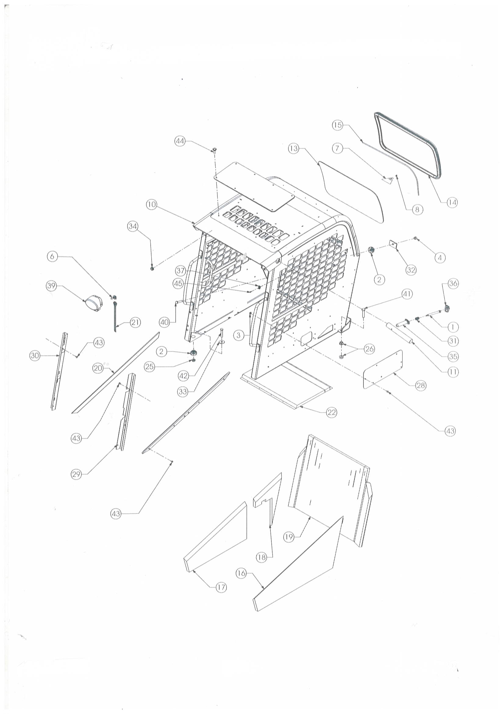

ROPS/FOPS
REF | PART NUMBER | DESCRIPTION | QTY
1 | 1400 | SCREW/SHOULDER #10 | 2
2 | 1401 | MOUNT/RUBBER | 4
3 | 1402 | NUT/LOCK SERRATED FLANGE 1/4 | 7
4 | 1345 | NUT/LOCK 1/2 | 5
6 | 1404 | BULB (INCLUDED WITH ITEM 39) | 3
7 | 1405 | TAG/RIP CORD | 1
8 | 1406 | RING | 1
10 | 1407 | WELDMENT/ROPS | 1
11 | 1408 | PIN/LIFTARM LOCK | 2
12 | 1409 | WINDOW/TOP | 1
13 | 1410 | WINDOW/REAR | 1
14 | 1411 | SEAL/WINDOW | 1
15 | 1412 | STRIP/LOCKING SEAL | 1
16 | 1413 | PAD/FOAM LEFT | 1
17 | 1414 | PAD/FOAM RIGHT | 1
18 | 1415 | PAD/FOAM RIGHT REAR | 1
19 | 1416 | PAD/REAR LOWER ROPS | 1
20 | 1417 | GUARD/HEADLINER | 2
21 | 1418 | PLUG/LIGHT | 2
22 | 1419 | PAD/FOAM/ROOF | 1
25 | 1242 | NUT/CENTERLOCK FLANGE 1/2 | 2
26 | 1421 | NUT/LOCK SERRATED FLANGE 5/8 | 4
28 | 1422 | COVER/HEATER ACCESS | 1
29 | 1423 | POST COVER/ROPS LEFT | 1
30 | 1424 | POST COVER/ROPS RIGHT | 1
31 | 1425 | SPRING/LOCK KNOB | 2
32 | 1426 | PLATE/CLAMP | 2
33 | 1427 | WASHER/FLAT 17/32 | 2
34 | 1428 | GROMMET | 2
35 | 1429 | KNOB/LIFTARM LOCK | 2
36 | 1430 | COVER/LIFTARM KNOB | 2
37 | 1431 | MOUNT/WIRE TIE | 9
39 | 1432 | HEADLIGHT (INCLUDES ITEM 6) | 3
 | 1404 | BULB | AR
40 | 1434 | SCREW/CAP 1/2 X 2-1/4 | 2
41 | 1435 | SCREW/CAP 5/8 X 2-3/4 | 2
42 | 1436 | SCREW/CAP 1/2 X 2-3/4 | 2
43 | 1437 | SCREW/MACHINE TRUSS HEAD SLOTTED 1/4 X 1/2 | 11
44 | 1438 | SCREW/SEM 1/4 X 1-1/8 | 8
45 | 1439 | RIVET/POP 3/16 | 9

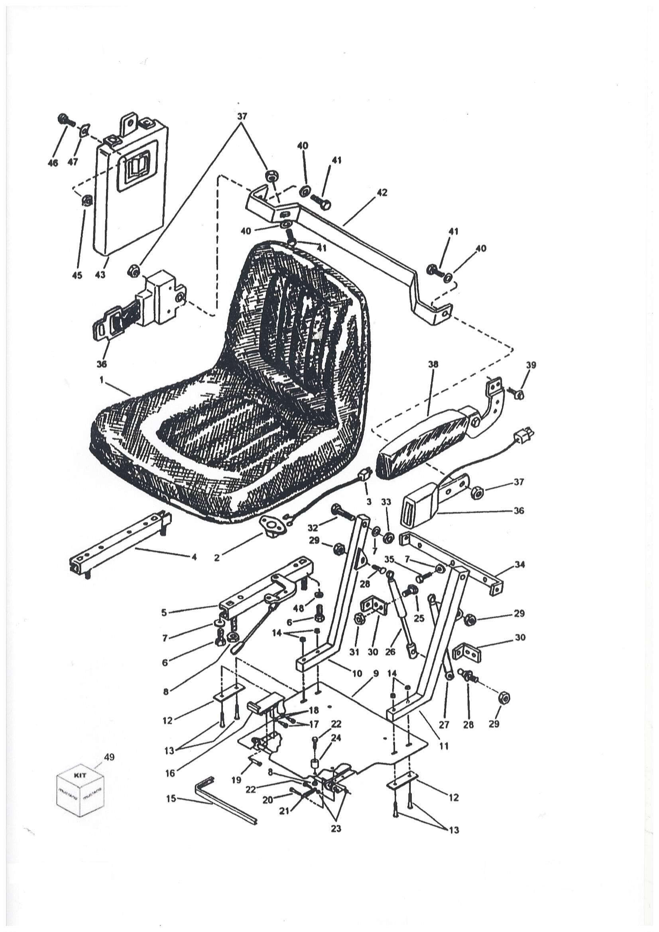
SEAT, SEAT MOUNTING AND RESTRAINT BAR
REF | PART NUMBER | DESCRIPTION | QTY
1 | 1500 | SEAT/OPERATOR STANDARD | 1
 | 1501 | SEAT/SUSPENSION WITH RAILS AND SLIDE/T-BAR | 1
 | 1502 | SEAT/SUSPENSION WITH RAILS AND SLIDE/DUAL LEVER | 1
 | 1503 | KNOB/SEAT ADJUSTER | 1
2 | 1504 | SWITCH/SEAT LOCKOUT/STANDARD | 1
 | 1505 | SWITCH/SEAT LOCKOUT/SUSPENSION | 1
3 | 1506 | WIRE/SWITCH TO HARNESS/STANDARD | 1
 | 1507 | WIRE/SWITCH TO HARNESS/SUSPENSION | 1
4 | 1508 | SEAT RAIL/SLAVE | 1
5 | 1509 | ADJUSTER/SEAT RAIL | 1
6 | 1510 | SCREW/CAP 5/16-18NC X 3/4 | 4
7 | 1511 | WASHER/FLAT 3/8 | 4
8 | 1512 | NUT/HEX WHIZLOCK 5/16-18NC | 5
9 | 1513 | PLATE/SEAT | 1
10 | 1514 | ARM/SWING RIGHT | 1
11 | 1515 | ARM/SWING LEFT | 1
12 | 1516 | PLATE/BACKER | 2
13 | 1517 | BOLT/CARRIAGE 3/8-16NC X 1-3/4 | 4
14 | 1518 | NUT/HEX FLANGED CENTERLOCK 3/8-16NC | 4
15 | 1519 | SEAL/BULB | 1
16 | 1520 | RELEASE HANDLE/SEAT | 1
17 | 1521 | BOLT/SHOULDER 3/8 X 5/8 LONG 5/16-18NC | 2
18 | 1522 | BUSHING/SPACER | 2
19 | 1523 | BOLT/SHOULDER 3/8 X 1-1/4 LONG 5/16-18NC | 1
20 | 1524 | SCREW/CAP 5/16-18NC X 1-1/2 | 1
21 | 1525 | SPRING | 1
22 | 1526 | SCREW/CAP 5/16-18NC X 1 | 2
23 | 1527 | NUT/HEX JAM 5/16-18NC | 2
24 | 1528 | SPACER | 1
25 | 1529 | SCREW/CAP 3/8-16NC X 3/4 | 4
26 | 1530 | GAS SPRING/NON-LOCKING | 1
27 | 1531 | GAS SPRING/LOCKING | 1
28 | 1532 | STUD/BALL | 4
29 | 1533 | NUT/HEX CENTERLOCK 5/16-18NC | 4
30 | 1534 | BRACKET/MOUNT | 2
31 | 1535 | NUT/HEX CENTERLOCK 3/8-16NC | 4
32 | 1536 | BOLT/SHOULD 1/2 X 1-1/4 LONG 3/8-16NC | 2
33 | 1537 | NUT/HEX CENTERLOCK 3/8-16NC | 2
34 | 1538 | BRACKET/SEAT PIVOT/T-BAR | 1
35 | 1539 | SCREW/CAP 3/8-16NC X 3/4 | 4
36 | 1540 | BELT/SEAT | 1
37 | 1541 | NUT/HEX CENTERLOCK 7/16-20NF | 4
38 | 1542 | KIT/ARMREST/STANDARD | 1
 | 1543 | ARMREST/STANDARD | 1
39 | 1544 | SCREW/CAP 5/16-18NC X 5/8 (INCLUDED IN ITEM #38) | 4
40 | 1545 | WASHER/FLAT 7/16 | 4
41 | 1546 | SCREW/CAP 7/16-20NF X 1 | 4
42 | 1547 | BRACKET/SEAT BELT/STANDARD | 1
43 | 1548 | HOLDER/MANUAL | 1
45 | 1549 | NUT/SERRATED FL 1/4 | 2
46 | 1550 | BOLT/CARRIAGE 1/4-20NC X 5/8 | 2
47 | 1551 | NUT/SINGLE THREAD 1/4-20NC | 2
48 | 1552 | WASHER/FLAT 1/4 | 4
49 | 1553 | KIT/ARM REST ASSEMBLY - SUSPENSION SEATS ONLY | 1

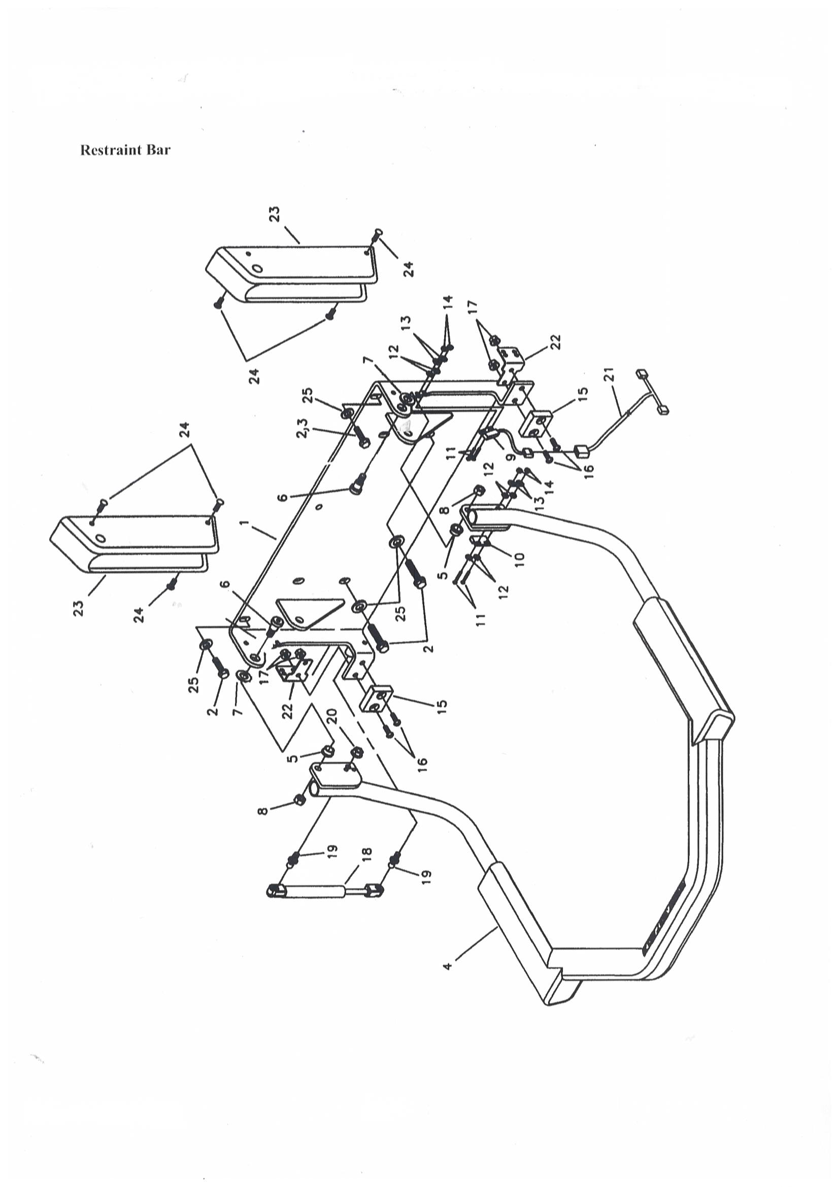
SEAT, SEAT MOUNTING AND RESTRAINT BAR
REF | PART NUMBER | DESCRIPTION | QTY
1 | 1554 | SEAT MOUNT/RESTRAINT BAR | 1
2 | 1555 | SCREW/CAP WHIZLOCK 3/8-16NC X 3/4 | 4
4 | 1556 | BAR/RESTRAINT WITH PAD | 1
5 | 1557 | BUSHING/OILITE/FLANGED | 2
6 | 1558 | BOLT/SHOULDER 3/8 - 16NC X 1/2 | 2
7 | 1559 | WASHER/SPECIAL | 2
8 | 1560 | NUT/HEX CENTERLOCK 3/8-16NC | 2
9 | 1561 | SWITCH/ROPS SIDE | 1
10 | 1562 | SWITCH/RESTRAINT BAR/MAGNET | 1
11 | 1563 | SCREW/MACHINE ROUND HEAD #6-32NC X 3/4 | 4
12 | 1564 | WASHER/FLAT #6 | 6
13 | 1565 | WASHER/LOCK #6 | 4
14 | 1566 | NUT/HEX #6-32NC | 4
15 | 1567 | STOP/RESTRAINT BAR | 2
16 | 1568 | SCREW/MACHINE TRUSS HEAD 1/4-20NC X 1 | 4
17 | 1569 | NUT/HEX WHIZLOCK 1/4-20NC | 4
18 | 1554 | GAS SPRING/RESTRAINT BAR | 1
19 | 1532 | STUD/BALL | 2
20 | 1512 | NUT/HEX WHIZLOCK 5/16 - 18NC | 1
21 | 1573 | WIRE HARNESS/RESTRAINT BAR | 1
22 | 1574 | COVER BRACKET/RESTRAINT BAR | 2
23 | 1575 | COVER/RESTRAINT BAR HINGE | 2
24 | 1576 | CLIP | 6
25 | 1511 | WASHER/FLAT 3/8 | 4

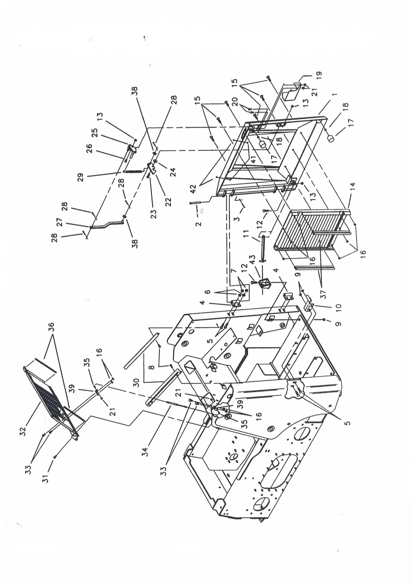
REAR DOOR AND ENGINE COVER
REF | PART NUMBER | DESCRIPTION | QTY
1 | 1600 | DOOR/REAR | 1
2 | 1601 | PIN/CLEVIS 1/2 X 4-1/2 | 2
3 | 1602 | PIN/COTTER 5/32 X 1 | 2
4 | 1603 | HINGE/REAR DOOR | 2
5 | 1604 | BOLT/CARRIAGE 1/2-13NC X 1-1/4 | 6
6 | 1605 | WASHER/LOCK 1/2 | 4
7 | 1606 | NUT/HEX FLANGED 1/2-13NC | 4
8 | 1607 | SCREW/CAP SELF-TAPPING 5/16-18NC X 1/2 | 4
9 | 1608 | NUT/HEX FLANGED 1/2-13NC | 2
10 | 1609 | PIN/LATCH | 1
11 | 1610 | BAR/LOCK | 1
12 | 1611 | BOLT/CARRIAGE 1/2-13NC X 1-1/2 | 2
13 | 1612 | NUT/HEX CENTERLOCK 1/2-13NC | 3
14 | 1613 | GRILLE | 1
15 | 1614 | BOLT/CARRIAGE 3/8-16NC X 1 | 6
16 | 1615 | NUT/HEX WHIZLOCK 3/8-16NC | 10
17 | 1616 | BUMPER/RUBBER | 2
18 | 1617 | NUT/HEX JAM 3/8-16NC | 2
19 | 1618 | GUARD/HAND | 1
20 | 1619 | BOLT/CARRIAGE 5/16-18NC X 3/4 | 2
21 | 1620 | NUT/HEX WHIZLOCK 5/16-18NC | 4
22 | 1621 | LATCH/REAR DOOR | 1
23 | 1622 | SCREW/CAP 1/2-13NC X 1-1/2 | 1
24 | 1623 | WASHER/FLAT 7/16 | AR
25 | 1624 | HANDLE | 1
26 | 1625 | BOLT/CARRIAGE 1/2-13NC X 2-1/4 | 1
27 | 1626 | RELEASE/LATCH ARM | 1
28 | 1602 | PIN/COTTER 5/32 X 1 | 4
29 | 1628 | SPRING/LATCH | 1
30 | 1629 | BRACKET/DOOR SUPPORT | 2
31 | 1630 | SCREW/CAP SELF-TAPPING 5/16-18NC X 3/4 | 4
32 | 1631 | COVER/ENGINE | -
 | 1632 | COVER/ENGINE | 1
33 | 1633 | SCREW/CAP 3/8-16NC X 3/4 | 4
34 | 1634 | SHOCK/GAS SPRING | 1
35 | 1635 | STUD/BALL | 2
36 | 1636 | EDGING/TOP DOOR | 2
37 | 1637 | TRIM/RADIATOR SEAL | 2
38 | 1638 | WASHER/FLAT 3/8 | 2
39 | 1639 | BRACKET/SHOCK MOUNT | 2
41 | 1640 | BUMPER/RUBBER | 2
42 | 1641 | SCREW/MACHINE #8-32 X 3/8 | 2
43 | 1642 | LOCK/GUIDE | 1

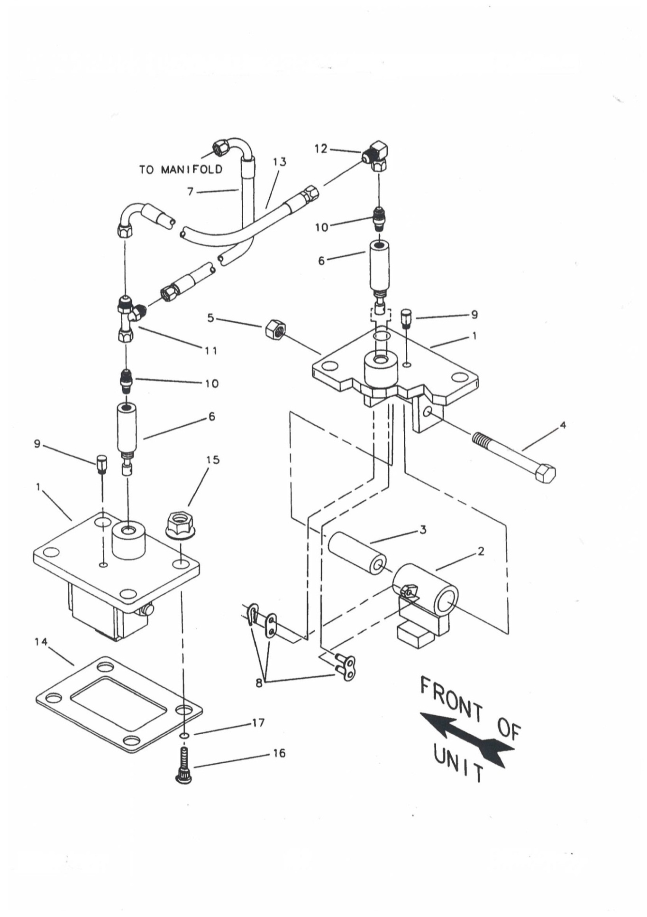

BRAKE SYSTEM
REF | PART NUMBER | DESCRIPTION | QTY
1 | 2100 | MOUNT/BRAKE | 2
 | 2101 | COVER/BRAKE ACCESS (IMER BRAKES) | -
2 | 2102 | STOP/BRAKE | 2
3 | 2103 | TUBE/PIVOT | 2
4 | 2104 | SCREW/CAP 1/2-13NC X 4 | 2
5 | 2105 | NUT/HEX CENTERLOCK 1/2-13NC | 2
6 | 2106 | CYLINDER/BRAKE | 2
7 | 2107 | ASSEMBLY/HYDRAULIC HOSE AND TUBE | 1
8 | 2108 | LINK/CONNECTING #50 | 2
9 | 2109 | BREATHER | 2
10 | 2110 | ADAPTER 7/16 | 2
11 | 2111 | FITTING/TEE SWIVEL 7/16 | 1
12 | 2112 | FITTING/90° ELBOW 7/16 | 1
13 | 2113 | ASSEMBLY/HOSE AND TUBE/BRAKE TO BRAKE | 1
14 | 2114 | GASKET | 2
15 | 2115 | NUT/HEX WHIZLOCK 1/2-13NC | 8
16 | 2116 | BOLT/HUB 1/2-20NF X 1-35/64 | -
17 | 2117 | O-RING | -

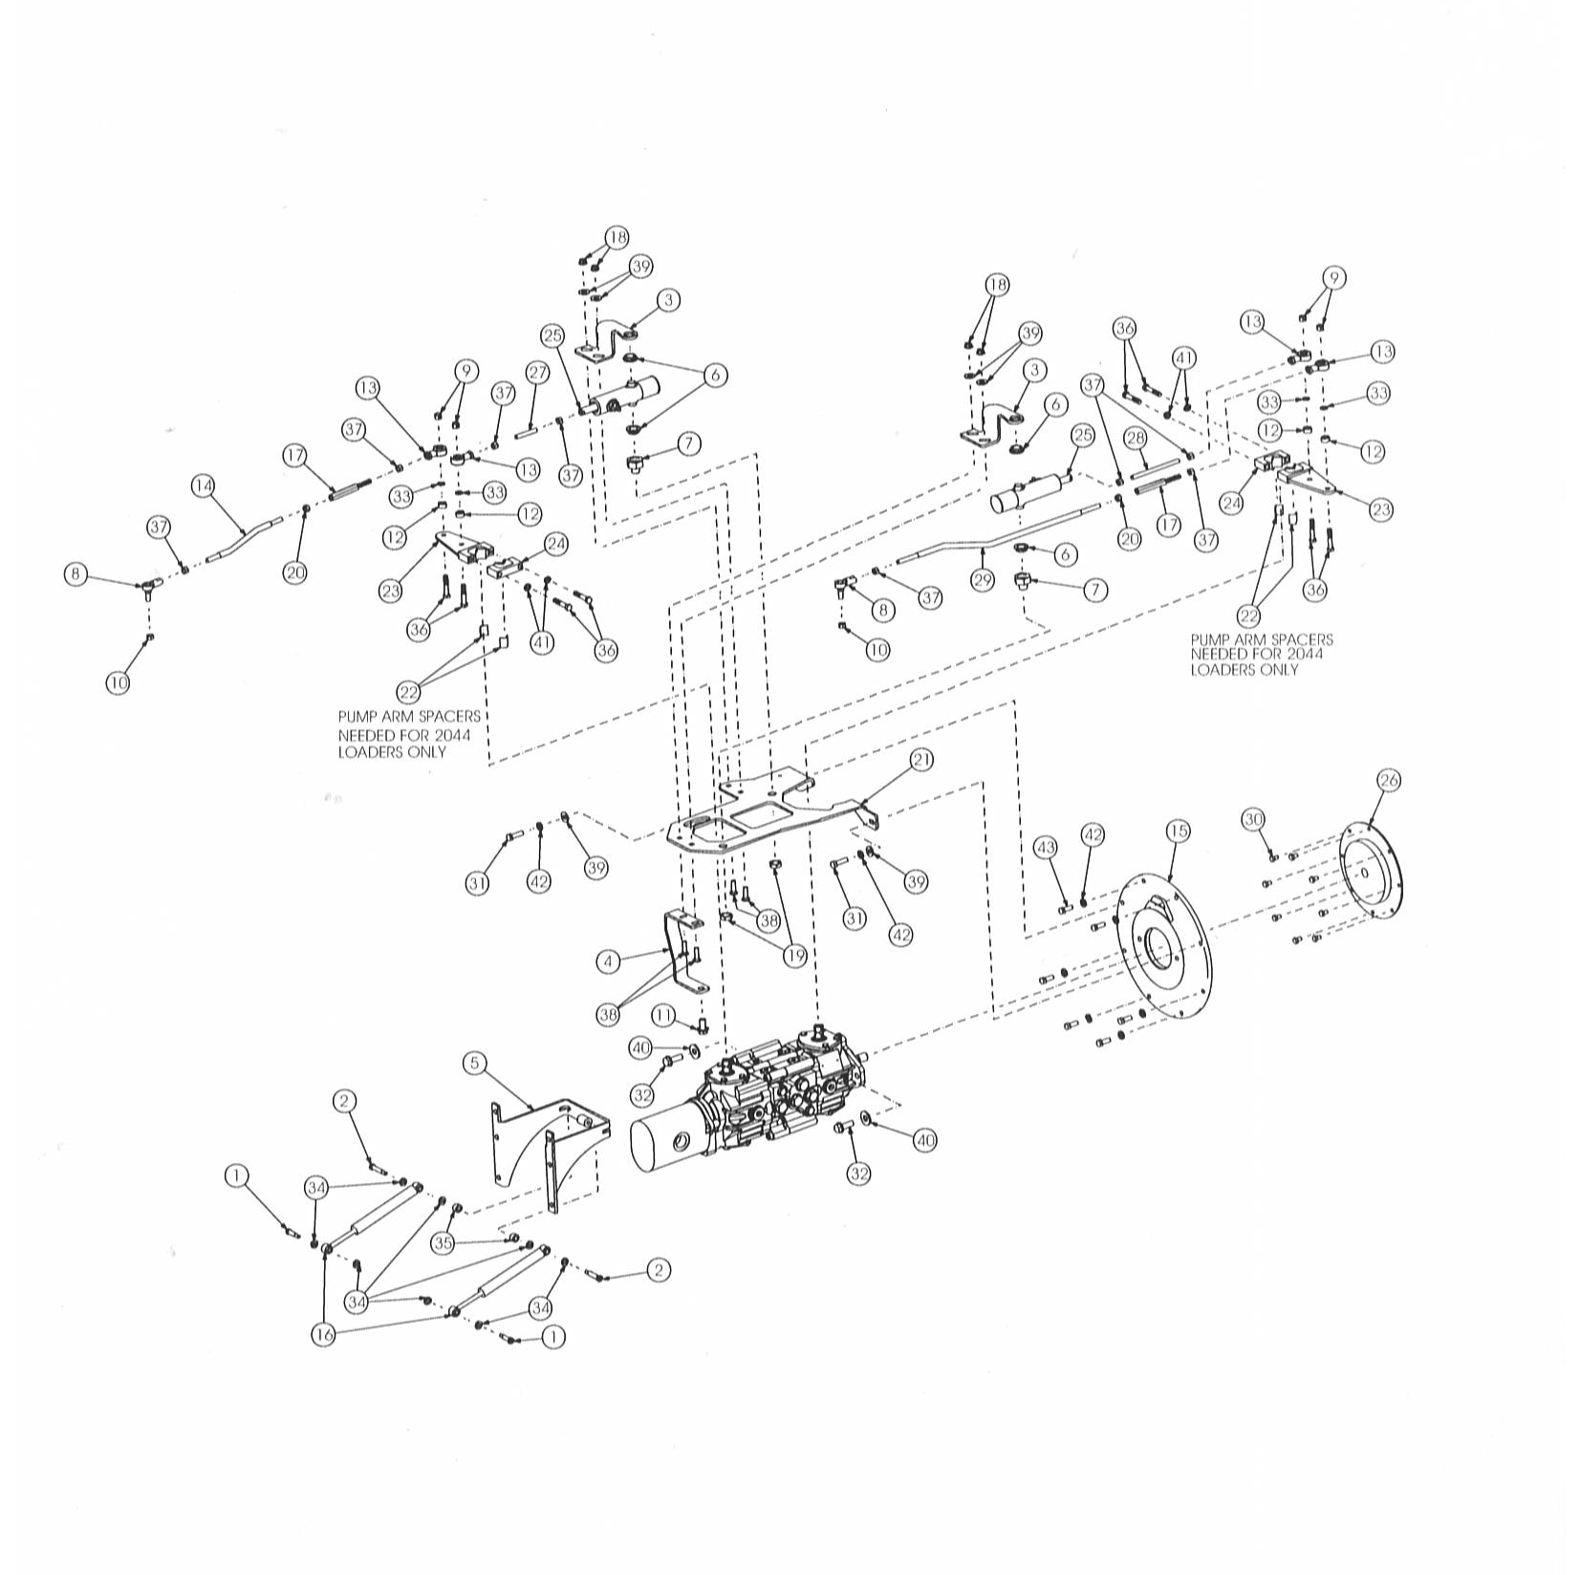
HYDROSTATIC MOUNT AND LINKAGE

REF | PART NUMBER | DESCRIPTION | QTY
1 | 2200 | SCREW/SHOULDER 5/16-18 X 1 | 2
2 | 2201 | SCREW/SHOULDER 5/16-18 X 1-1/2 | 2
3 | 2202 | BRACKET/NEUTRAL CENTER SUPPORT TOP | 2
4 | 2203 | BRACKET/FRONT SUPPORT | 1
5 | 2204 | MOUNT/SHOCK | 1
6 | 2205 | BUSHING/OILITE FLANGED | 4
7 | 2206 | BUSHING/LOWER NEUTRAL MOUNT | 2
8 | 2207 | ROD END/FEMALE WITH STUD | 2
9 | 2208 | NUT/HEX CENTERLOCK 3/8-16NC | 4
10 | 2209 | NUT/HEX CENTERLOCK 3/8-24NF | 2
11 | 2210 | SCREW/CAP WHIZLOCK 1/2-13NC X 1 | 1
12 | 2211 | SPACER | 4
13 | 2212 | ROD END/ELASTOMERIC CUSHIONED | 4
 | 2213 | ROD END/FEMALE STANDARD | 4
14 | 2214 | ROD/STEERING RIGHT | 1
15 | 2215 | PUMP/MOUNTING PLATE | 1
16 | 2216 | ABSORBER/SHOCK | 2
17 | 2217 | TURNBUCKLE | -
 | 2218 | TURNBUCKLE | 2
18 | 2219 | NUT/HEX FLANGED CENTERLOCK 3/8-16NC | 4
19 | 2220 | NUT/BULKHEAD 3/4-16NC | 2
20 | 2221 | NUT/HEX 3/8-24NF LEFT THREAD | 2
21 | 2222 | ARM/CONTROL MOUNT | 1
22 | 2223 | SPACER/CUSHIONED CONTROL ARM (2044 MODELS ONLY) | -
23 | 2224 | ARM/CUSHIONED CONTROL | 2
 | 2225 | ARM/PUMP STANDARD 2044 | -
 | 2226 | ARM/PUMP STANDARD 2054 | 2
24 | 2227 | CLAMP/CUSHIONED CONTROL ARM | 2
 | 2228 | RETAINER/PUMP ARM STANDARD 2044 | -
 | 2229 | RETAINER/PUMP ARM STANDARD 2054 | 2
25 | 2230 | ASSEMBLY/NEUTRAL START AND CENTERING | 2
26 | 2231 | PLATE/FLEXIBLE DRIVE | 1
27 | 2232 | ROD/CONTROL RIGHT | 1
28 | 2233 | ROD/CONTROL LEFT | 1
29 | 2234 | ROD/STEERING LEFT | 1
30 | 2235 | SCREW/CAP M8-1.25 X 12MM | 8
31 | 2236 | SCREW/CAP M10-1.50 X 35MM | 2
32 | 2237 | SCREW/CAP FLANGED 1/2-13NC X 1-1/2 | 2
33 | 2238 | WASHER/SPECIAL | 4
34 | 2239 | WASHER/SPECIAL | 8
35 | 2240 | BUSHING | 2
36 | 2241 | SCREW/CAP 3/8-16NC X 2 | 8
37 | 2242 | NUT/HEX 3/8-24NF | 8
38 | 2243 | BOLT/CARRIAGE 3/8-16NC X 1-1/4 | 4
39 | 2244 | WASHER/FLAT 3/8 | 6
40 | 2245 | WASHER/FLAT 1/2 | 2
41 | 2246 | WASHER/LOCK 3/8 | 4
42 | 2247 | WASHER/LOCK 7/16 | 8
43 | 2248 | SCREW/CAP M10-1.50 X 25MM | 6
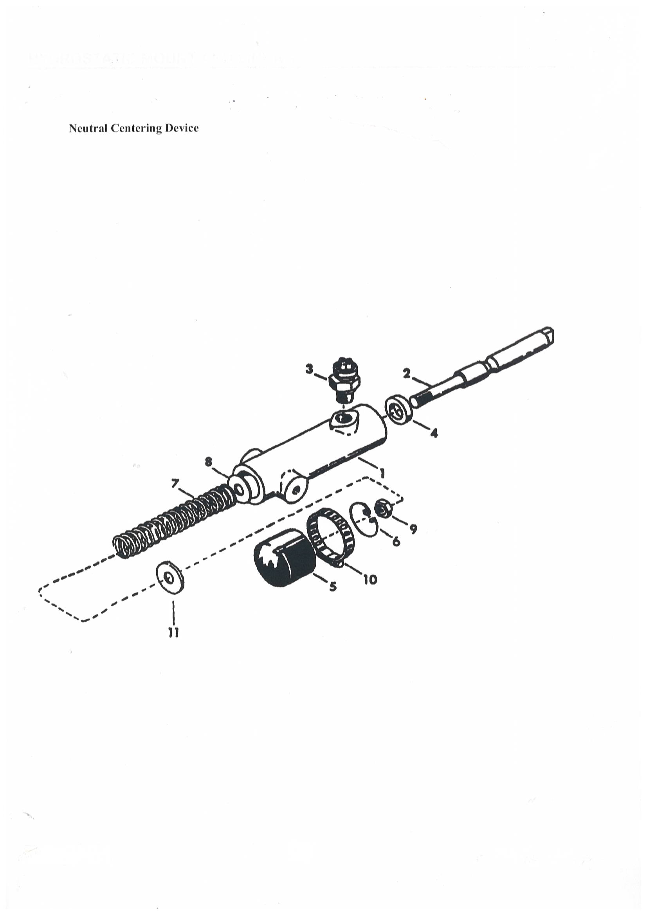
HYDROSTATIC MOUNT AND LINKAGE

REF | PART NUMBER | DESCRIPTION | QTY
 | 2230 | ASSEMBLY/NEUTRAL START (INCLUDES ITEMS 1-11) | 1
1 | 2250 | HOUSING/CENTERING | 1
2 | 2251 | ROD | 1
3 | 2252 | SWITCH/NEUTRAL | 1
4 | 2253 | SEAL/WIPER ROD | 1
5 | 2254 | CAP/DUST | 1
6 | 2255 | RING/SNAP | 1
7 | 2256 | SPRING | 1
8 | 2244 | WASHER/FLAT 3/8 | 1
9 | 2258 | NUT/LOCK 3/8-24NF | 1
10 | 2259 | CLAMP/HOSE | 1
11 | 2260 | WASHER/SPECIAL | 1

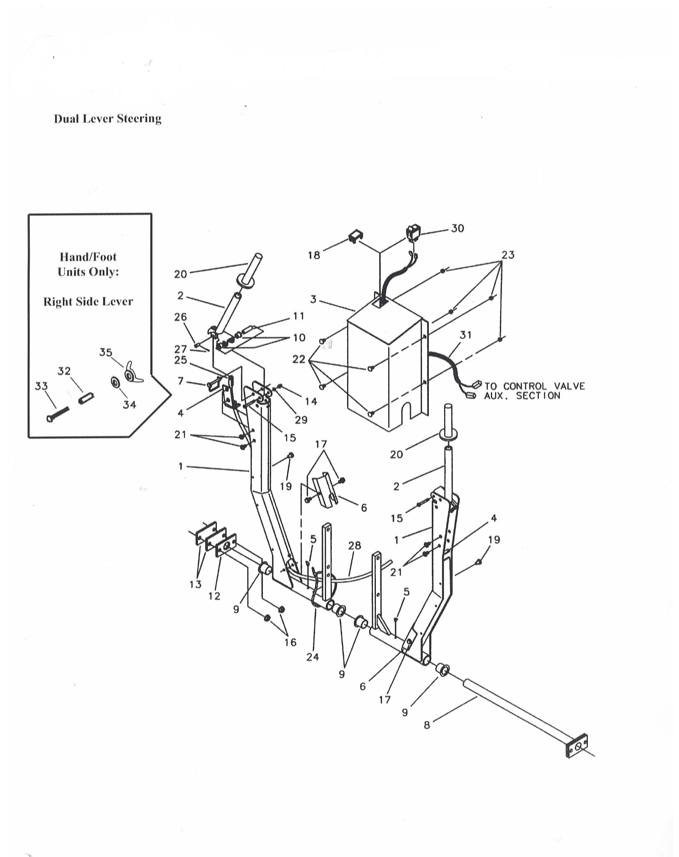

STEERING CONTROLS
REF | PART NUMBER | DESCRIPTION | QTY
1 | 2300 | HANDLE/DUAL LEVER | 2
2 | 2301 | HANDLE/DUAL LEVER | 2
3 | 2302 | WRAPPER | 1
4 | 2303 | BRACKET/CONTROL CABLE | 1
5 | 2304 | FITTING/GREASE | 2
6 | 2305 | COVER/CABLE | 2
7 | 2306 | PIN/SNAPPER (HAND/FOOT ONLY) | 2
8 | 2307 | ASSEMBLY/PIVOT SHAFT PRESS | 1
9 | 2308 | BUSHING/FLANGED | 4
10 | 2309 | BUSHING/OILITE FLANGED | 4
11 | 2310 | BUSHING/HANDLE PIVOT | 2
12 | 2311 | PIVOT | 1
13 | 2312 | SHIM/SHAFT | 2
14 | 2313 | NUT/ACORN | 2
15 | 2314 | SCREW/BUTTON HEAD 1/4-20NC X 2 | 2
16 | 2315 | NUT/HEX WHIZLOCK 3/8-16NC | 4
17 | 2316 | SCREW/SELF-TAPPING 5/16-18NC X 1/2 | 4
18 | 2317 | PLUG | 1
19 | 2318 | BUMPER | 2
20 | 2319 | GRIP | 2
 | 2320 | SWITCH/ALTERNATE ACTION (RIGHT DUAL LEVER) | 1
21 | 2321 | SCREW/BUTTON HEAD 5/16-18NC X 1/2 | 2
22 | 2322 | BOLT/CARRIAGE 5/16-18NC X 1 | 4
23 | 2323 | NUT/HEX WHIZLOCK 5/16-18NC | 4
24 | 2324 | TIE/CABLE | 2
25 | 2325 | CLEVIS | 1
26 | 2326 | PIN/CLEVIS 1/4 X 3/4 | 1
27 | 2327 | PIN/COTTER 1/16 X 3/4 | 1
28 | 1315 | CABLE/CONTROL | 1
29 | 2329 | WASHER/FLAT 3/16 | 2
30 | 2330 | SWITCH/AUXILIARY (HANDS ONLY CONTROLS) | 1
31 | 2331 | WIRE HARNESS/AUXILIARY LOCK (HANDS ONLY CONTROLS) | 1
32 | 2332 | SPACER | 1
33 | 2333 | BOLT/CARRIAGE 5/16 X 2 | 1
34 | 2334 | WASHER/FLAT 5/16 | 1
35 | 2335 | NUT/WING 5/16 | 1

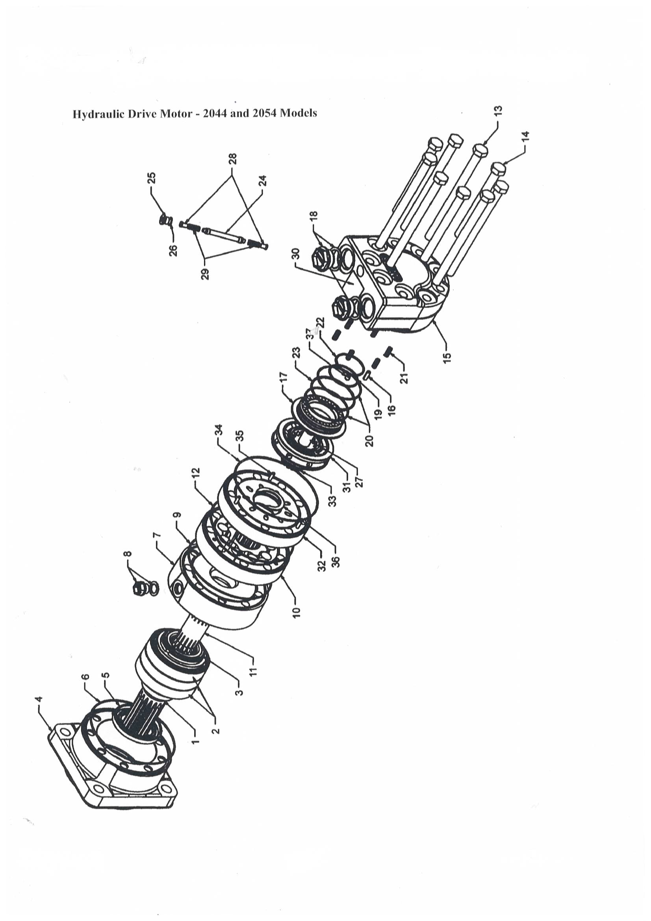

DRIVE MOTOR AND PARKING BRAKE
REF | PART NUMBER | DESCRIPTION | QTY
 | 2400 | ASSEMBLY/SHAFT (ITEMS 1-3) | 1
1 | 2400 | SHAFT/SPLINED | 1
2 | 2400 | BEARING | 1
3 | 2400 | NUT/BEARING | 1
 | 2401 | ASSEMBLY/MOUNTING FLANGE (ITEMS 4-6) | 1
4 | 2401 | MOUNTING FLANGE/BEARING HOUSE | 1
5 | 2401 | SEAL/SHAFT | 1
6 | 2401 | O-RING | 1
 | 2402 | ASSEMBLY/MOTOR FLANGE (ITEMS 7-9) | 1
7 | 2402 | FLANGE/MOTOR | 1
8 | 2402 | PLUG/DRAIN PORT | 1
9 | 2402 | O-RING | 1
 | 2403 | ASSEMBLY/GEAR SET (ITEMS 10-12) | 1
10 | 2403 | SET/GEAR | 1
11 | 2403 | SHAFT/CARDAN | 1
12 | 2403 | O-RING | 1
 | 2404 | ASSEMBLY/BOLT (ITEMS 13, 14) | 1
13 | 2404 | SCREW M12-1.00 X 190MM | 6
14 | 2404 | SCREW M12-1.00 X 160MM | 3
 | 2405 | ASSEMBLY/END COVER (ITEMS 15-30) | 1
15 | 2405 | END COVER/VALVE HOUSE | 1
16 | 2405 | PIN/GUIDE | 1
17 | 2405 | PLATE/BALANCE | 1
18 | 2405 | PLUG/MAIN PORT | 2
19 | 2405 | RING/BACKUP | 1
20 | 2405 | RING/BACKUP | 2
21 | 2406 | SPRING | 6
22 | 2406 | O-RING | 1
23 | 2406 | O-RING | 1
24 | 2406 | VALVE/FLUSHING | 1
25 | 2407 | PLUG | 1
26 | 2407 | O-RING | 1
27 | 2407 | SPACER | 1
28 | 2408 | VALVE STOP/FLUSHING | 2
29 | 2409 | SPRING | 2
30 | 2409 | PLATE/NAME | 1
 | 2410 | ASSEMBLY/VALVING (ITEMS 31-36) | 1
31 | 2410 | VALVE/DISC | 1
32 | 2410 | PLATE/CHANNEL | 1
33 | 2410 | DRIVE/VALVE | 1
34 | 2410 | O-RING | 1
35 | 2411 | PIN/GUIDE | 3
36 | 2412 | RING/STOP | 1
 | 2413 | ASSEMBLY/FLOW RESTRICTION (ITEM 37) | 1
37 | 2413 | SCREW/ORIFICE | 1
 | 2414 | KIT/SEAL (ITEMS 5, 6, 9, 12, 19, 20, 22, 23, 26, 34) | 1
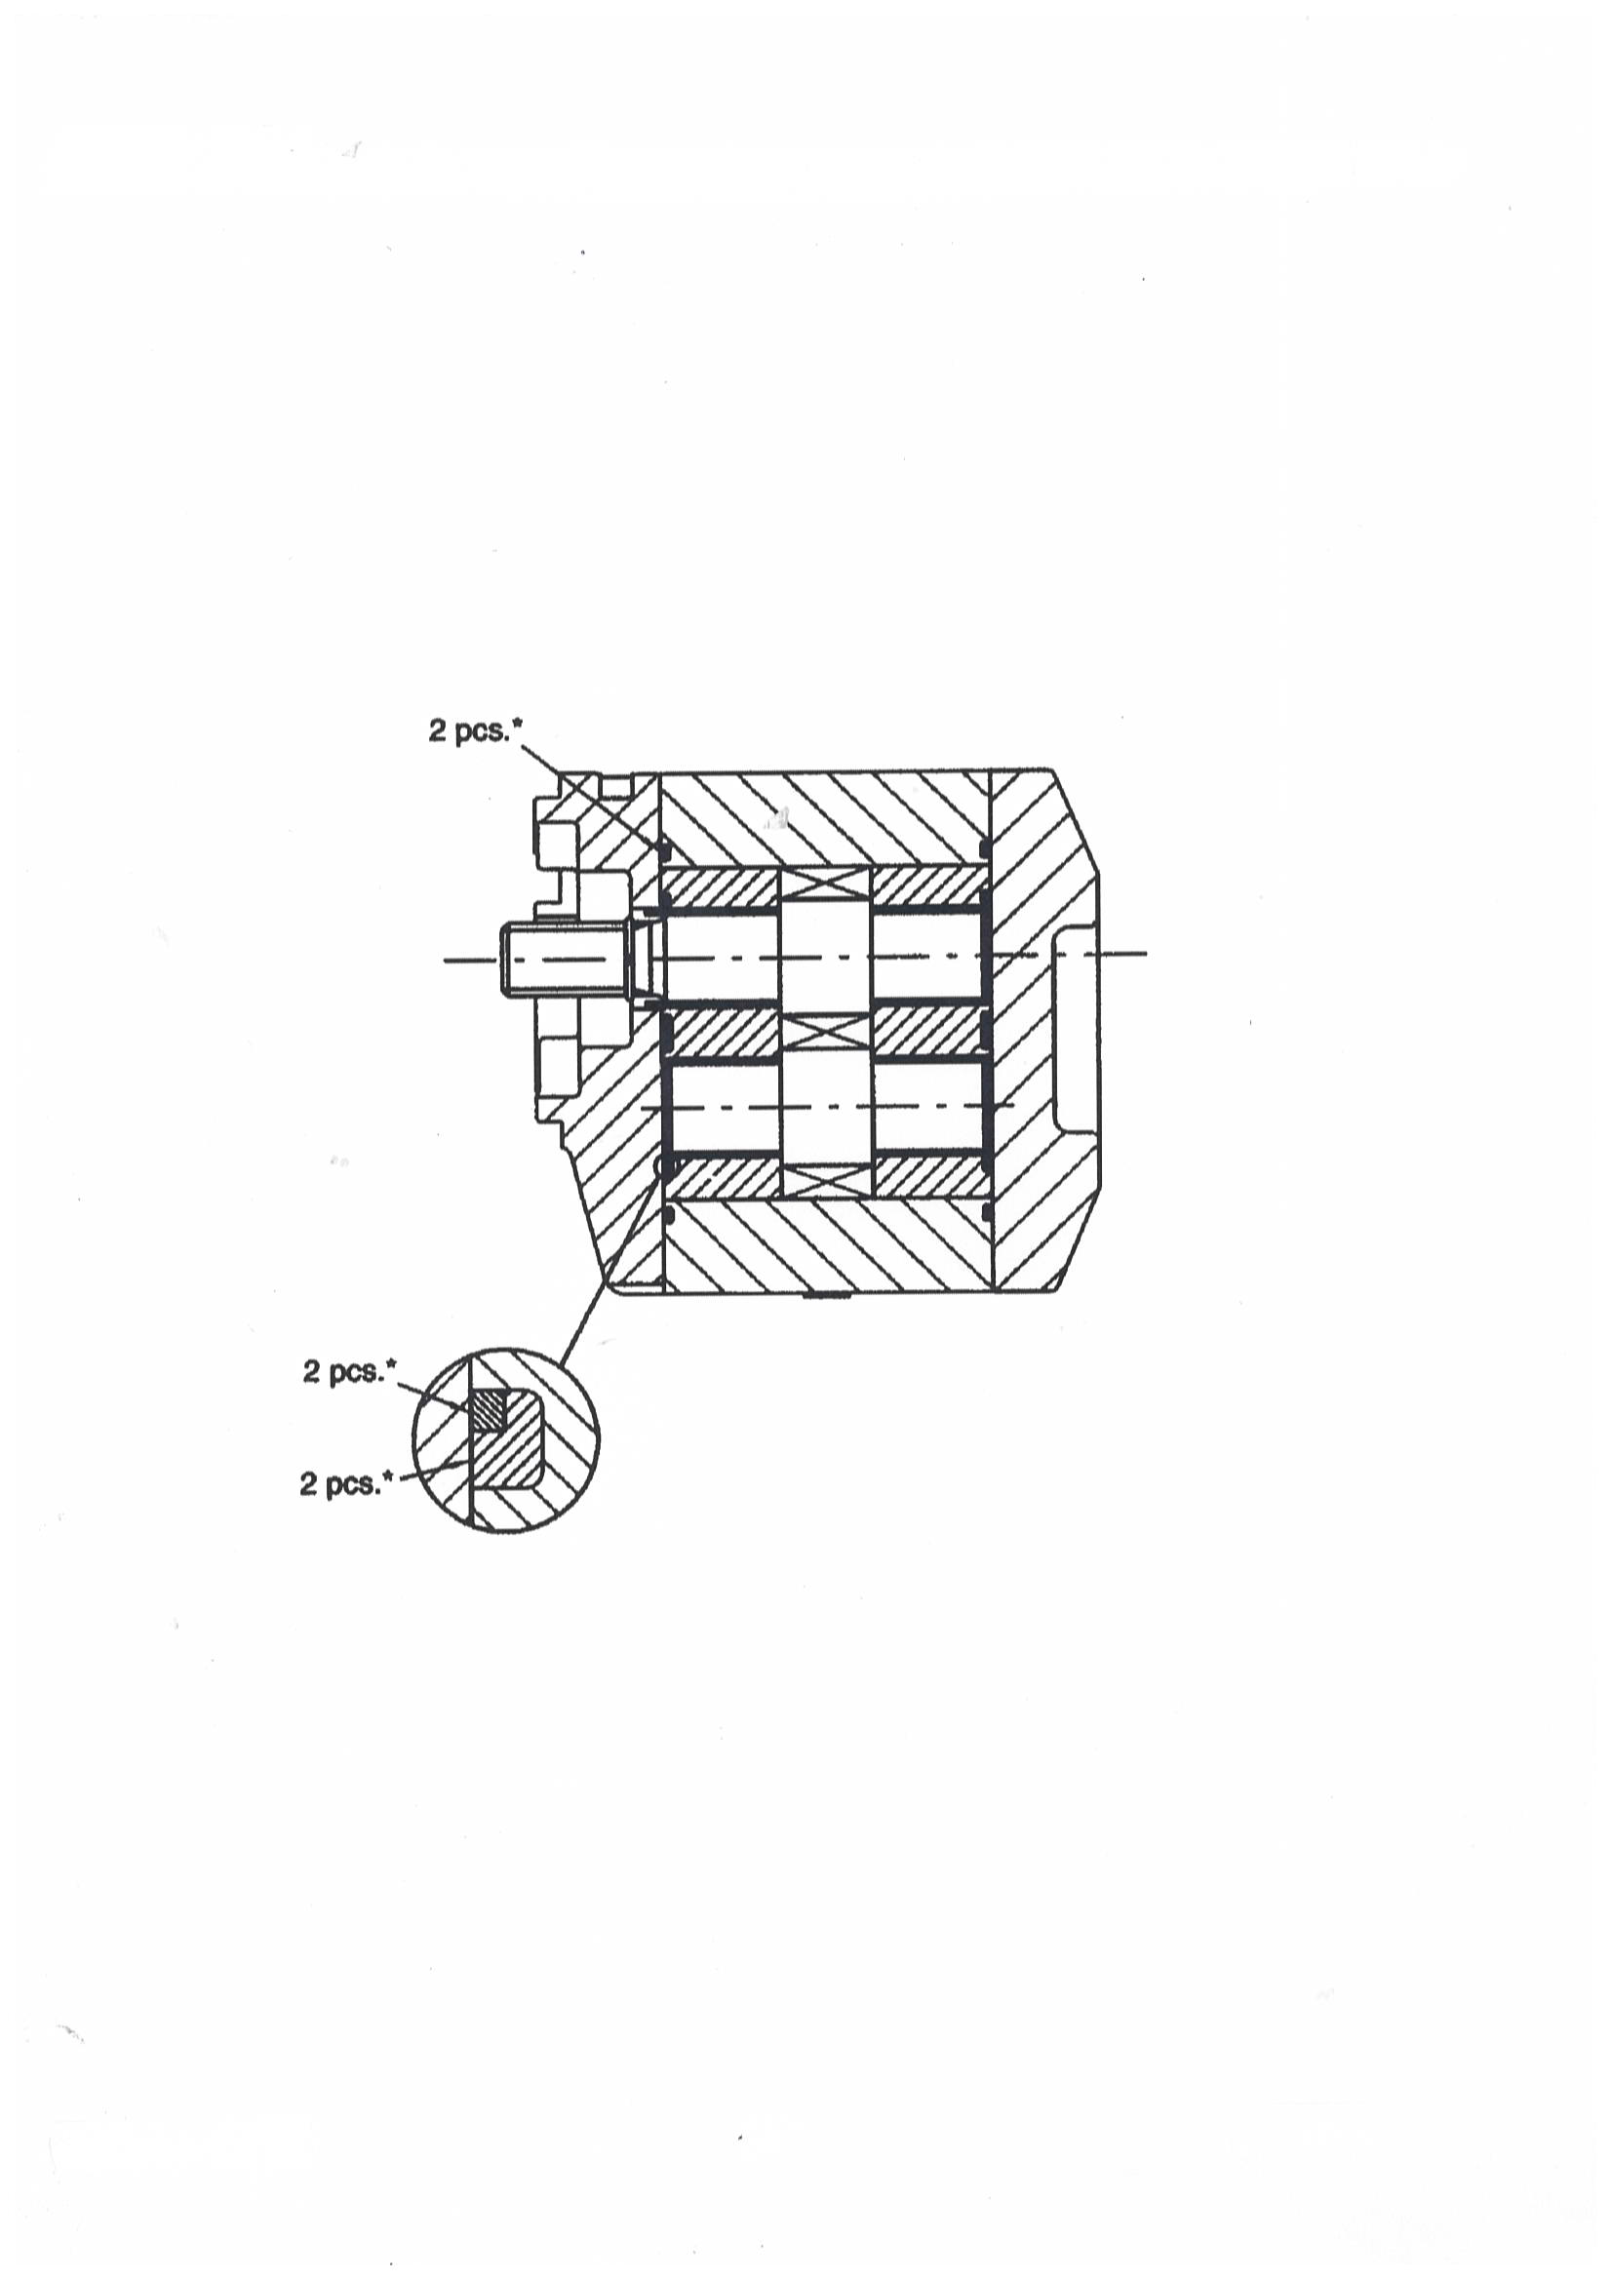

GEAR PUMP
REF | PART NUMBER | DESCRIPTION | QTY
1 | 2500 | PUMP/GEAR | 1
 | 2501 | KIT/SEAL (ASTERISK (*) INDICATES PARTS IN KIT) | 1

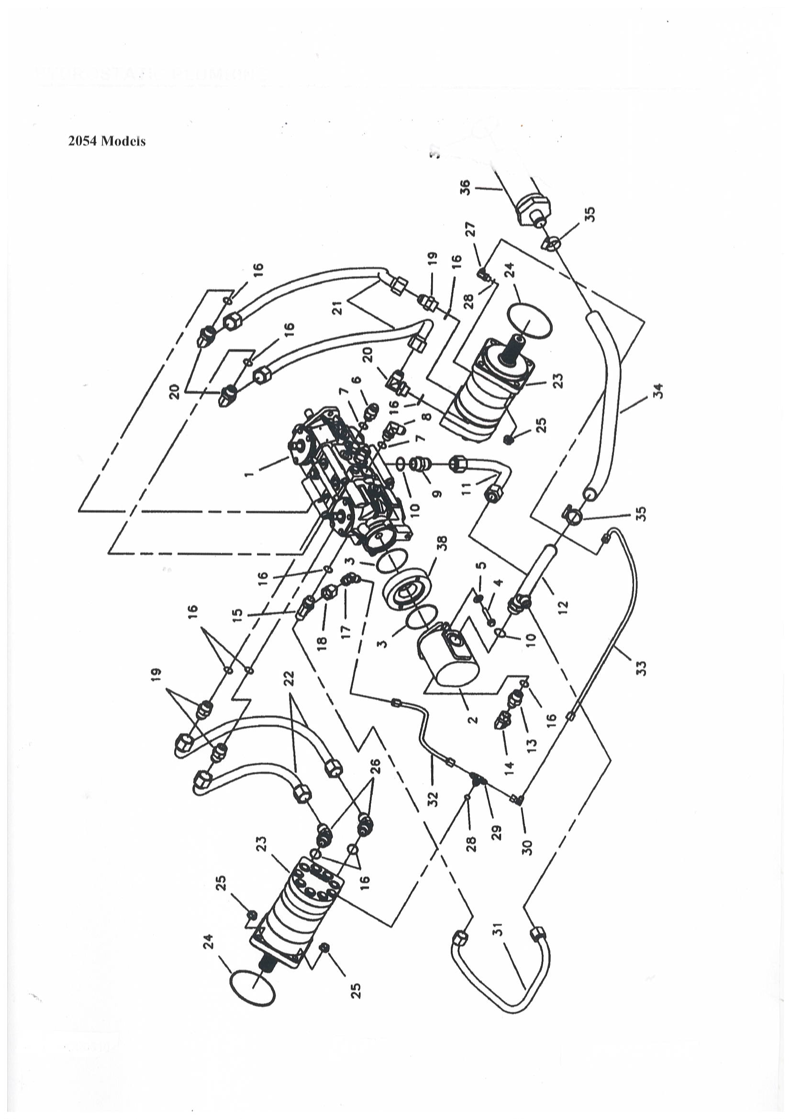
HYDROSTATIC PLUMBING

REF | PART NUMBER | DESCRIPTION | QTY
1 | 3100 | PUMP/TANDEM M44 | 1
2 | 3101 | PUMP/GEAR STANDARD | 1
 | 3102 | PUMP/GEAR HIGH FLOW | 1
3 | 3103 | O-RING | 1
4 | 3104 | SCREW/CAP 3/8-16NC X 1 STANDARD | 2
 | 3105 | SCREW/CAP 3/8-16NC X 2 HIGH FLOW | 2
5 | 3106 | WASHER/SPECIAL | 2
6 | 3107 | FITTING/STRAIGHT 7/8 SAE X 1-1/16 JIC | 1
7 | 3108 | O-RING | 2
8 | 3109 | FITTING/90° ELBOW 7/8 SAE X 7/8 JIC | 1
9 | 3110 | FITTING/STRAIGHT 1-5/16 SAE X 1-5/16 JIC | 1
10 | 3111 | O-RING | 2
11 | 3112 | LINE/HYDRAULIC STANDARD | 1
 | 3113 | HOSE AND TUBE/HYDRAULIC HIGH FLOW | 1
12 | 3114 | FITTING/PUMP SUCTION | 1
13 | 3115 | FITTING/STRAIGHT 1-1/16 SAE X 7/8 JIC | 1
14 | 3116 | FITTING/90° ADAPTER ELBOW 7/8 JIC | 1
15 | 3117 | FITTING/TEE 1-1/16 SAE X 1-1/16 JIC | 1
16 | 3118 | O-RING | 1
17 | 3119 | FITTING/45° ADAPTER ELBOW 3/4 JIC | 1
18 | 3120 | FITTING/REDUCER 1-1/16 SAE X 3/4 JIC | 1
19 | 3121 | FITTING/STRAIGHT 1-1/16 SAE X 1-1/16 JIC | 3
20 | 3122 | FITTING/90° 1-1/16 SAE X 1-1/16 JIC | 3
21 | 3123 | HOSE AND TUBE/HYDRAULIC 34-1/2 | 2
22 | 3124 | HOSE AND TUBE/HYDRAULIC 30-1/2 | 2
23 | 3125 | MOTOR/HYDRAULIC | 2
24 | 3126 | O-RING | 2
25 | 3127 | NUT/HEX FLANGED 1/2-20NF | 8
26 | 3128 | FITTING/45° 1-1/16 SAE X 1-1/16 JIC | 2
27 | 3129 | FITTING/90° 9/16 SAE X 9/16 JIC | 1
28 | 3130 | O-RING | 2
29 | 3131 | FITTING/TEE 9/16 SAE X 9/16 JIC | 1
30 | 3132 | FITTING/90° ADAPTER ELBOW 9/16 JIC | 1
31 | 3133 | HOSE/HYDRAULIC | 1
32 | 3134 | HOSE/HYDRAULIC | 1
33 | 3135 | HOSE/HYDRAULIC | 1
34 | 3136 | HOSE/SUCTION | 1
35 | 3137 | CLAMP/HOSE | 2
36 | 3138 | STRAINER | 1
37 | 3103 | O-RING | 1
38 | 3140 | PLATE/ADAPTER HIGH FLOW PUMP | 1
1 | 3100 | PUMP/TANDEM M44 | 1

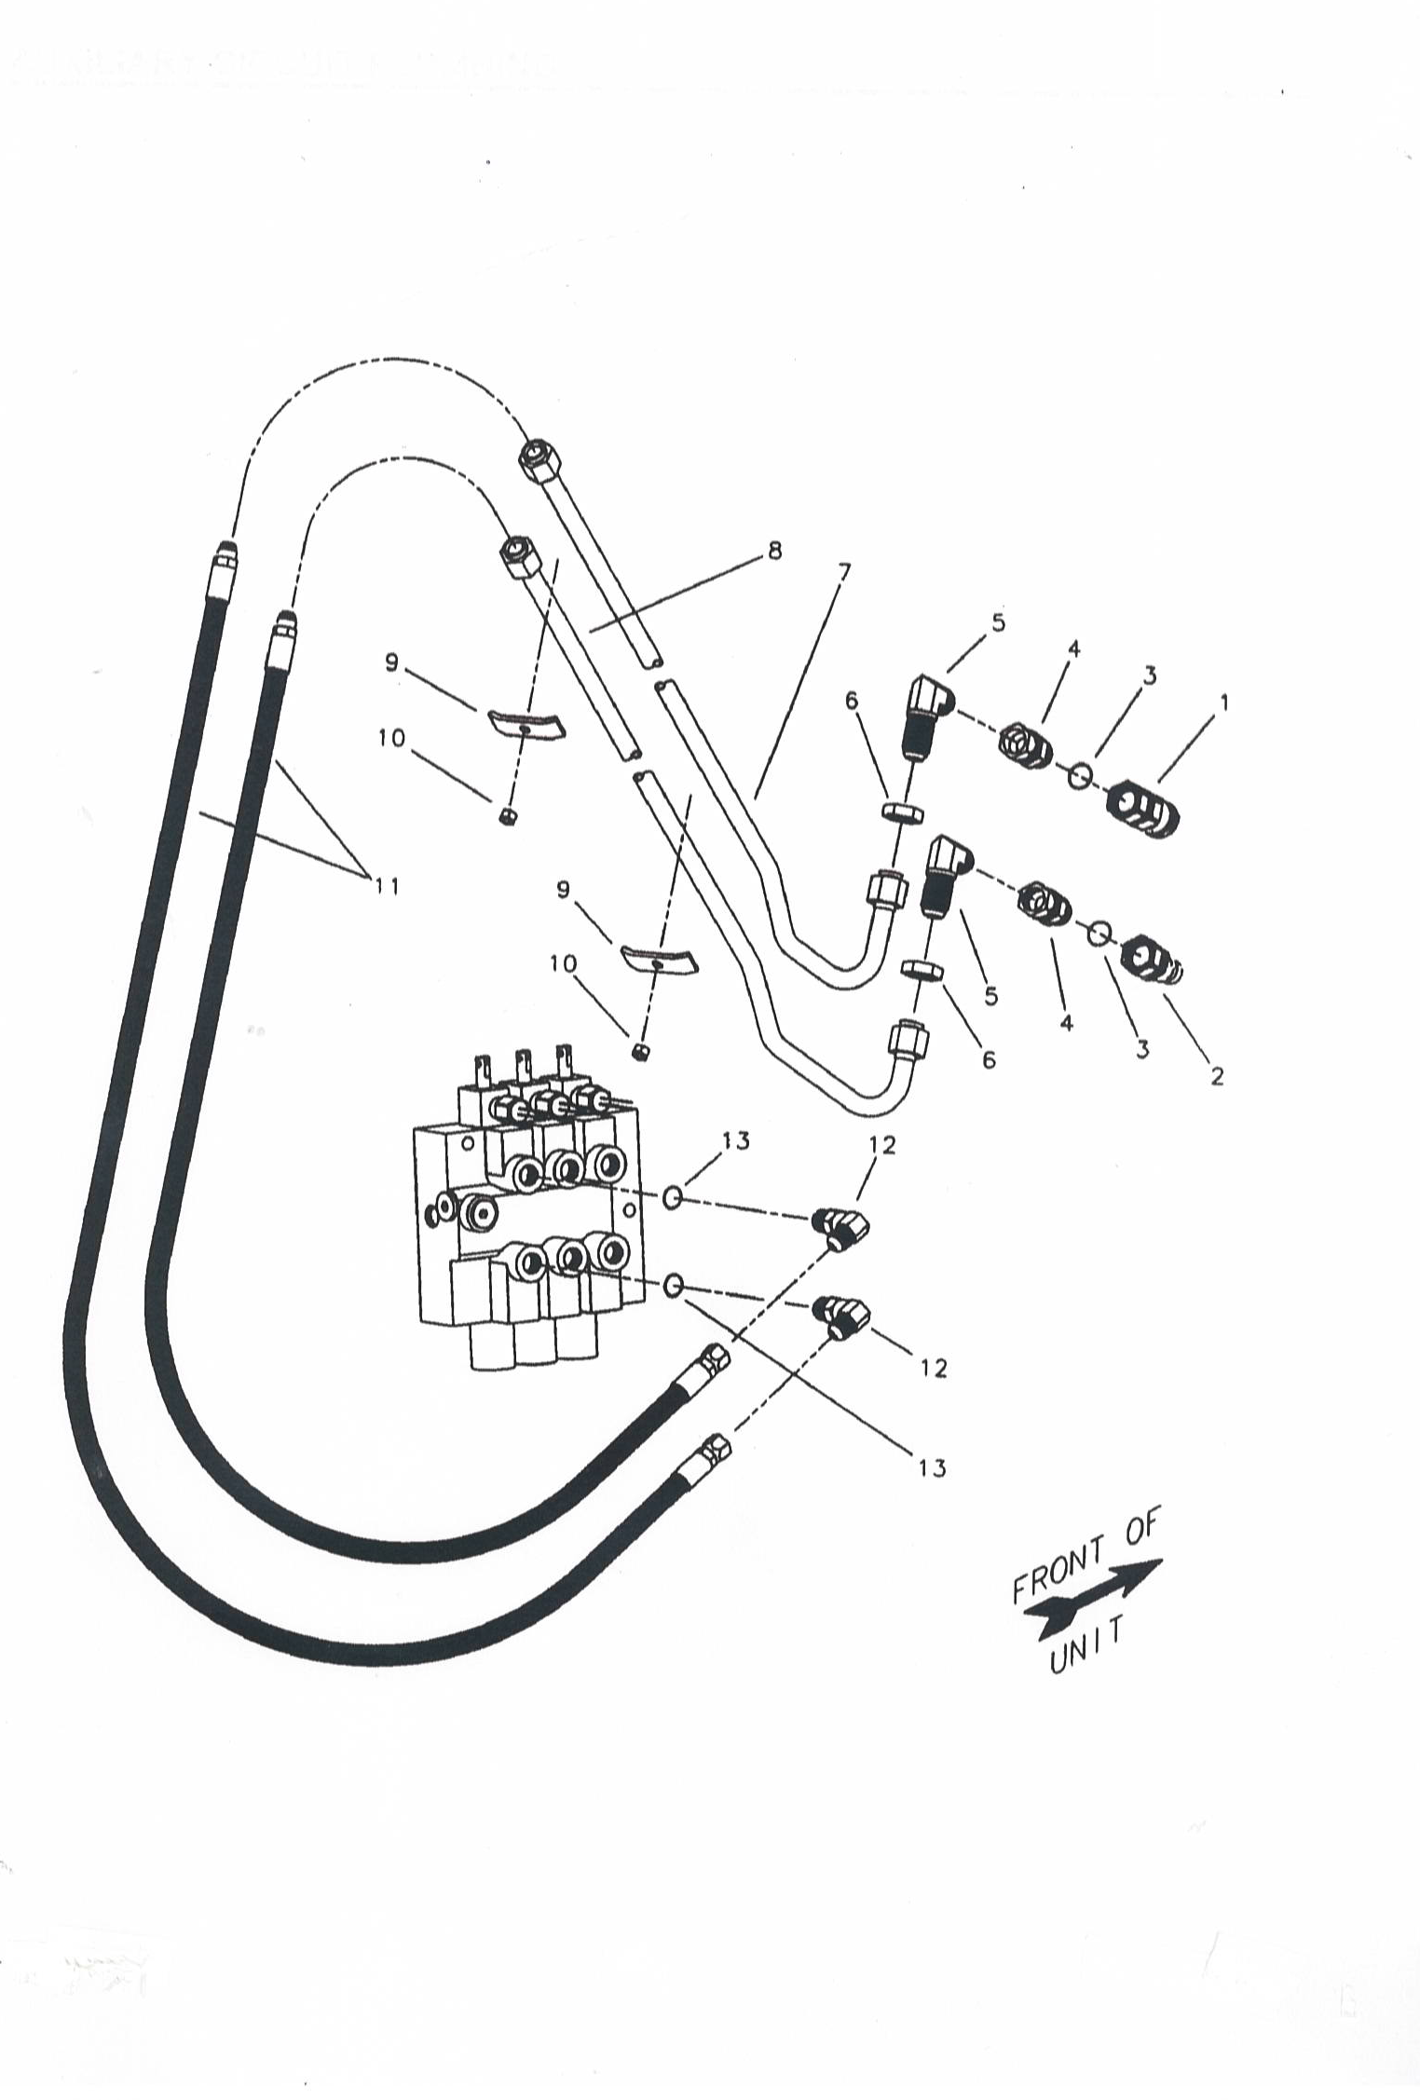
AUXILIARY CIRCUIT PLUMBLING

REF | PART NUMBER | DESCRIPTION | QTY
1 | 3200 | COUPLER/FEMALE | 1
2 | 3201 | COUPLER/MALE | 1
3 | 3202 | O-RING | 2
4 | 3203 | FITTING/STRAIGHT 1-1/16 SAE X 1-1/16 JIC | 4
5 | 3204 | FITTING/90° BULKHEAD ELBOW 1-1/16 JIC | 2
6 | 3205 | NUT/HEX 1-1/16 | 2
7  8 | 3206 | LINE/HYDRAULIC/INSIDE  LINE/HYDRAULIC/INSIDE LINE/HYDRAULIC/OUTSIDE | -  1  -
 | 3207 | LINE/HYDRAULIC/OUTSIDE | 1
9 | 3208 | CLAMP | 3
10 | 3209 | NUT/HEX CENTERLOCK 3/8-16NC | 3
11 | 3210 | HOSE/HYDRAULIC | 2
12 | 3211 | FITTING/90° ELBOW 7/8 SAE X 7/8 JIC | 2
13 | 3212 | O-RING | 2
 | 3213 | KIT/QUICK COUPLER 1-1/16 FLAT FACE (COUPLERS ONLY) | 1
 | 3214 | KIT/QUICK COUPLER 1-1/16 FLAT FACE | 1

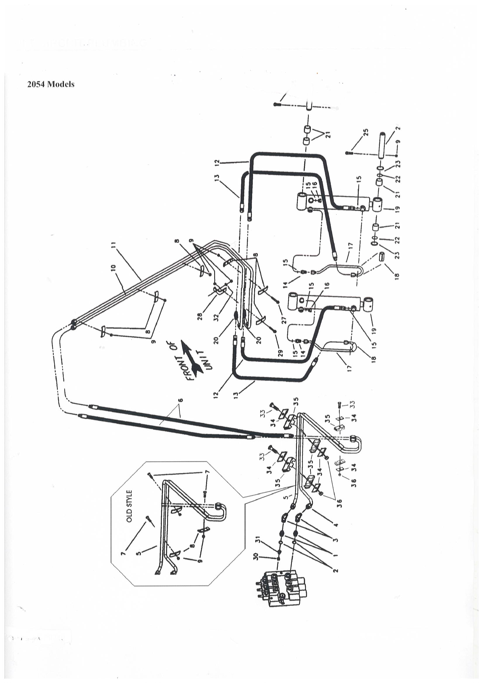
TILT CIRCUIT PLUMBING

REF | PART NUMBER | DESCRIPTION | QTY
1 | 3300 | FITTING/STRAIGHT 7/8 SAE X 7/8 JIC | 2
2 | 3301 | O-RING | 2
3 | 3302 | FITTING/90° ELBOW 7/8 JIC | 2
4 | 3303 | LINE/HYDRAULIC TILT BASE CROSSOVER | 1
5 | 3304 | LINE/HYDRAULIC TILT ROD CROSSOVER | 1
6 | 3305 | HOSE/HYDRAULIC | 2
7 | 3306 | BOLT/CARRIAGE 3/8-16NC X 1-1/2 | 3
8 | 3307 | CLAMP | 6
9 | 3308 | NUT/HEX CENTERLOCK 3/8-16NC | 8
10 | 3309 | LINE/HYDRAULIC TILT BASE LIFTARM | 1
11 | 3310 | LINE/HYDRAULIC TILT ROD LIFTARM | 1
12 | 3311 | HOSE/HYDRAULIC | 2
13 | 3312 | HOSE/HYDRAULIC | 2
14 | 3313 | FITTING/STRAIGHT 9/16 SAE X 3/4 JIC | 2
15 | 3314 | O-RING | 4
16 | 3315 | PLUG | 2
17 | 3316 | LINE/HYDRAULIC | 2
18 | 3317 | PROTECTOR/HYDRAULIC LINE | 2
19 | 3318 | CYLINDER/TILT | 2
 | 3600 | CYLINDER/TILT | 2
20 | 3320 | FITTING/TEE MALE 7/8 JIC | 2
21 | 3321 | BUSHING/OILITE | 8
22 | 3322 | SEAL | 4
23 | 3323 | WASHER/SPECIAL | AR
24 | 3324 | PIN/PIVOT | 2
25 | 3325 | SCREW/CAP 3/8-16NC X 2-1/2 | 2
26 | 3326 | PIN/PIVOT | 2
27 | 3327 | SCREW/CAP 3/8-16NC X 2-1/2 | 1
28 | 3328 | BRACKET/LINE MOUNT | 1
29 | 3329 | SCREW/CAP WHIZLOCK 3/8-16NC X 1-1/2 | 1
30 | 3330 | RESTRICTOR | 1
31 | 3331 | SPRING | 1
32 | 3332 | WASHER/FLAT 3/8 | 1
33 | 3333 | BOLT/CARRIAGE 5/16 X 2-1/4 | 3
34 | 3334 | PLATE/TWIN COVER | 6
35 | 3335 | CLAMP/TWIN TUBE | 3
36 | 3336 | NUT/LOCK 5/16 | 3

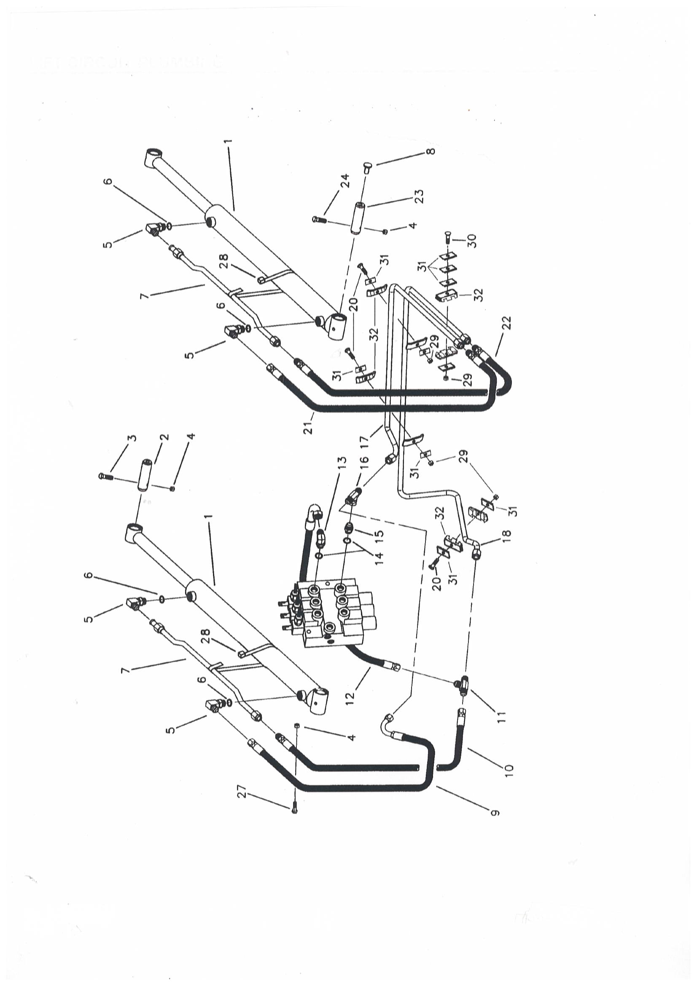
LIFT CIRCUIT PLUMBING

REF | PART NUMBER | DESCRIPTION | QTY
1 | 3400 | CYLINDER/LIFT | 2
2 | 3401 | PIN/PIVOT ROD END | -
 | 3402 | PIN/PIVOT ROD END | 2
3 | 3403 | SCREW/CAP 3/8-16NC X 2-1/2 | 2
4 | 3404 | NUT/HEX CENTERLOCK 3/8-16NC | 7
5 | 3405 | FITTING/90° ELBOW 3/4 SAE X 3/4 JIC | 4
6 | 3406 | O-RING | 4
7 | 3407 | LINE/HYDRAULIC | 2
8 | 3408 | PLUG | -
 | 3409 | PLUG | 2
9 | 3410 | HOSE AND TUBE/HYDRAULIC | 1
10 | 3411 | HOSE/HYDRAULIC | 1
11 | 3412 | FITTING/TEE 7/8 JIC | 1
12 | 3413 | HOSE AND TUBE/HYDRAULIC | 1
13 | 3414 | FITTING/45° ELBOW MALE | 1
14 | 3415 | O-RING | 2
15 | 3416 | FITTING/STRAIGHT 7/8 SAE X 7/8 JIC | 1
16 | 3417 | FITTING/TEE 7/8 JIC | 1
17 | 3418 | HYDRAULIC LIFT TUBE/CROSSOVER | 1
18 | 3419 | TUBE/HYDRAULIC LIFT | 1
20 | 3420 | BOLT/CARRIAGE 5/16 X 2-1/4 | 3
21 | 3421 | HOSE/HYDRAULIC | 1
22 | 3422 | HOSE/HYDRAULIC | 1
23 | 3423 | PIN/PIVOT BASE END | -
 | 3424 | PIN/PIVOT BASE END | 2
24 | 3425 | SCREW/CAP 3/8-16NC X 2-1/4 | 2
28 | 3426 | CLAMP/HOSE | 2
29 | 3427 | NUT/LOCK 5/16 | 4
30 | 3428 | BOLT/CARRIAGE 5/16 X 2-1/2 | 1
31 | 3429 | PLATE/TWIN COVER | 10
32 | 3430 | CLAMP/TWIN TUBE | 4

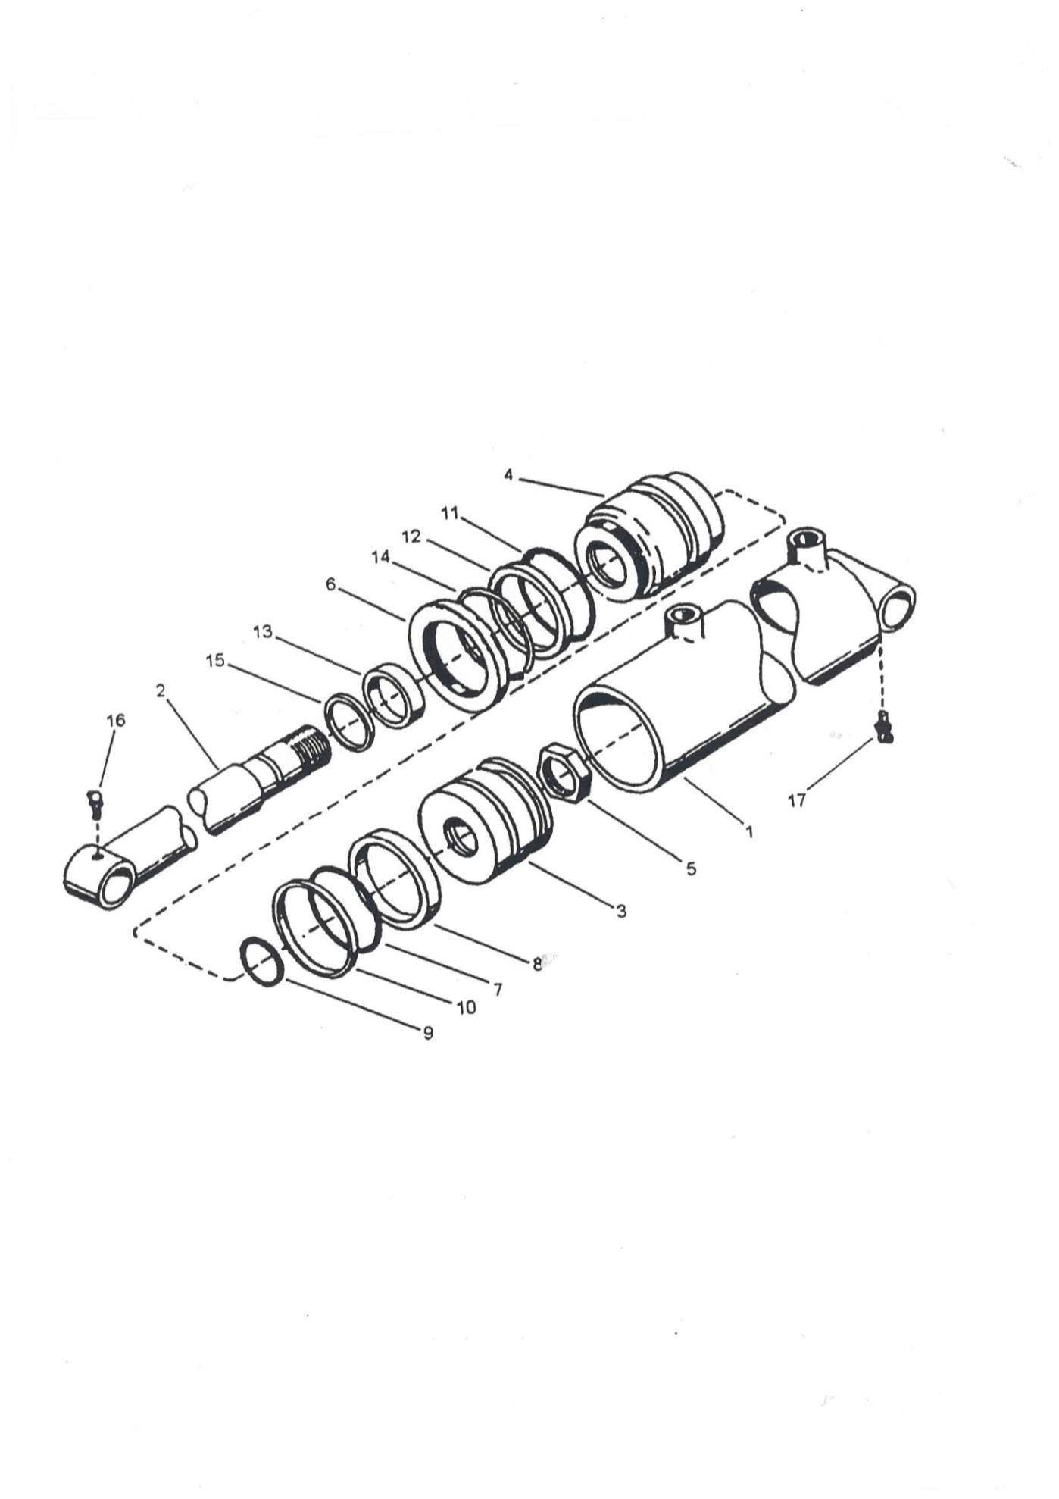
LIFT CYLINDER
REF | PART NUMBER | DESCRIPTION | QTY
 | 3500 | CYLINDER/LIFT | 2
1 | 3501 | BARREL | 2
2 | 3502 | ROD | 2
3 | 3503 | PISTON | 2
4 | 3504 | GLAND | 2
5 | 3505 | NUT/SPECIAL | 2
6 | 3506 | NUT/SPECIAL | 2
7-15 | 3507 | KIT/SEAL | 2
16 | 3508 | ZERK/GREASE 90° | 2
17 | 3509 | ZERK/GREASE 90° | 2

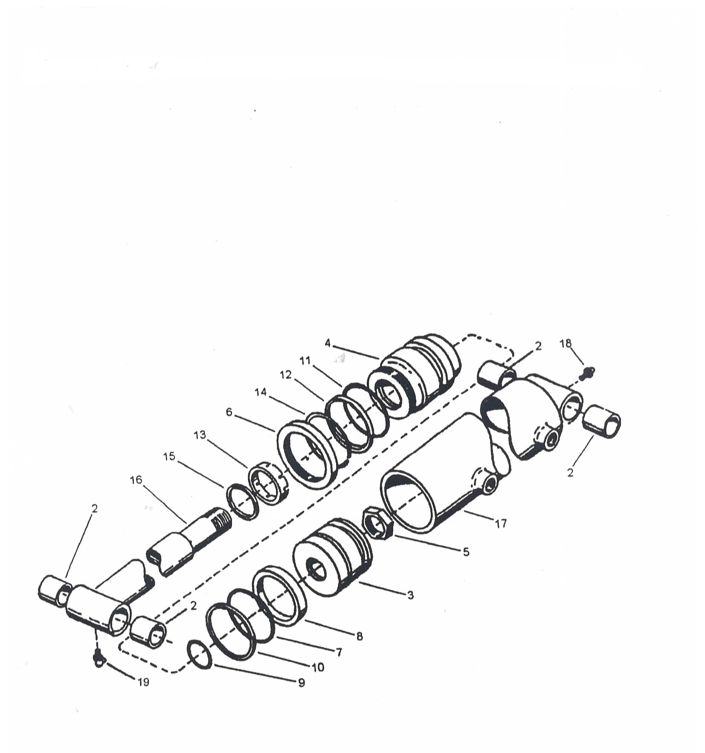

TILT CYLINDER
REF | PART NUMBER | DESCRIPTION | QTY
 | 3600 | CYLINDER/TILT | 2
2 | 3601 | BUSHING | 8
3 | 3602 | PISTON | 2
4 | 3603 | GLAND | 2
5 | 3604 | NUT | 2
6 | 3605 | NUT/SPECIAL | 2
7-15 | 3606 | KIT/SEAL | 2
16 | 3607 | ROD | 2
17 | 3608 | BARREL | 2
 | 3609 | BARREL | 2
18 | 3610 | ZERK/GREASE | 2
19 | 3611 | ZERK/GREASE 90° | 2

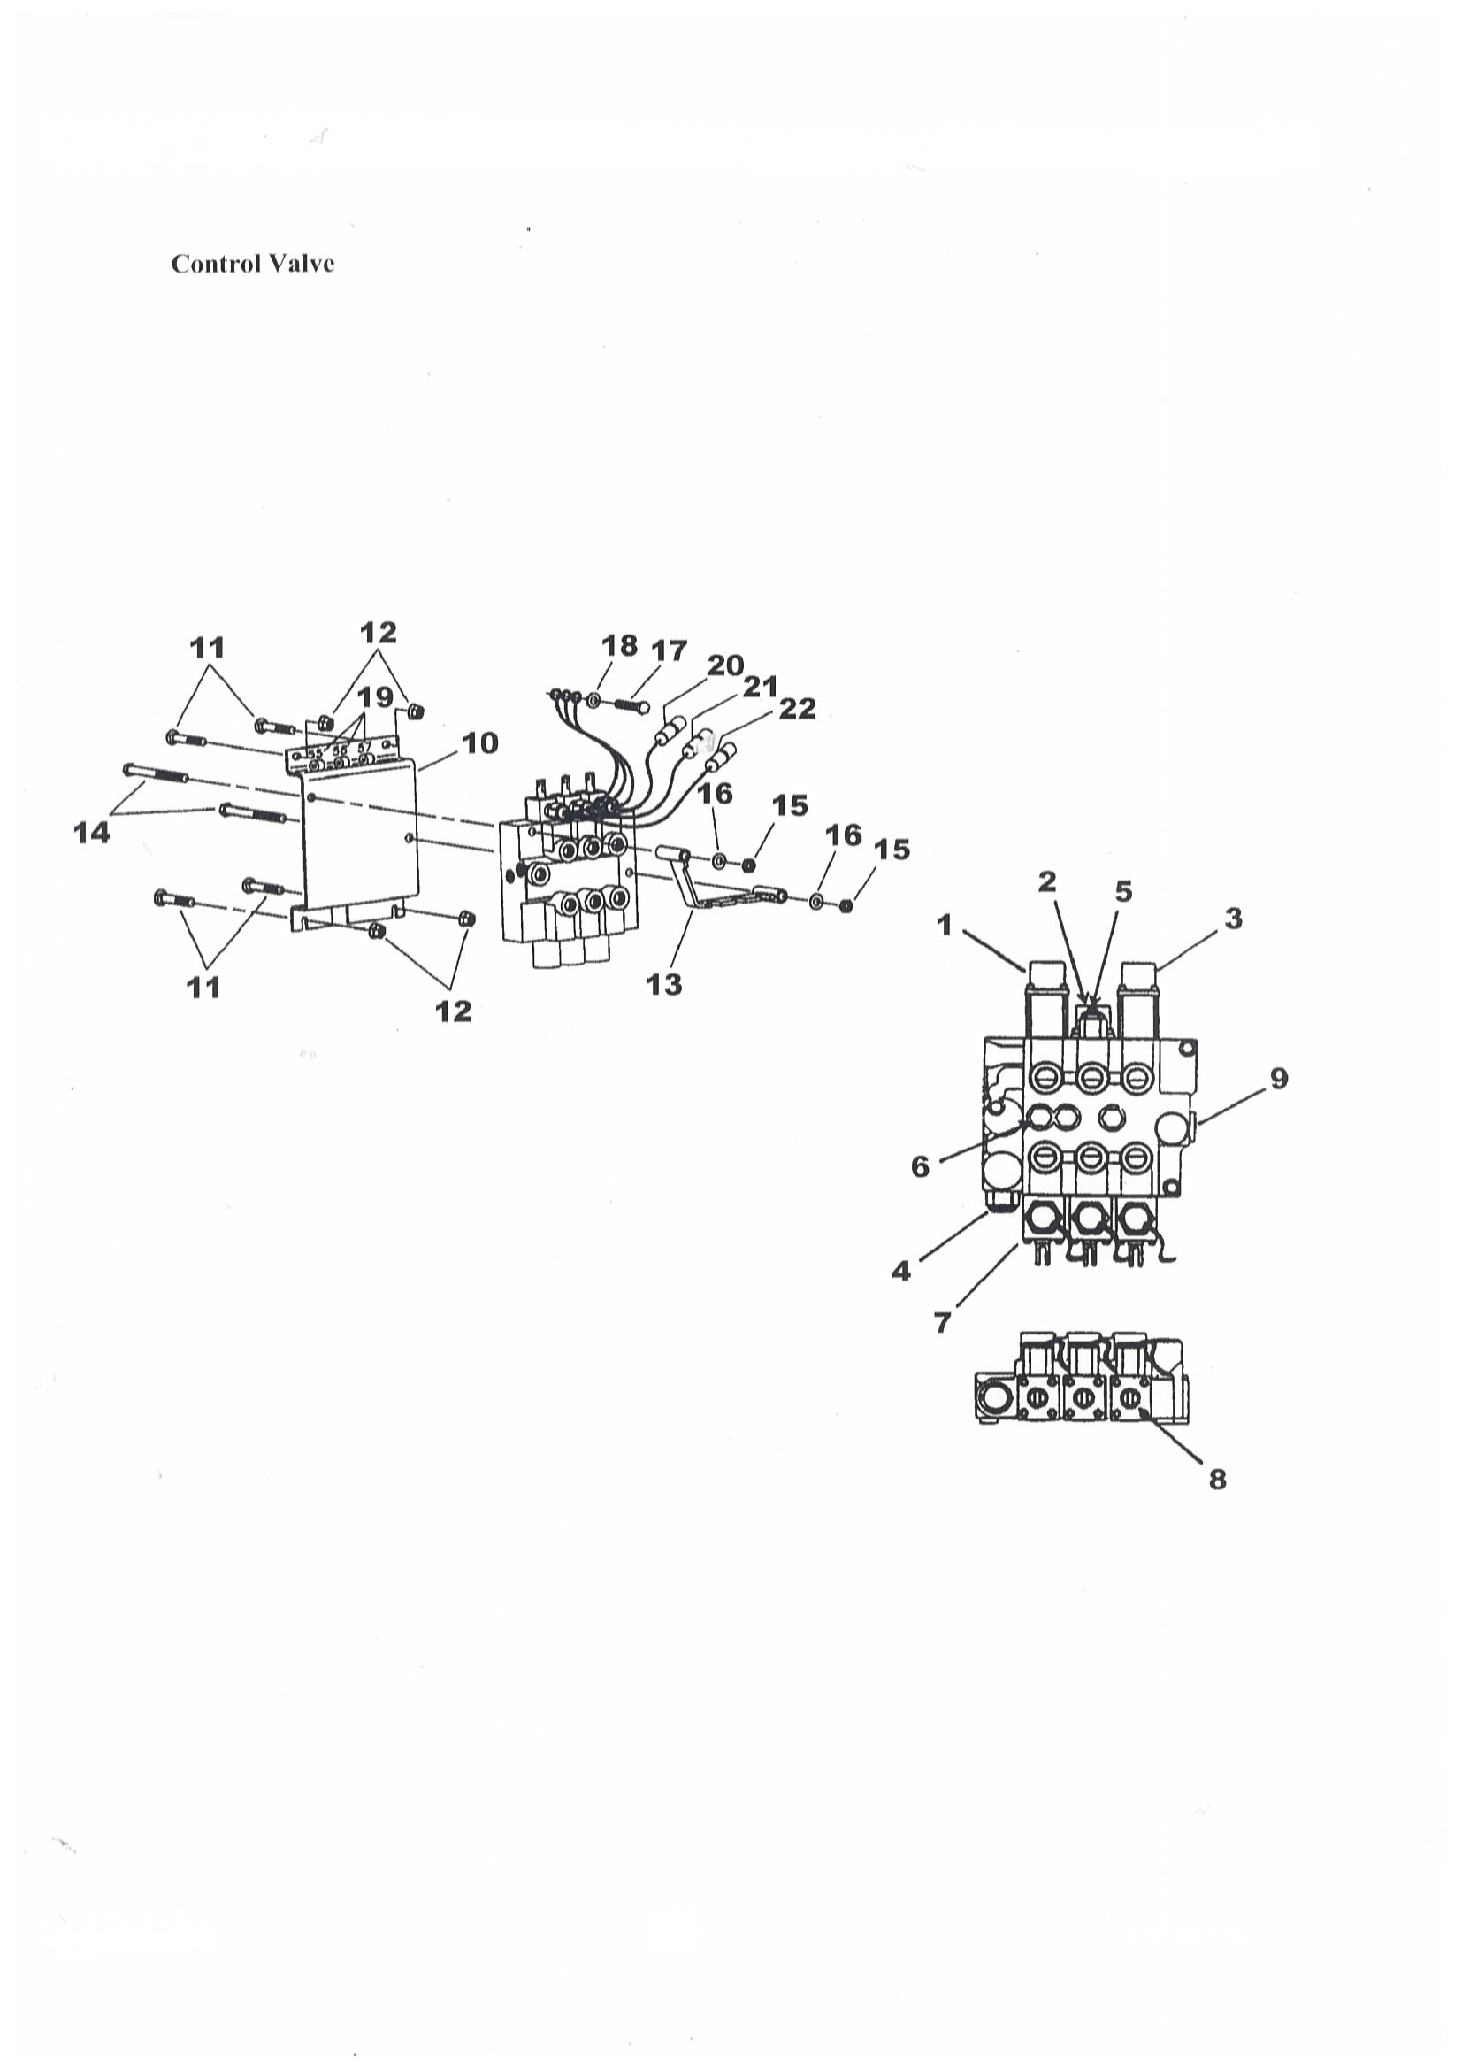
MAIN CONTROL VALVE
REF | PART NUMBER | DESCRIPTION | QTY
 | 3700  3701 | VALVE/CONTROL VALVE/CONTROL | -
 | 3700  3701 | VALVE/CONTROL VALVE/CONTROL | 1  1
1 | 3704 | POSITIONER/FLOAT | 1
2 | 3705 | POSITIONER/SPOOL | 1
3 | 3706 | POSITIONER/R DETENT | 1
4 | 3707 | CARTRIDGE/RELIEF RCM | -
 | 3708 | CARTRIDGE/RELIEF RCM | 1
5 | 3709 | CARTRIDGE/RELIEF RP10-AAC | 1
6 | 3710 | PLUG/LOAD CHECK | 3
7 | 3711 | KIT/SPOOL LOCK | 3
8 | 3712 | KIT/SEAL SPOOL | 1
9 | 3713 | PLUG | 3
10 | 3714 | BRACKET/VALVE MOUNTING | 1
11 | 3715 | BOLT/CARRIAGE 3/8-16NC X 1 | 4
12 | 3716 | NUT/HEX WHIZLOCK 3/8-16NC | 4
13 | 3717 | BRACKET/CABLE MOUNT | 1
14 | 3718 | SCREW/CAP 7/16-14NC X 6 | 2
15 | 3719 | NUT/HEX CENTERLOCK 7/16-14NC | 2
16 | 3720 | WASHER/FLAT 3/8 | 2
17 | 3721 | SCREW/SELF-TAPPING 5/16-18NC X 3/4 | 1
18 | 3722 | WASHER/FLAT 1/4 | 1
19 | 3723 | DECAL/VALVE SECTION IDENTIFICATION | 1
20 | 3724 | TIE/CABLE YELLOW | 1
21 | 3725 | TIE/CABLE BLUE | 1
22 | 3726 | TIE/CABLE RED | 1

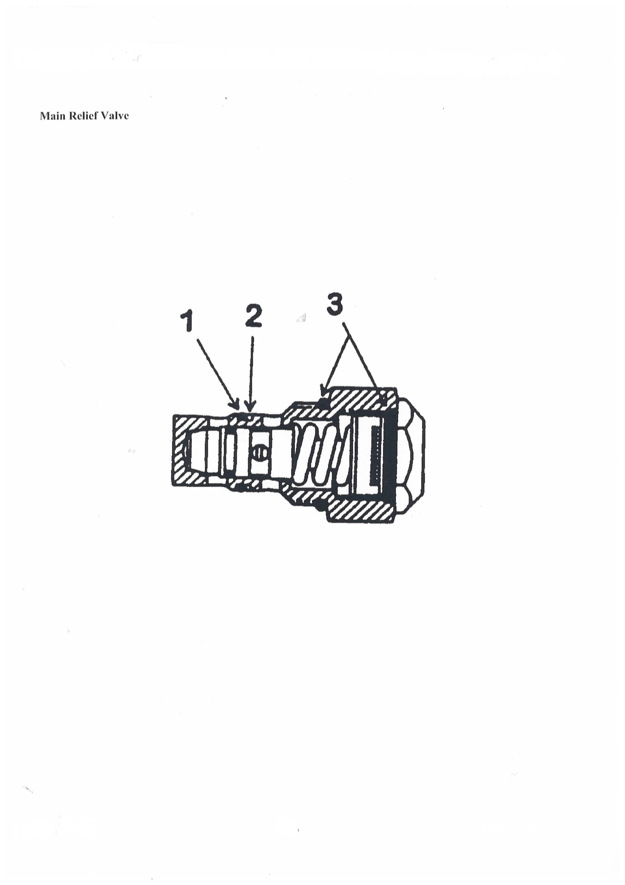
MAIN CONTROL VALVE
REF | PART NUMBER | DESCRIPTION | QTY
 | 3707 | CARTRIDGE/RELIEF RCM | -
 | 3708 | CARTRIDGE/RELIEF RCM | 1
1 | 3708 | O-RING | 1
2 | 3708 | RING/BACKUP | 1
3 | 3708 | SEAL/O-RING | 2
 | 3732 | KIT/SEAL (INCLUDES ITEMS 1-3) | 1

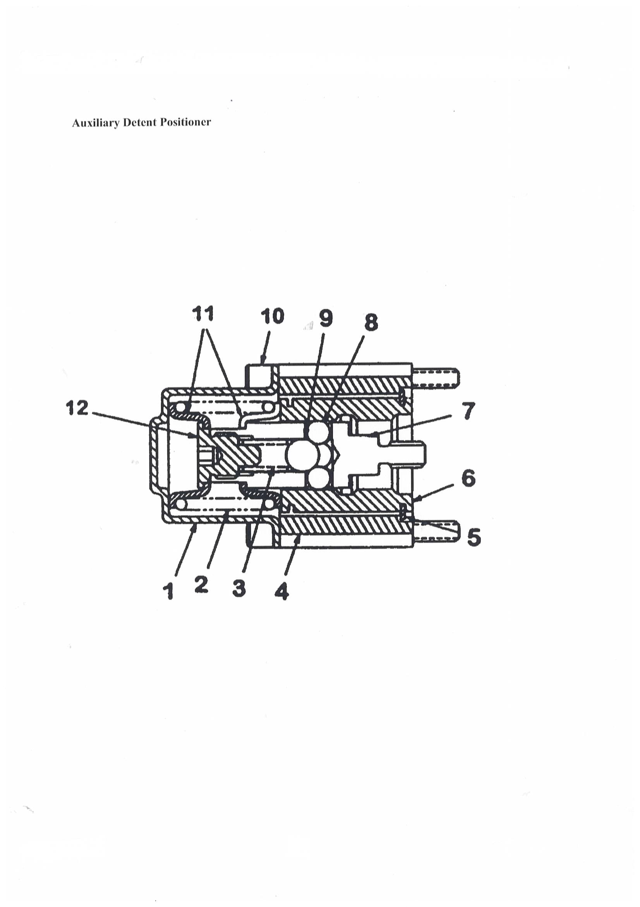
MAIN CONTROL VALVE
REF | PART NUMBER | DESCRIPTION | QTY
 | 3733 | POSITIONER KIT/R DETENT (INCLUDES ITEMS 1-12) | 1
1 |  | BONNET | 1
2 |  | SPRING/LARGE | 1
3 |  | SPRING/SMALL | 1
4 |  | SPACER | 1
5 |  | RING/RETAINING | 1
6 |  | SLEEVE/DETENT | 1
7 |  | BALL HOLDER/DETENT | 1
8 |  | BALL 1/4 | 4
9 |  | BALL 3/8 | 1
10 |  | SCREW | 4
11 |  | COLLAR/SPRING | 2
12 |  | COLLAR/SPOOL | 1

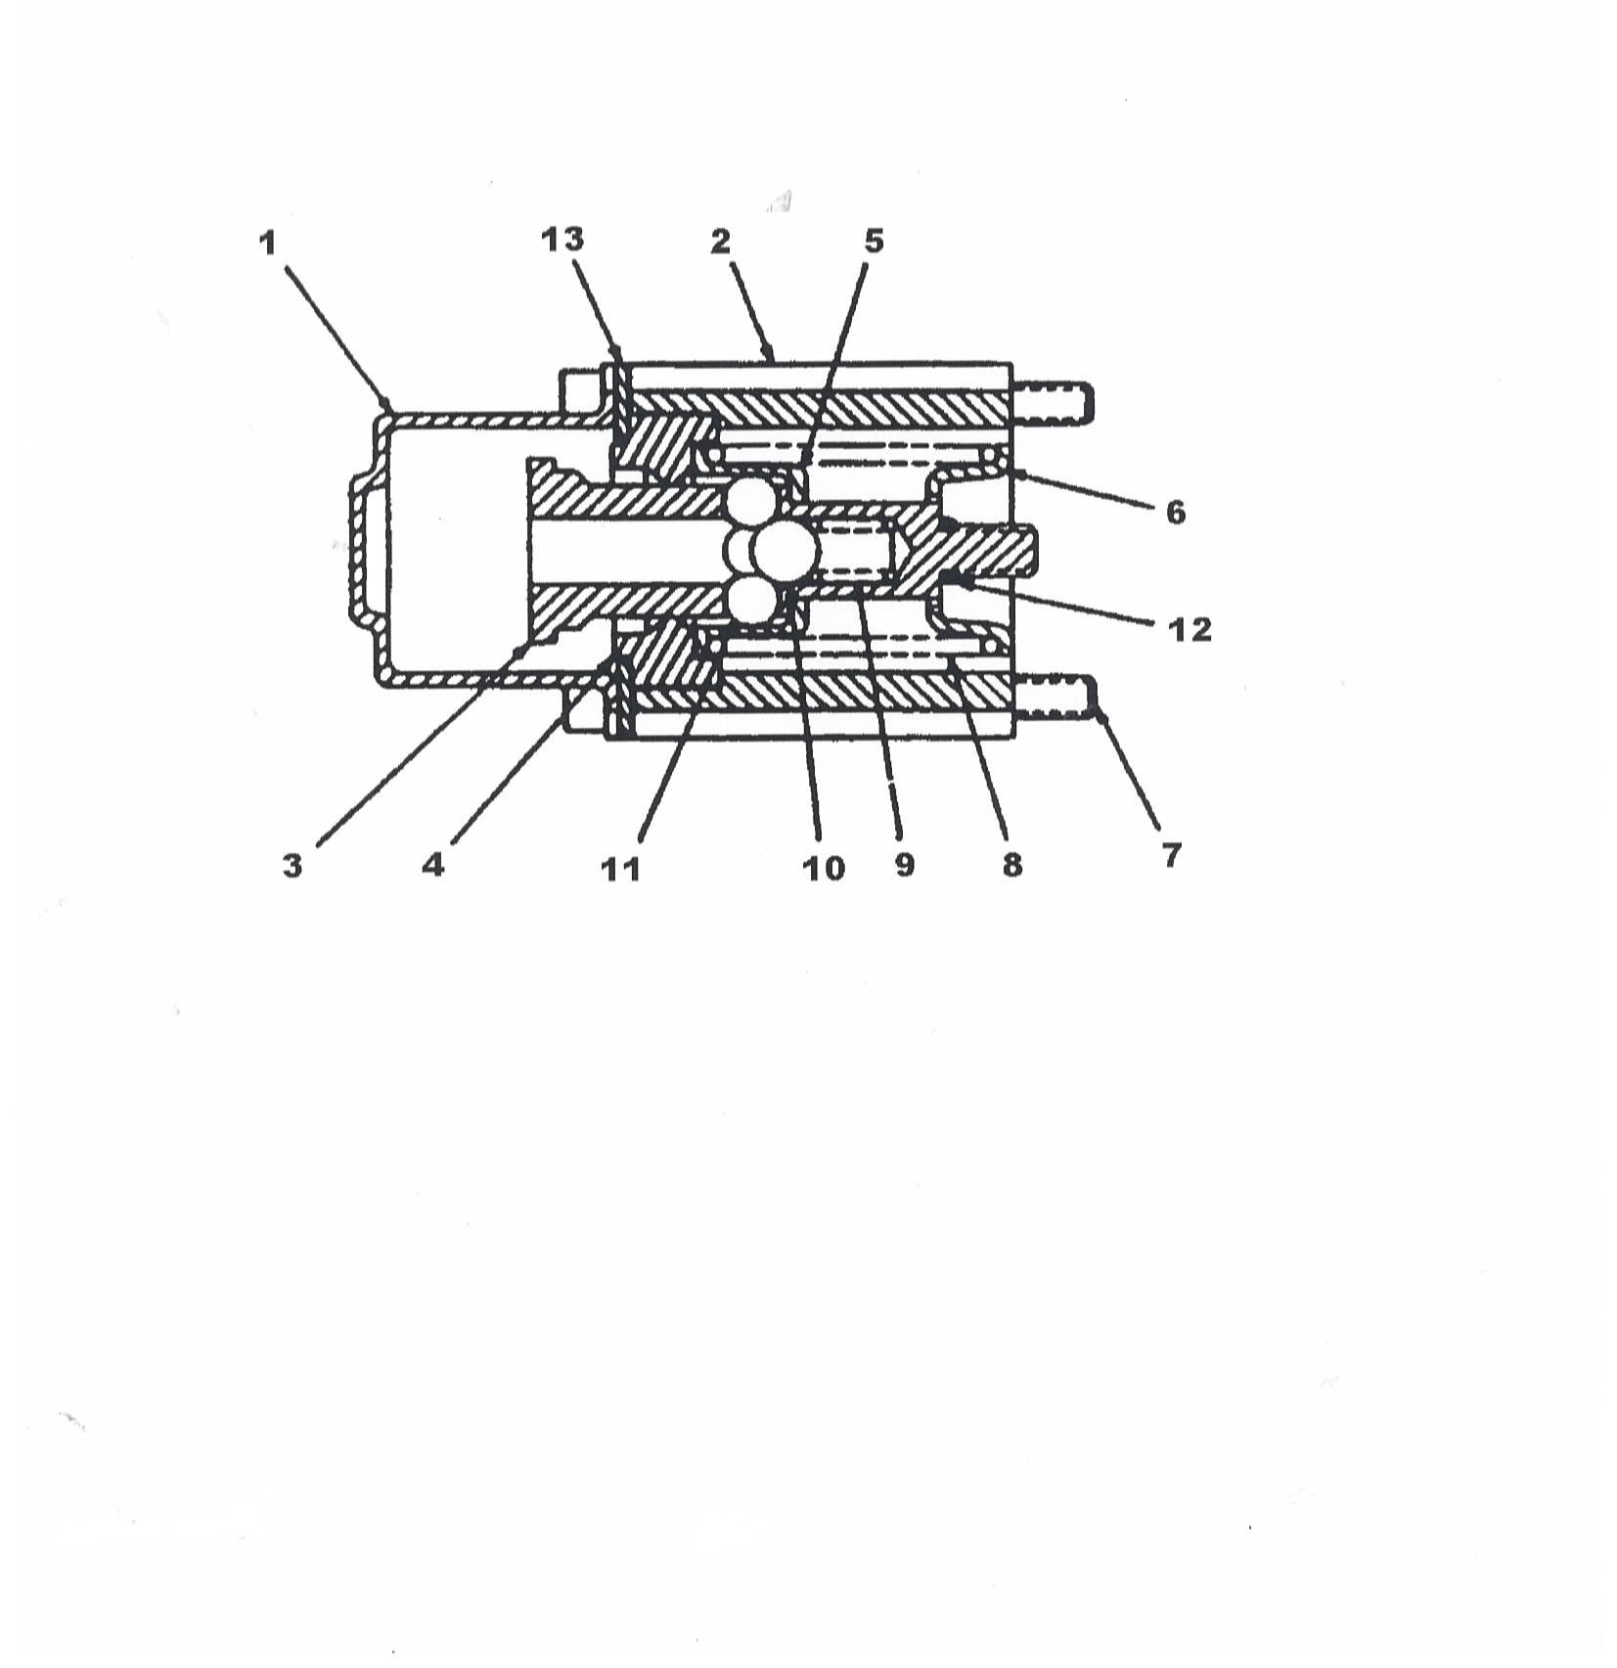

MAIN CONTROL VALVE
REF | PART NUMBER | DESCRIPTION | QTY
 | 3704 | POSITIONER KIT/FLOAT (INCLUDES ITEMS 1-13) | 1
1 |  | BONNET | 1
2 |  | SPACER | 1
3 |  | BALL HOLDER/DETENT | 1
4 |  | SLEEVE/DETENT | 1
5 |  | COLLAR/SPRING | 1
6 |  | COLLAR/SPRING | 1
7 |  | SCREW | 4
8 |  | SPRING | 1
9 |  | SPRING/DETENT | 1
10 |  | BALL 3/8 | 1
11 |  | BALL 1/4 | 4
12 |  | SEAL/O-RING | 1

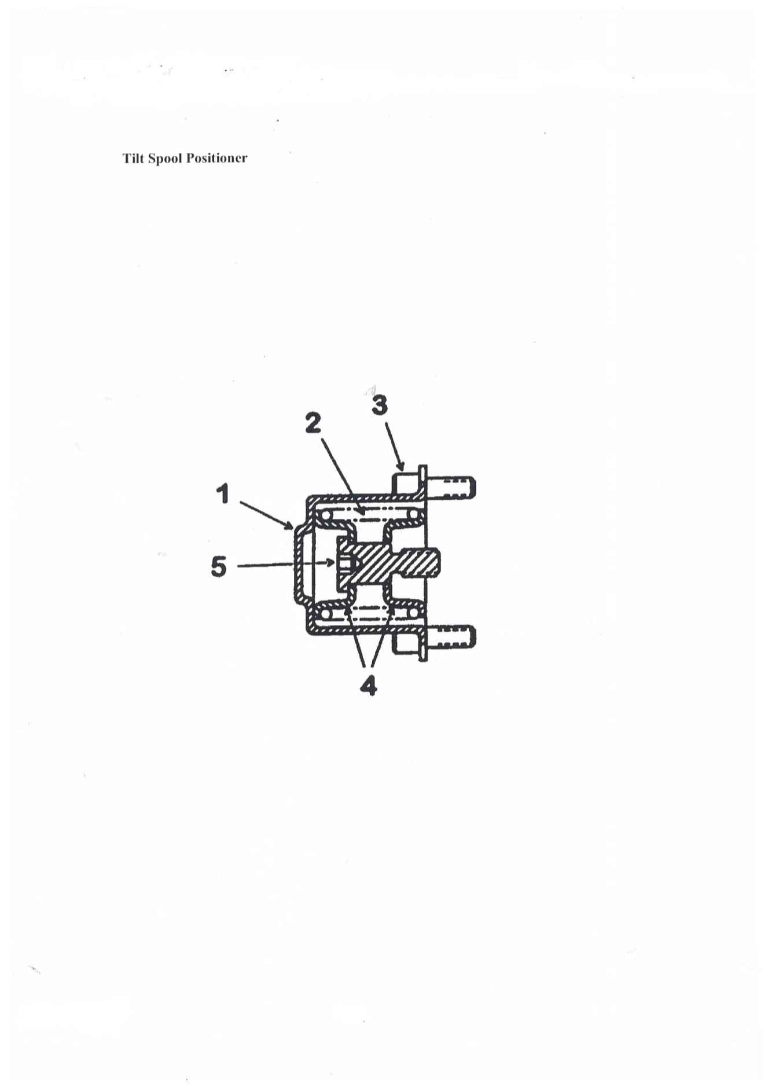

MAIN CONTROL VALVE
REF | PART NUMBER | DESCRIPTION | QTY
 | 3705 | POSITIONER KIT/SPOOL (INCLUDES ITEMS 1-5) | 1
1 |  | BONNET | 1
2 |  | SPRING | 1
3 |  | SCREW | 4
4 |  | COLLAR/SPRING | 2
5 |  | COLLAR/SPOOL | 1

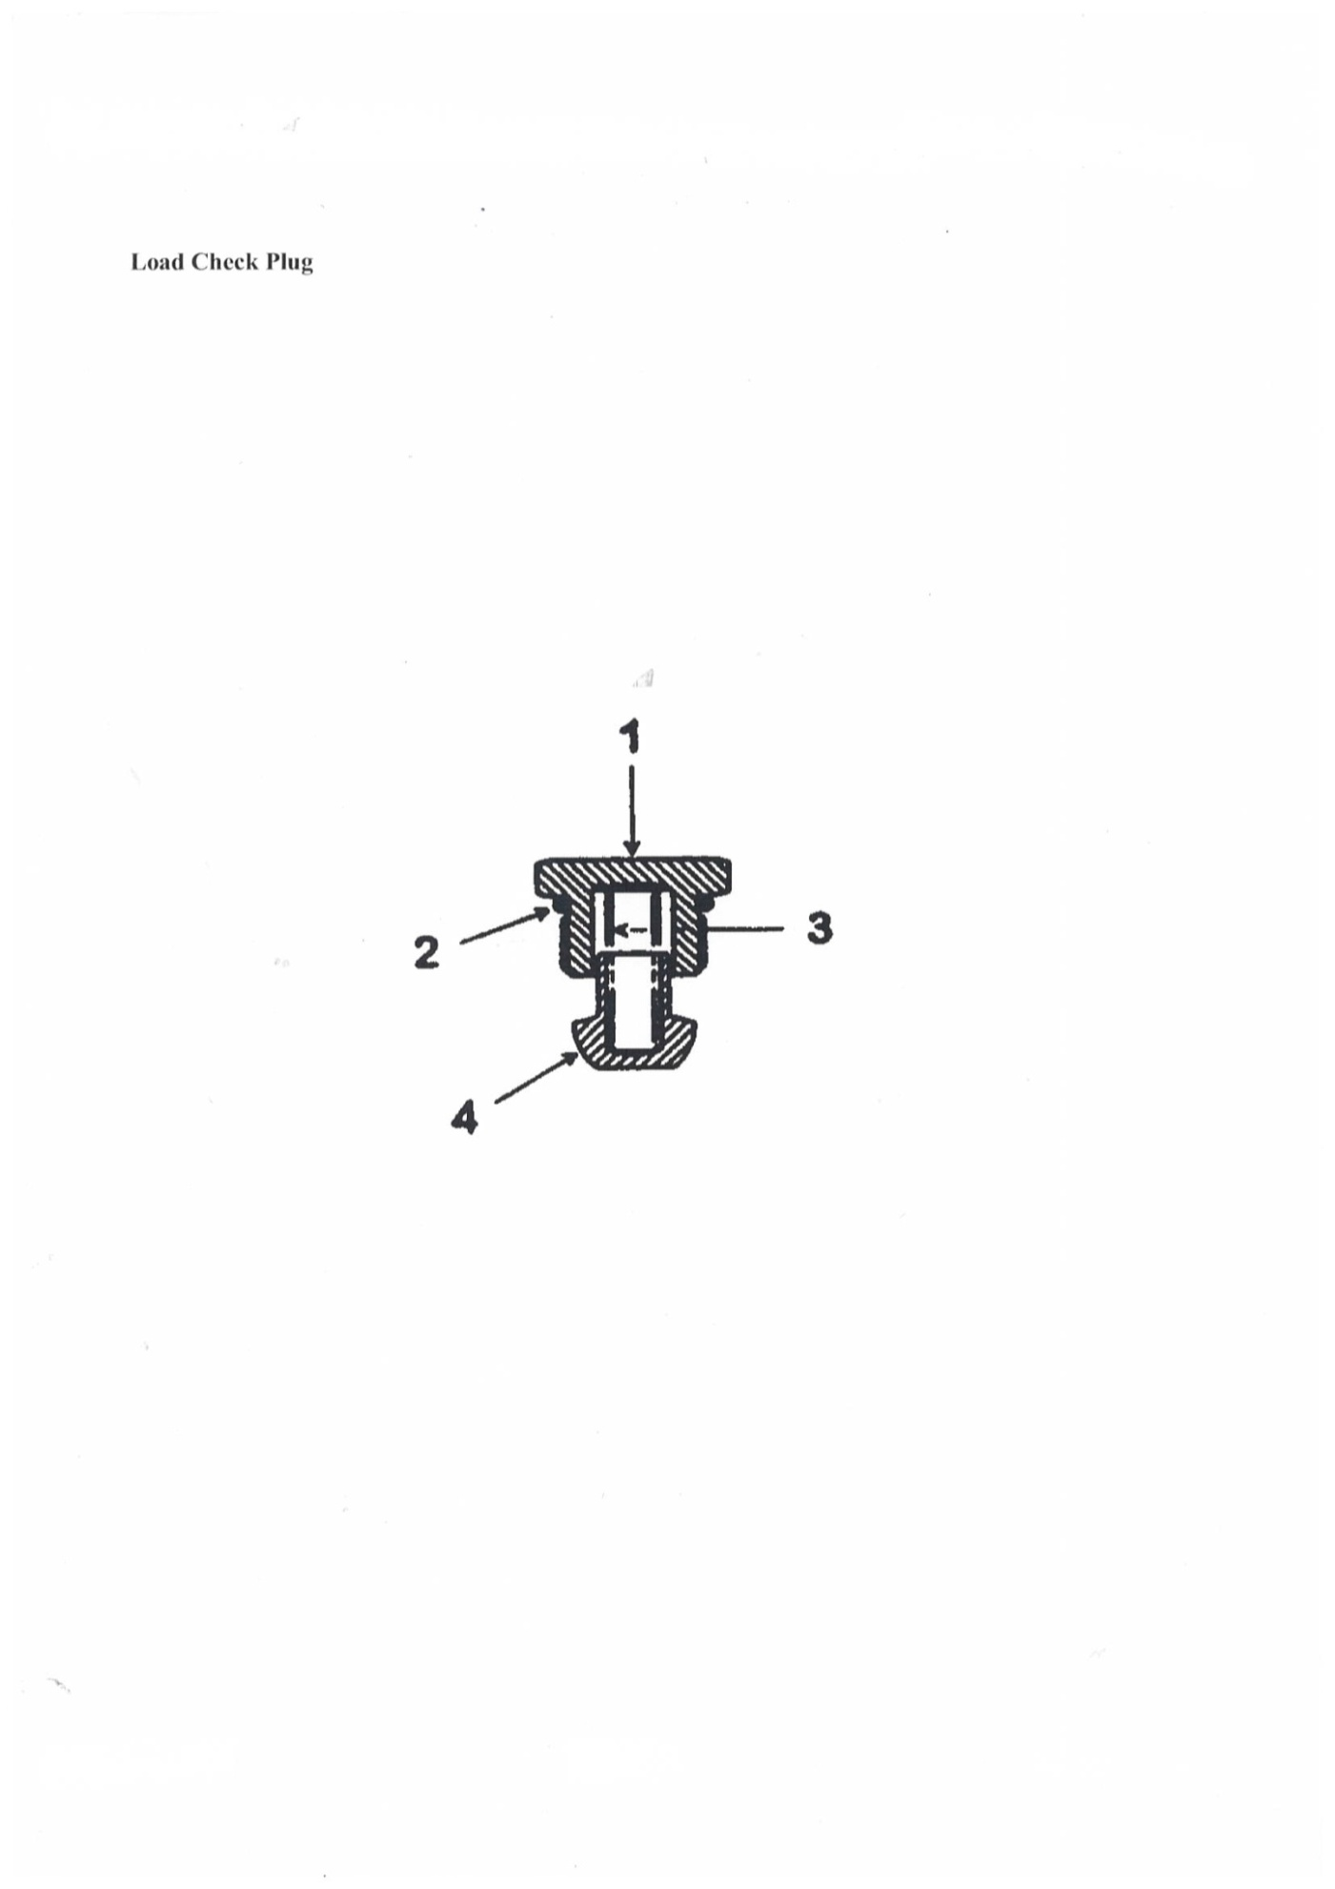
MAIN CONTROL VALVE
REF | PART NUMBER | DESCRIPTION | QTY
 | 3710 | PLUG KIT/LOAD CHECK (INCLUDES ITEMS 1-4) | 1
1 |  | PLUG | 1
2 |  | SEAL/O-RING | 1
3 |  | SPRING | 1
4 |  | POPPET | 1
 | 3710 | PLUG KIT/LOAD CHECK (INCLUDES ITEMS 1-4) | 1

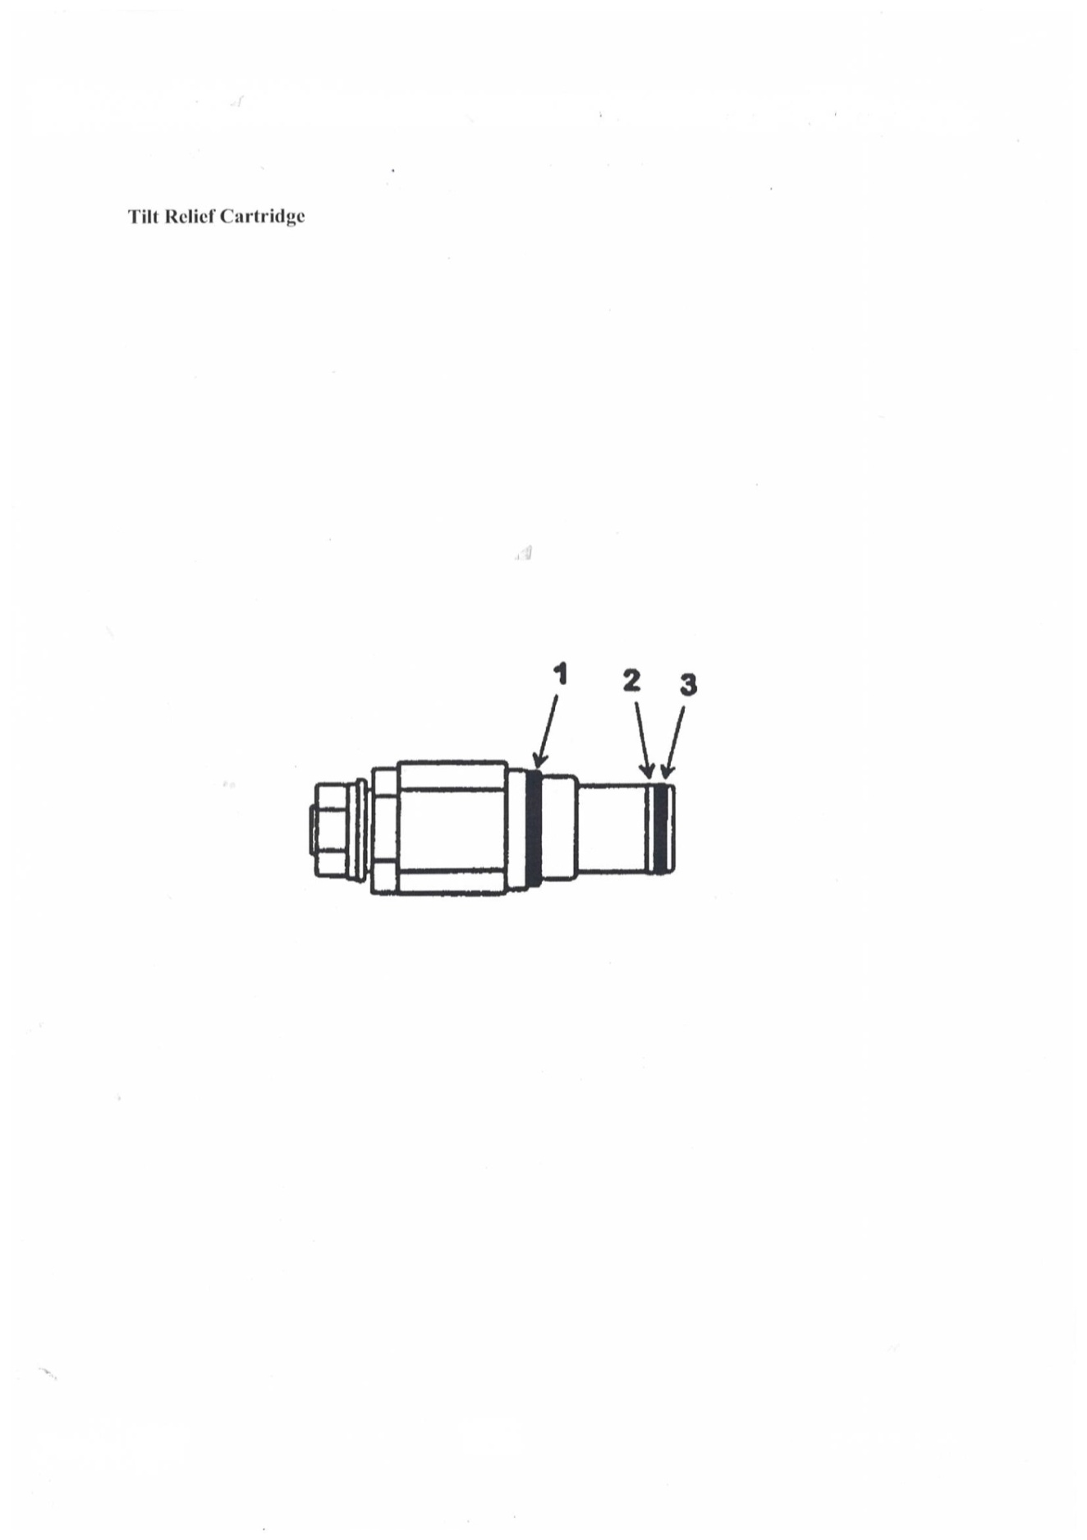

MAIN CONTROL VALVE
REF | PART NUMBER | DESCRIPTION | QTY
 | 3709 | CARTRIDGE/RELIEF RP10-AAC | 1
1 |  | SEAL/O-RING | 1
2 |  | RING/BACKUP | 1
3 |  | SEAL/O-RING | 1
 | 3734 | KIT/SEAL (INCLUDES ITEMS 1-3) | 1
 | 3709 | CARTRIDGE/RELIEF RP10-AAC | 1

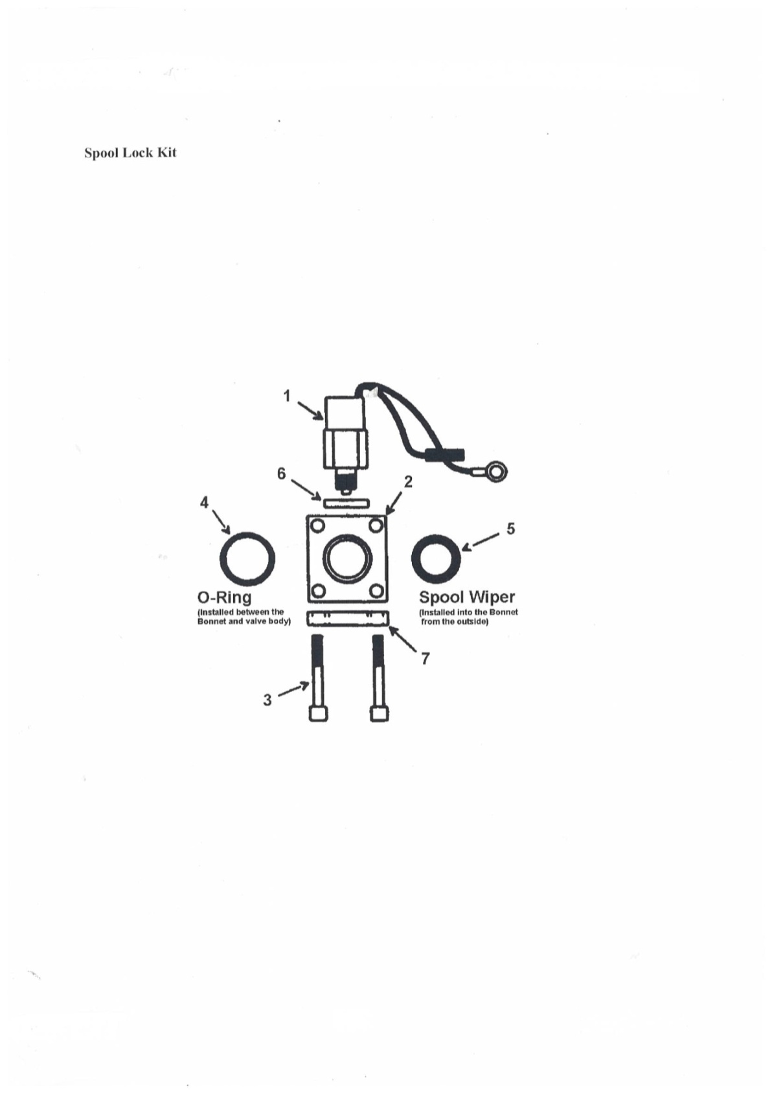

MAIN CONTROL VALVE
REF | PART NUMBER | DESCRIPTION | QTY
 | 3711 | LOCK KIT/SPOOL (INCLUDES ITEMS 1-7) | 1
1 | 3735 | SOLENOID | 1
2 |  | BONNET | 1
3 |  | SCREW | 4
4 |  | SEAL/O-RING | 1
5 | 3736 | WIPER | 1
6 | 3737 | SPACER | 1
7 |  | PLATE | 1

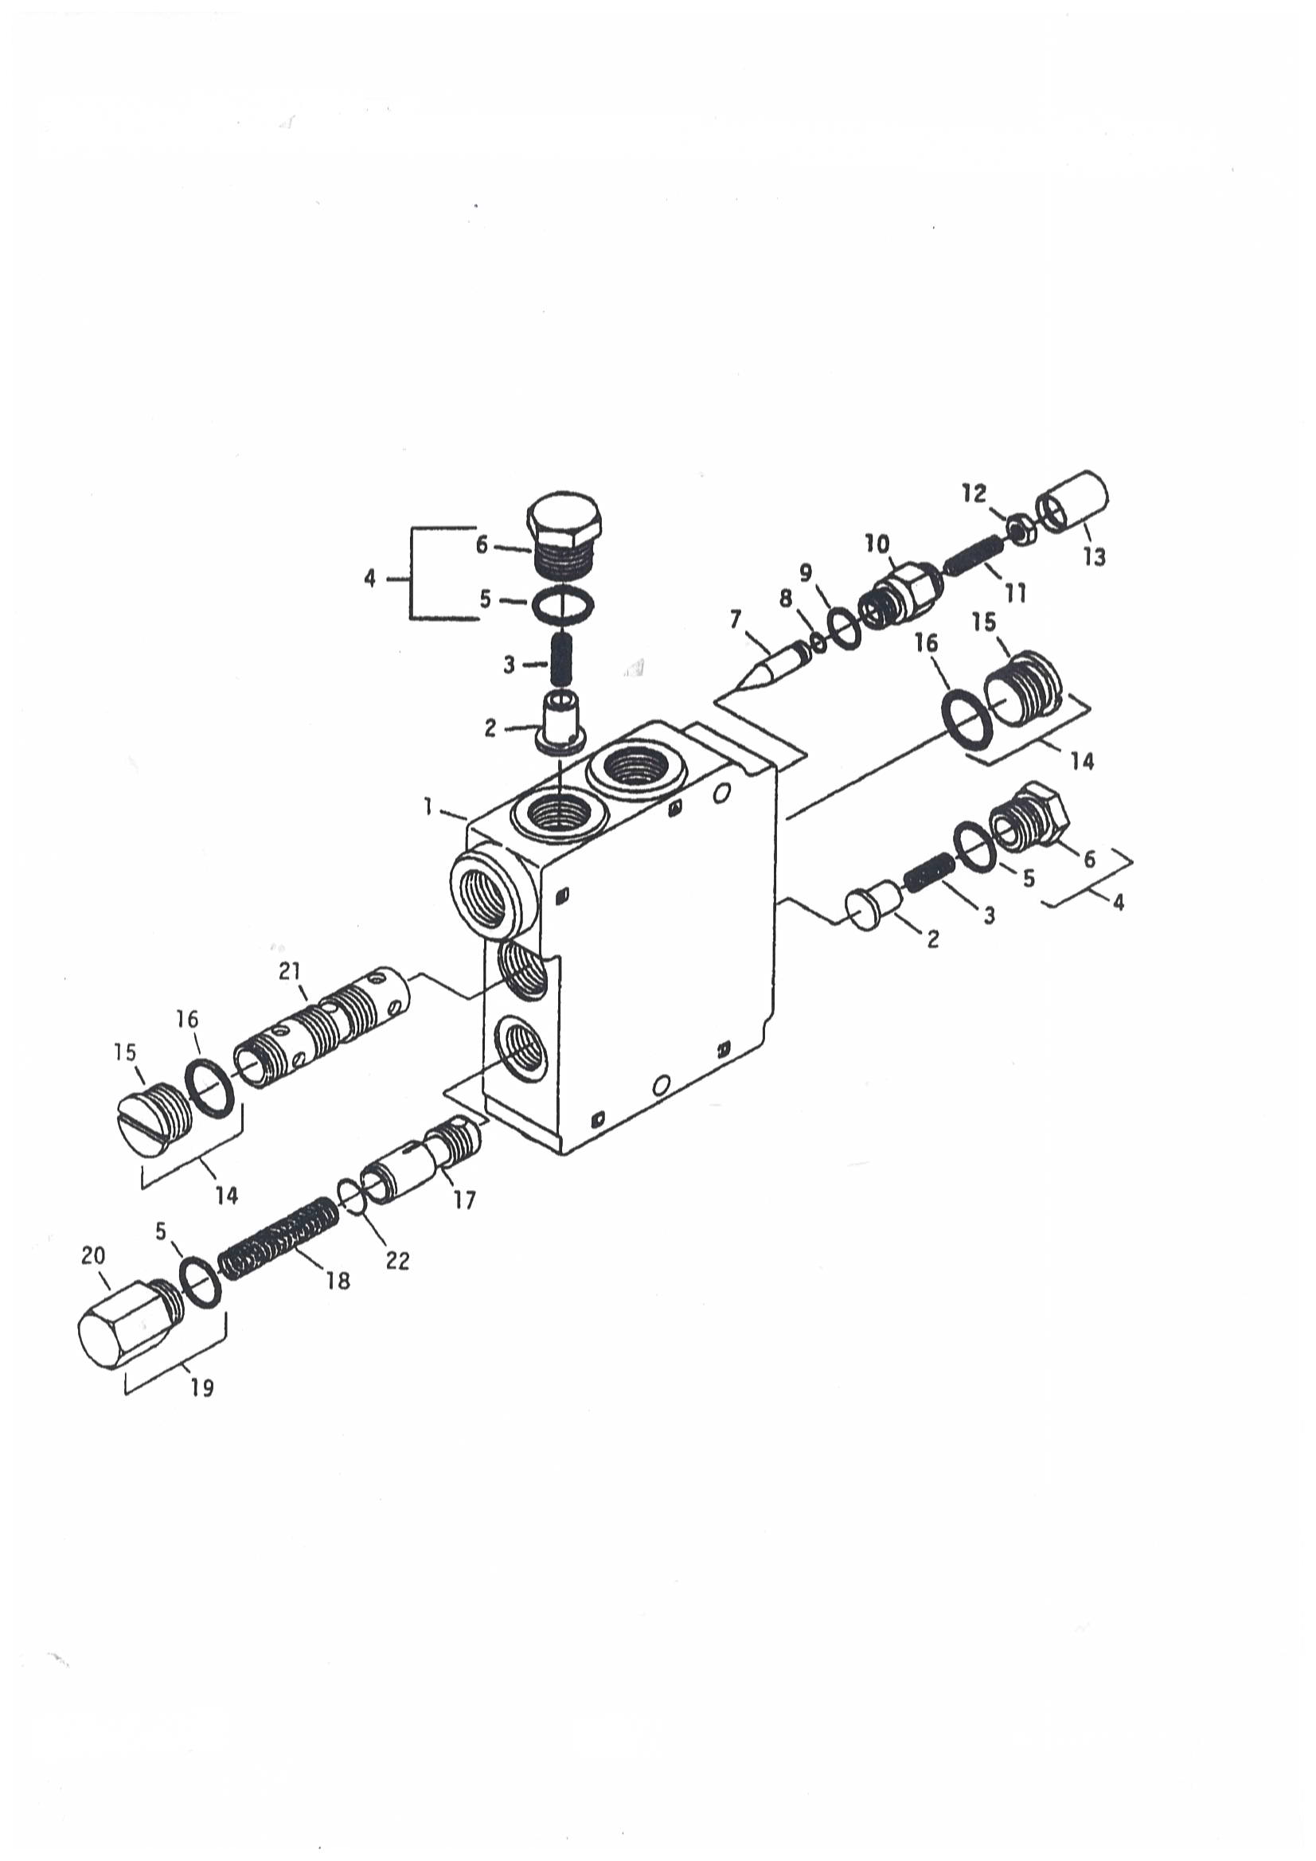

SELF-LEVELING VALVE
REF | PART NUMBER | DESCRIPTION | QTY
 | 3800 | VALVE/SELF-LEVELING | 1
1 |  | BODY | 1
2 | 3801 | PLUNGER | 2
3 | 3802 | SPRING | 2
4 | 3803 | PLUG | 2
5 |  | O-RING | 3
6 |  | PLUG | 2
7 | 3804 | PIN | 1
8 |  | O-RING | 1
9 |  | O-RING | 1
10 | 3805 | CAP/ADJUSTMENT | 1
11 | 3806 | SCREW/SET | 1
12 | 3807 | NUT/JAM | 1
13 | 3808 | COVER/TAMPER PROOF | 1
14 | 3809 | PLUG | 2
15 |  | PLUG | 2
16 |  | O-RING | 2
17 |  | SPOOL/UNLOADING | 1
18 | 3810 | SPRING | 1
19 | 3811 | PLUG | 1
20 |  | PLUG | 1
21 |  | SPOOL/FLOW DIVIDER | 1

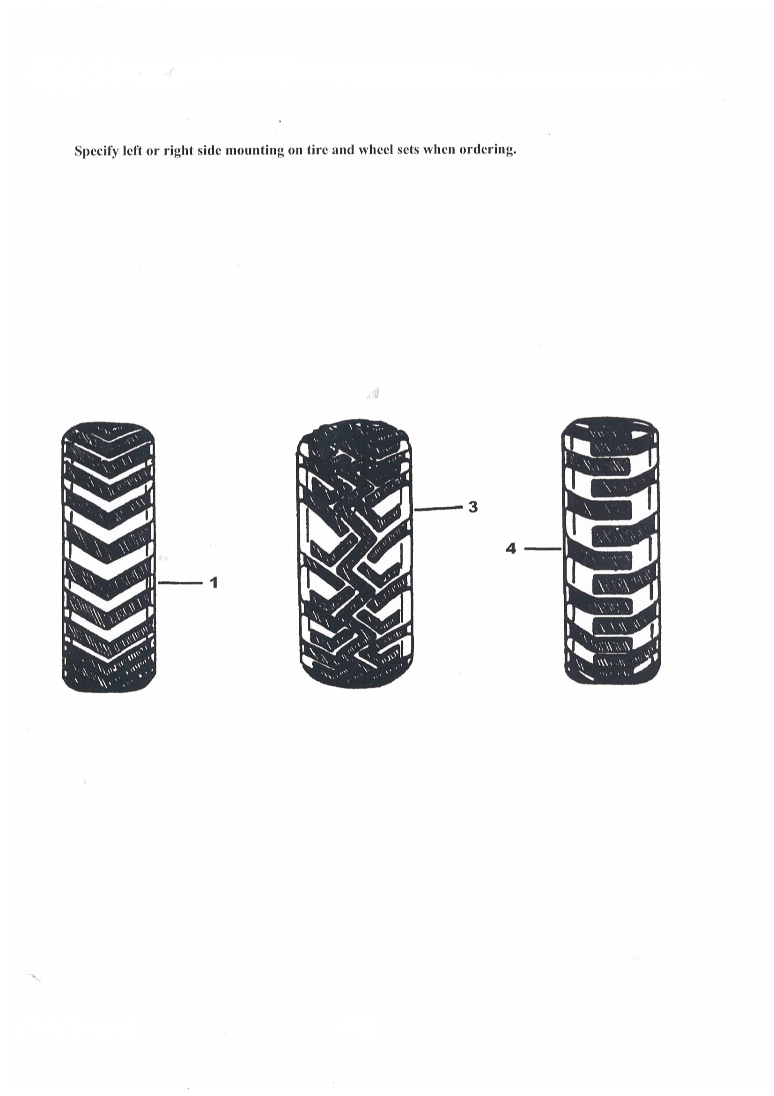
TYRES
REF | PART NUMBER | DESCRIPTION | QTY
1 | 4100 | TYRE AND WHEEL / 6.5 X 16.5 / SOLID RUBBER | 1
 | REF A | TYRE/SOLID RUBBER / 650 X 16.5 | 1
3 | 4102 | ASSY/WHEEL 31 X 15.50-16.5 | 1
 | 4103 | WHEEL 16.5 X 12 | 1
 | 4104 | TIRE/SUPER UGL 31 X 15.5 | 1
 | 4105 | STEM/VALVE | 1
4 | 4106 | TYRE AND RIM/FLOTATION 10 X 16.5 8-PLY | 1
 | REF A | TYRE/HEAVY DUTY 10 X 16.5 8-PLY | 1
 | 4108 | WHEEL 16.5 X 8.25 | 1
 | 4105 | STEM/VALVE | 1
4 | 4110 | TYRE AND RIM/HEAVY DUTY / 10 X 16.5 8-PLY HD / RIM | 1
 | REF A | TYRE/HEAVY DUTY 10 X 16.5 8-PLY | 1
 | 4112 | WHEEL/HEAVY DUTY 16.5 X 8.25 | 1
 | 4105 | STEM/VALVE | 1
4 | 4114 | TYRE AND RIM / 10 X 16.5 6-PLY / STANDARD | -
 | REF A | TYRE / 10 X 16.5 6-PLY / TUBELESS | -
 | 4108 | WHEEL 16.5 X 8.25 | -
 | 4105 | STEM/VALVE | -
4 | 4118 | ASSY/WHEEL 10 X 16.5 HEAVY RIM | 1
 | REF A | TYRE/HEAVY DUTY 10 X16.5 8-PLY | 1
 | 4120 | WHEEL/16.5 X 8.25 HEAVY DUTY | 1
 | 4105 | STEM/VALVE | 1
4 | 4122 | ASSY/WHEEL SEVERE DUTY 10 X 16.5 HEAVY RIM | 1
 | REF A | TYRE/SEVERE DUTY 10 X 16.5 | 1
 | 4120 | WHEEL/16.5 X 8.25 HEAVY DUTY | 1
 | 4105 | STEM/VALVE | 1
4 | 4126 | ASSY/WHEEL 31 X 15.50-15 | 1
 | REF A | TYRE/HEAVY DUTY 31 X 15.50-15 8-PLY | 1
 | 4128 | WHEEL 15 X 13 | 1
 | 4105 | STEM/VALVE | 1
4 | 4130 | ASSY/WHEEL SOLID FLEX 10 X 16.5 LEFT | 1
 | 4131 | ASSY/WHEEL SOLD FLEX 10 X 16.5 RIGHT | 1
 | 4105 | STEM/VALVE | 1
4 | 4118 | ASSY/WHEEL 10 X 16.5 HEAVY RIM | 1
 | REF A | TIRE/HEAVY DUTY 10 X16.5 8-PLY | 1
 | 4120 | WHEEL/16.5 X 8.25 HEAVY DUTY | 1
 | 4105 | STEM/VALVE | 1

DECALS
PART NUMBER | DIMENSIONS | DESCRIPTION | QTY
105400 | 60 x 40mm | CHAIN CASE OIL LEVEL PLUG | 2
105401 | 75 x 25mm | ISOLATION POINT | 2
105402 | 90 x 30mm | RUDD LINK 4 Tonne capacity | 2
105403 | 90 x 30mm | SWL - 748kgs | 1
105404 | 120 x 30mm | CAN NOT BE TOWED | 2
105405 | 60 x 150mm | LOW WATER SHUTDOWN OVERRIDE TEST VALVES | 1
105406 | 100 x 50mm | LOW WATER EXHAUST CONDITIONER TEST VALVE | 1
105407 | 60 x 60mm | FUEL SHUT-OFF CAPACITY | 1
105408 | 110 x 30mm | AIR RECEIVER FILL POINT | 1
105409 | 50 x 50mm | EXHUAST CONDITIONER SUPPLY | 1
105410 | 90 x 15mm | AIR RECEIVER DRAIN | 1
105411 | 100 x 40mm | TYRE PRESSURE - 400kPa WHEEL NUT TORQUE - 160-175Nm | 2
105412 | 150 x 100mm | WARNING BEFORE MAINTENANCE ON LOAD FRAME OR LIFTING HYDRAULICS... | 1
105413 | 150 x 40mm | WARNING HIGH SPEEN FAN - KEEP CLEAR | 1
105414 | 200 x 120mm | WARNING DEATH OR INJURY MAY RESULT MECHANICAL PARTS OR THIS VEHICLE...... | 1
105415 | 100 x 100mm | WARNINGS DEATH OR INJURY MAY RESULT EAR PROTECTION MUST BE WORN... | 1
105416 | 100 x 50mm | CAUTION ENGINE COLLANT CONTENTS MAY BE HOT AND UNDER PRESSURE | 1
105417 | 270 x 120mm | INSTRUCTION MOVING THE MINELOADER IN CASE OF A BREAKDOWN... | 1
105418 | 200 x 200mm | PRE-START CHECKS... | 1
105419 | 350 x 15mm | WARNING - COMPRESSED AIR CAN KILL OR INJURE DRAIN SYSTEM BEFORE DISCONNECTING ANY FITTING | 1
105420 | 415 x 45mm | LOAD FRAME LOCK DEVICE | 1
105421 | 700 x 42 | WARNING - DEATH OR INJURY MAY RESULT SEAT BAR MUST BE LOWERED BEFORE DRIVING MACHINE ... | 1
105422 | 100 x 40mm | TYRE PRESSURE - 400kPa WHEEL NUT TORQUE - 160-175Nm | 1
105423 | 300 x 200mm | COMPLIANCE & SPECIFICATIONS PLATE | 1
105424 | 50 x 15mm | MDR 120207 DES MDA 120949 DES | 1
105425 | 140 x 120mm | BRAKING SYSTEM COMPLIANCE PLATE | 1
105426 | 100 x 60mm | WARNING THE ENGINE MUST NOT BE OPERATED WITHOUT A FILTER FITTED TO THIS HOUSING DO NOT FIT A FILTER BYPASS VALVE | 1
105427 | 100 x 45mm | WARNING REPLACE FILTER ELEMENT WITH HMS-EF001 SAFET OPERATING TEMP. <170°c | 1
105428 | 60 x 40mm | NOM. STATIC WATER LEVEL | 1
105429 | 110 x 30mm | EXHAUST CONDITIONER "DRAIN POINT" | 1
105430 | 110 x 30mm | EXHAUST CONDITIONER "TEST POINT" | 1

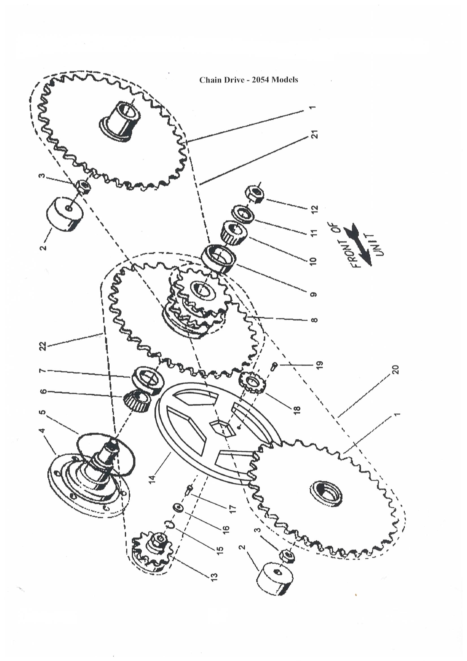
WHEEL DRIVES

REF | PART NUMBER | DESCRIPTION | QTY
1 | 5100 | SPROCKET/AXLE | 4
2 | 5101 | GUIDE | 4
3 | 5102 | NUT/HEX CENTERLOCK FLANGED 3/8-16NC | 4
4 | 5103 | SHAFT/DRIVE PRIMARY | 2
5 | 5104 | O-RING | 2
6 | 5105 | CONE/BEARING | 2
7 | 5106 | CUP/BEARING | 2
8 | 5107 | SPROCKET/CLUSTER | 2
9 | 5108 | CUP/BEARING | 2
10 | 5109 | CONE/BEARING | 2
11 | 5110 | WASHER/FLAT | 2
12 | 5111 | NUT/LOCK NYLON INSERT 1-1/4 | 2
13 | 5112 | MOTOR/SPROCKET 60-C-17 | 2
14 | 5113 | DISC/BRAKE | 2
15 | 5114 | RING/SNAP | 2
16 | 5115 | WASHER/SPECIAL | 2
17 | 5116 | SCREW/CAP 3/8-16NC X 1 | 2
18 | 5117 | NUT/SPECIAL | 2
19 | 5118 | SCREW/CAP SELF-TAPPING 5/16-18NC X 3/4 | 2
20 | 5119 | ASSEMBLY/ROLLER CHAIN 80HK LEFT REAR/RIGHT FRONT | 2
21 | 5120 | ASSEMBLY/ROLLER CHAIN 80HK LEFT FRONT/RIGHT REAR | 2
22 | 5121 | ASSEMBLY/ROLLER CHAIN WITH CONNECTOR | 2
23 | 5122 | LINK/CONNECTOR | 2

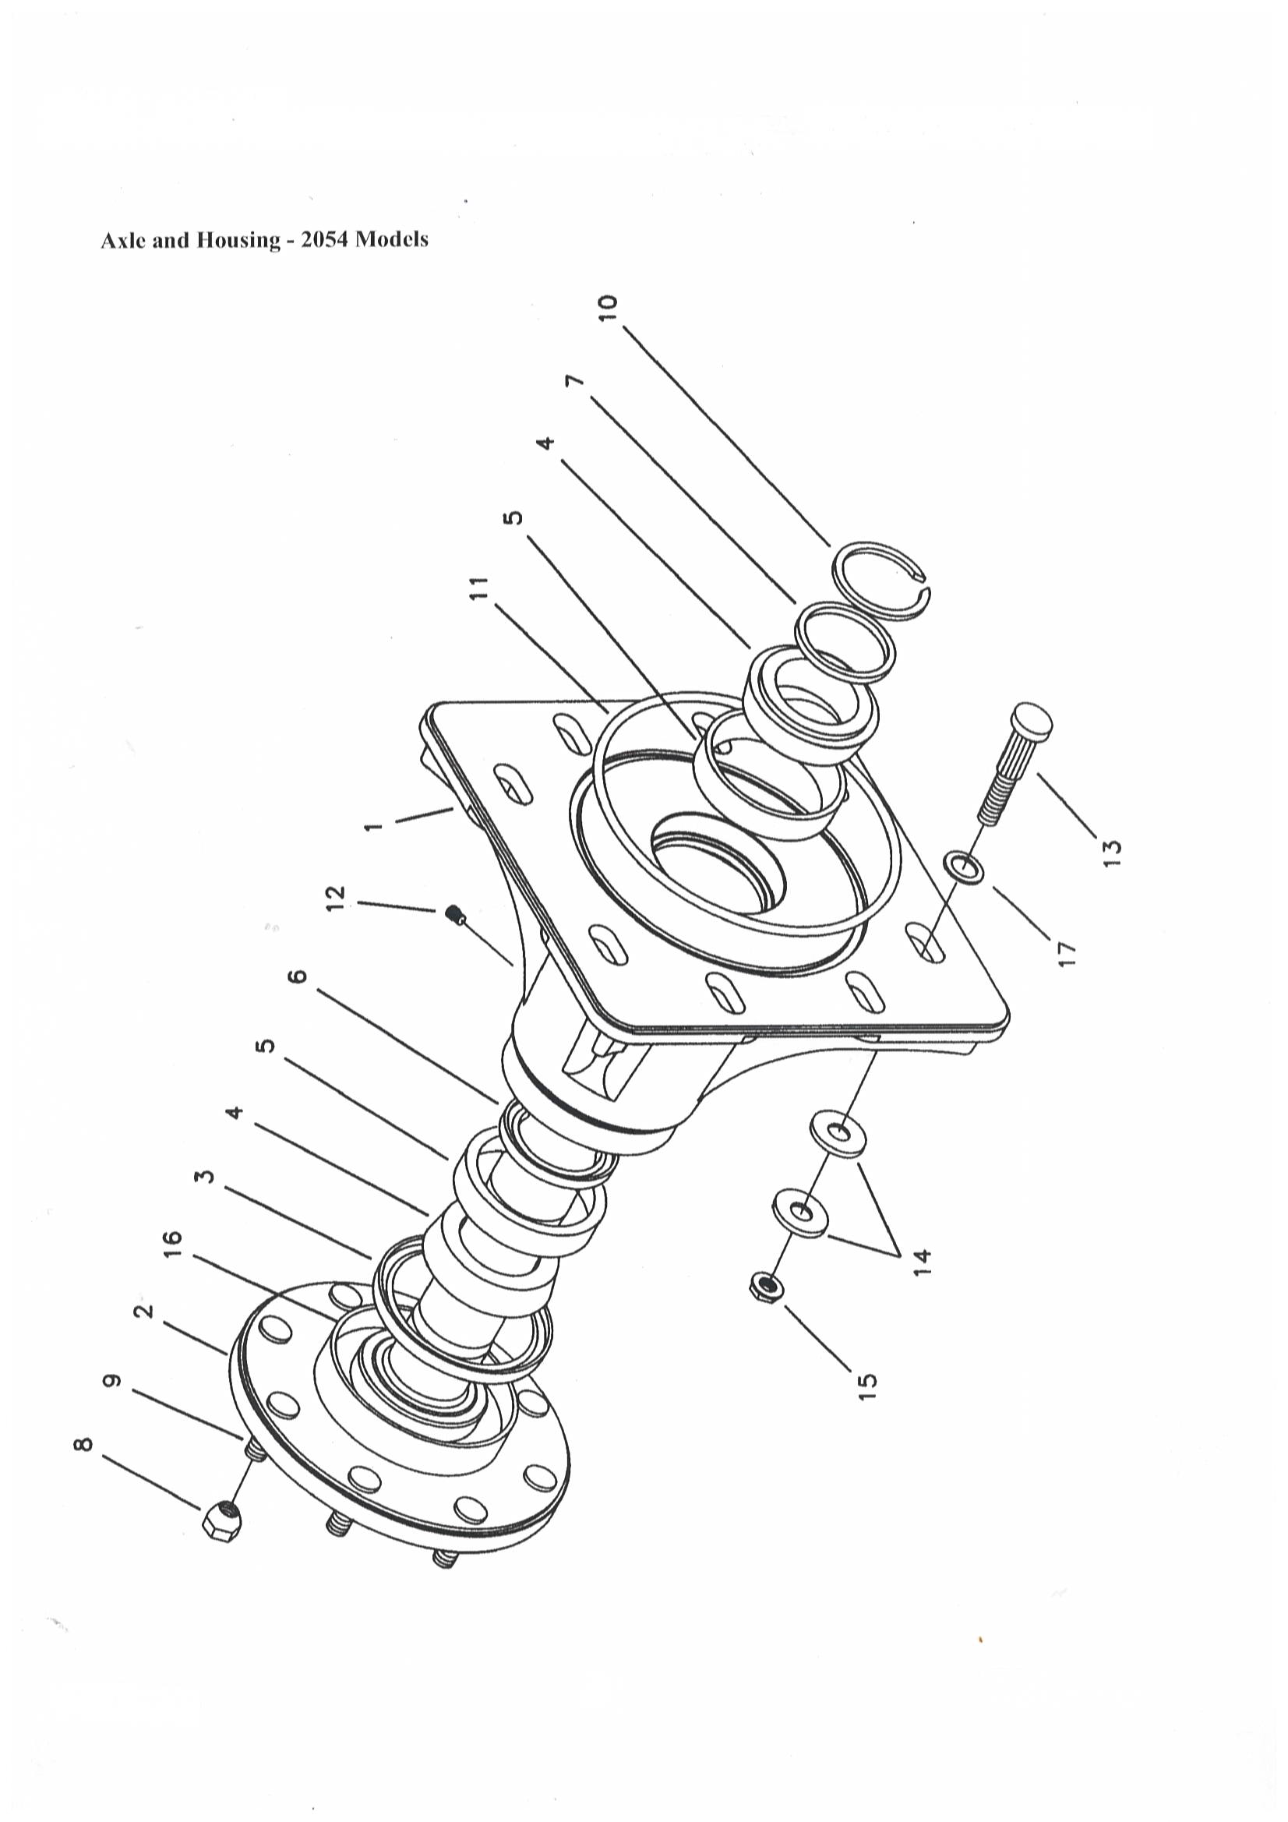
WHEEL DRIVES

REF | PART NUMBER | DESCRIPTION | QTY
 | 5123 | ASSY/AXLE AND SUPPORT | 1
1 | 5124 | HOUSING/AXLE | 4
2 | 5125 | ASSEMBLY/AXLE AND LUG | 4
3 | 5126 | SEAL/OUTER | 4
4 | 5127 | BEARING/CONE | 8
5 | 5106 | BEARING/CUP | 8
6 | 5129 | SEAL/INNER | 4
7 | 5130 | WASHER/SPECIAL .226 | AR
 | 5131 | WASHER/SPECIAL .230 | AR
 | 5132 | WASHER/SPECIAL .234 | AR
 | 5133 | WASHER/SPECIAL .238 | AR
 | 5134 | WASHER/SPECIAL .242 | AR
 | 5135 | WASHER/SPECIAL .246 | AR
 | 5136 | WASHER/SPECIAL .250 | AR
 | 5137 | WASHER/SPECIAL .254 | AR
8 | 5138 | NUT/LUG | 32
9 | 5139 | BOLT/LUG | 32
10 | 5140 | RING/SNAP | 4
11 | 5141 | O-RING | 4
12 | 5142 | PLUG | 4
13 | 5143 | BOLT/SERRATED 5/8-18NF X 2-1/4 | 32
14 | 5144 | WASHER/SPECIAL | 64
15 | 5145 | NUT/HEX LOCK FLANGED 5/8-18NF | 32
16 | 5146 | SEAL PROTECTOR/AXLE | 4
17 | 5147 | O-RING | 32

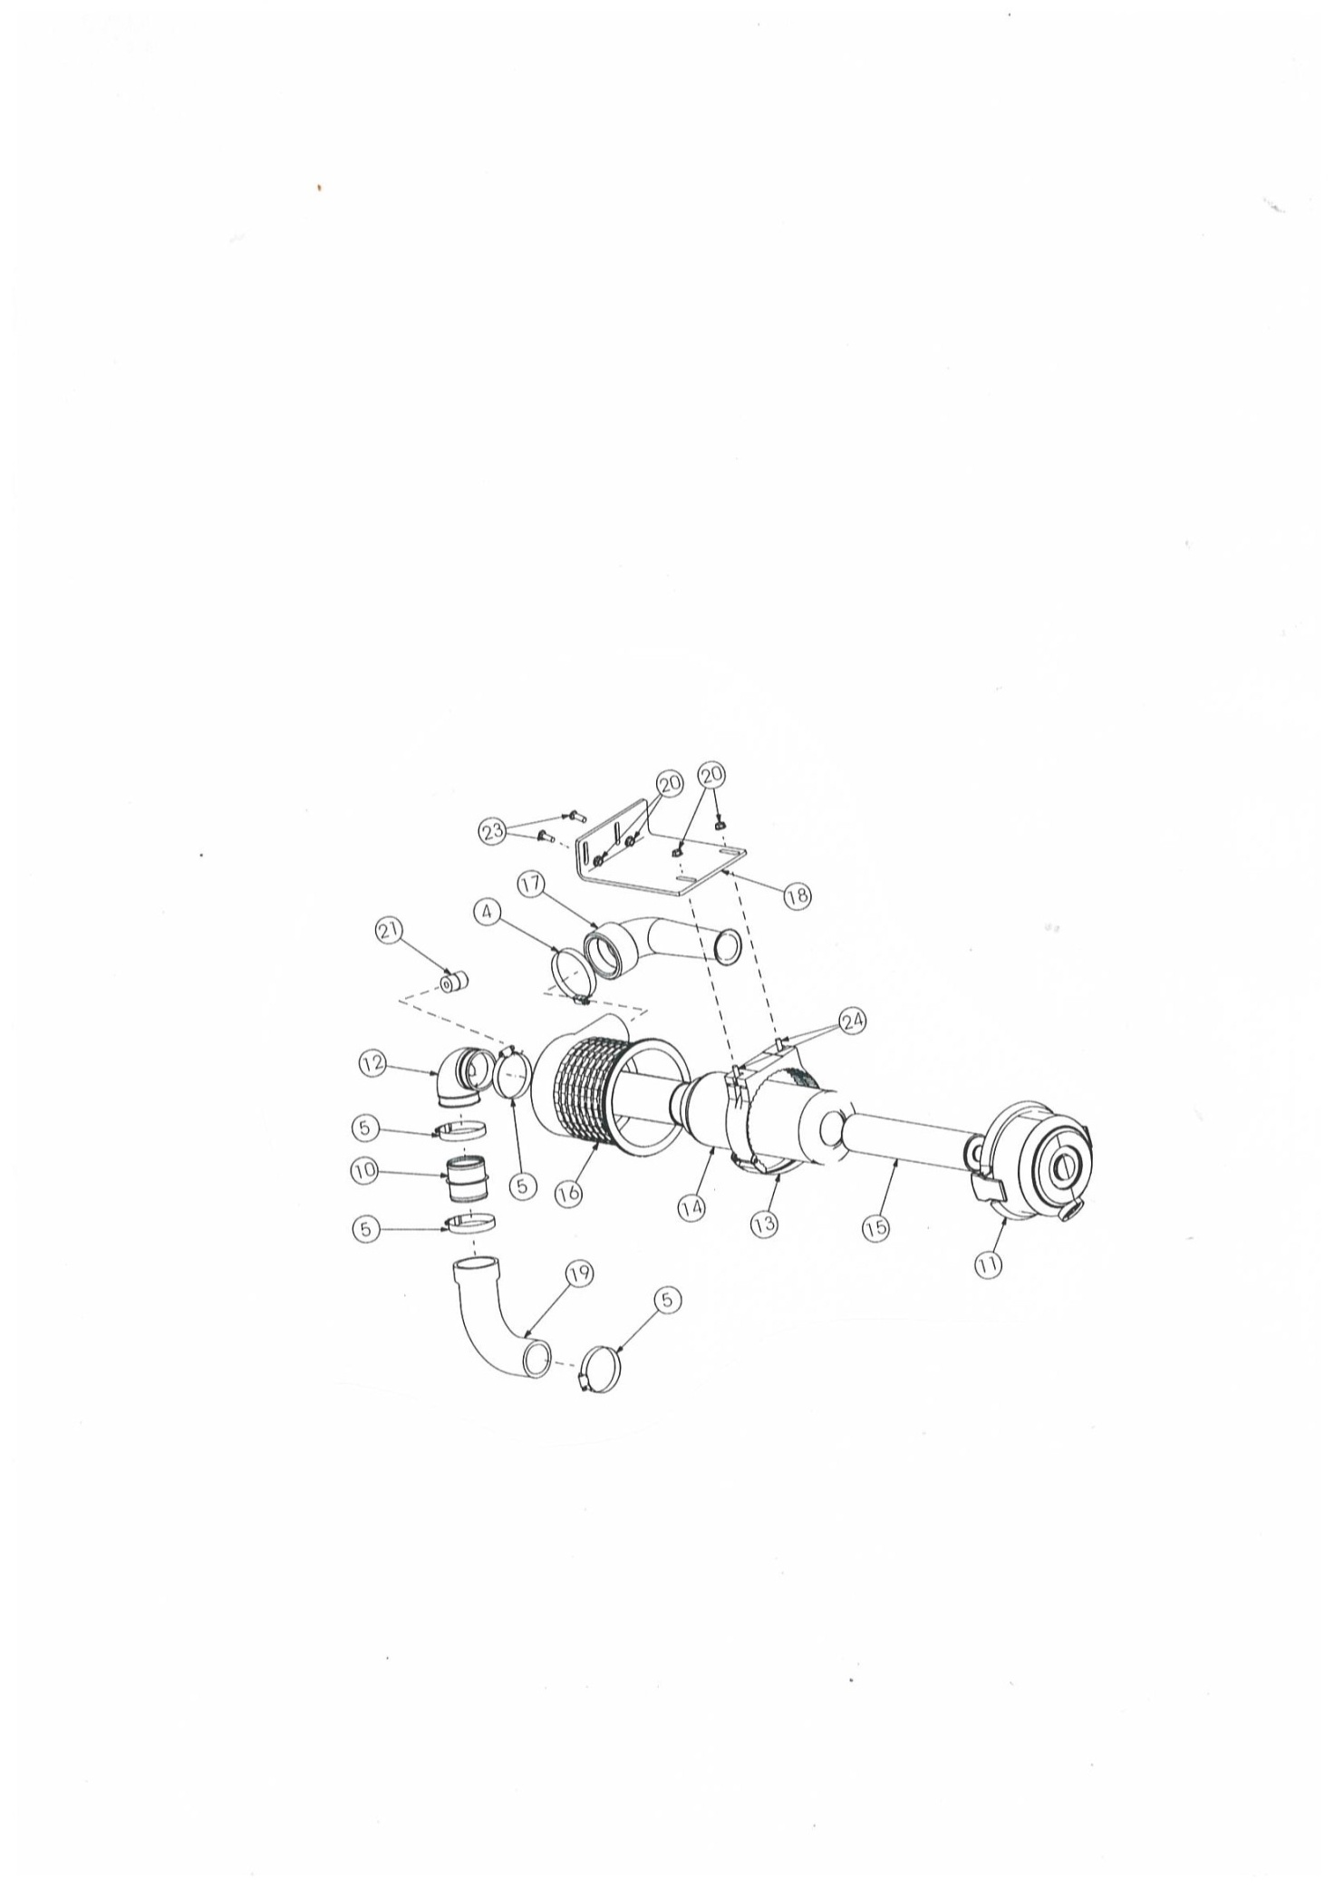

AIR CLEANER

REF | PART NUMBER | DESCRIPTION | QTY
4 | 5200 | CLAMP/HOSE #52 | 1
5 | 5201 | CLAMP/HOSE #40 | 4
10 | 5202 | TUBE/HOSE CONNECTOR | 1
11 | 5203 | END CAP / AIR FILTER | 1
12 | 5204 | 200 SERIES ELBOW | 1
13 | 5205 | CLAMP/FILTER | 1
14 | 5206 | ELEMENT/PRIMARY | 1
15 | 5207 | ELEMENT/SECONDARY | 1
16 | 5208 | CLEANER/AIR | 1
17 | 5209 | DIFFUSER/SOUND | 1
18 | 5210 | BRACKET/AIR FILTER | 1
19 | 5211 | HOSE/MOLDED AIR FILTER | 1
20 | 5212 | NUT/HEXWHIZLOCK 5/16-18NC | 4
21 | 5213 | GAUGE/RESTRICTION | 1
23 | 5214 | BOLT/CARRIAGE 5/16 X 1 | 2
24 | 5215 | BOLT/CARRIAGE 5/16 X 1-1/4 | 2

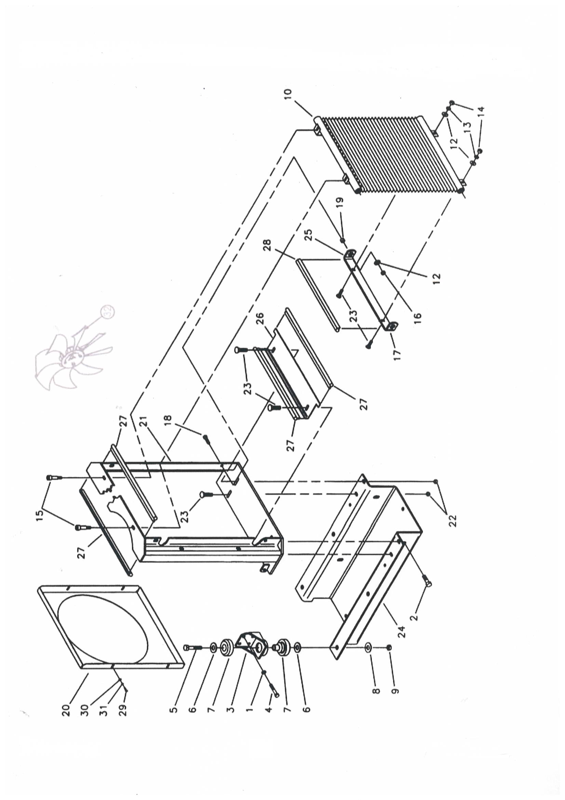
COOLER WATER SYSTEM
REF | PART NUMBER | DESCRIPTION | QTY
1 | 5300 | WASHER/LOCK 7/16 | 16
2 | 5301 | SCREW/CAP WHIZLOCK 1/2-13NC X 1-1/4 | 4
3 | 5302 | MOUNT/ENGINE | 4
4 | 5303 | SCREW/CAP M10-1.50 X 25 MM | 16
5 | 5304 | SCREW/CAP 5/8-11NC X 4 | 4
6 | 5305 | WASHER/SPECIAL 3/16 | 10
7 | 5306 | MOUNT/RUBBER | 4
8 | 5307 | WASHER/FLAT 5/8 | 4
9 | 5308 | NUT/HEX CENTERLOCK 5/8-11NC | 4
10 | 5309 | COOLER/OIL STANDARD | 1
 | 5310 | COOLER/OIL HIGH FLOW | 1
12 | 5311 | WASHER/FLAT 3/8 | 4
13 | 5312 | WASHER/LOCK 3/8 | 2
14 | 5313 | NUT/HEX 3/8-16NC | 2
15 | 5314 | BOLT/SHOULDER 3/8-16NC X 1-5/8 STANDARD | 2
 | 5315 | BOLT/SHOULDER 3/8-16NC X 1-1/8 HIGH FLOW | 2
16 | 5316 | NUT/HEX CENTERLOCK 3/8-16NC | 2
17 | 5317 | BRACKET/BOTTOM OIL COOLER MOUNT | 1
18 | 5318 | SCREW/CAP 3/8-16NC X 1-1/4 | 2
19 | 5319 | SPACER | 2
20 | 5320 | SHROUD/FAN | 1
21 | 5321 | MOUNT/RADIATOR | 1
22 | 5322 | NUT/HEX WHIZLOCK 3/8-16NC | 4
23 | 5323 | BOLT/CARRIAGE 3/8-16NC X 1-1/4 | 6
24 | 5324 | SUPPORT/ENGINE AND RADIATOR | 1
26 | 5325 | BRACKET/BOTTOM RADIATOR | 1
27 | 5326 | BULB SEAL/REAR GRILLE | 4
28 | 5327 | BULB SEAL/BOTTOM RADIATOR | 1
29 | 5328 | SCREW/CAP M6-1.00 X 16 MM | 4
30 | 5329 | WASHER/FLAT 3/16 | 4
31 | 5330 | WASHER/LOCK 1/4 | 4
32 | 5331 | KIT/FAN REPLACEMENT (INCLUDES ITEMS REFERENCED BELOW) | 1
 | 5332 | FAN/1 HR 16-3/4 | 1
 | 5333 | SPACER/FAN 8 MM | 1
 | 5334 | SCREW/CAP M6 X 30 MM | 4

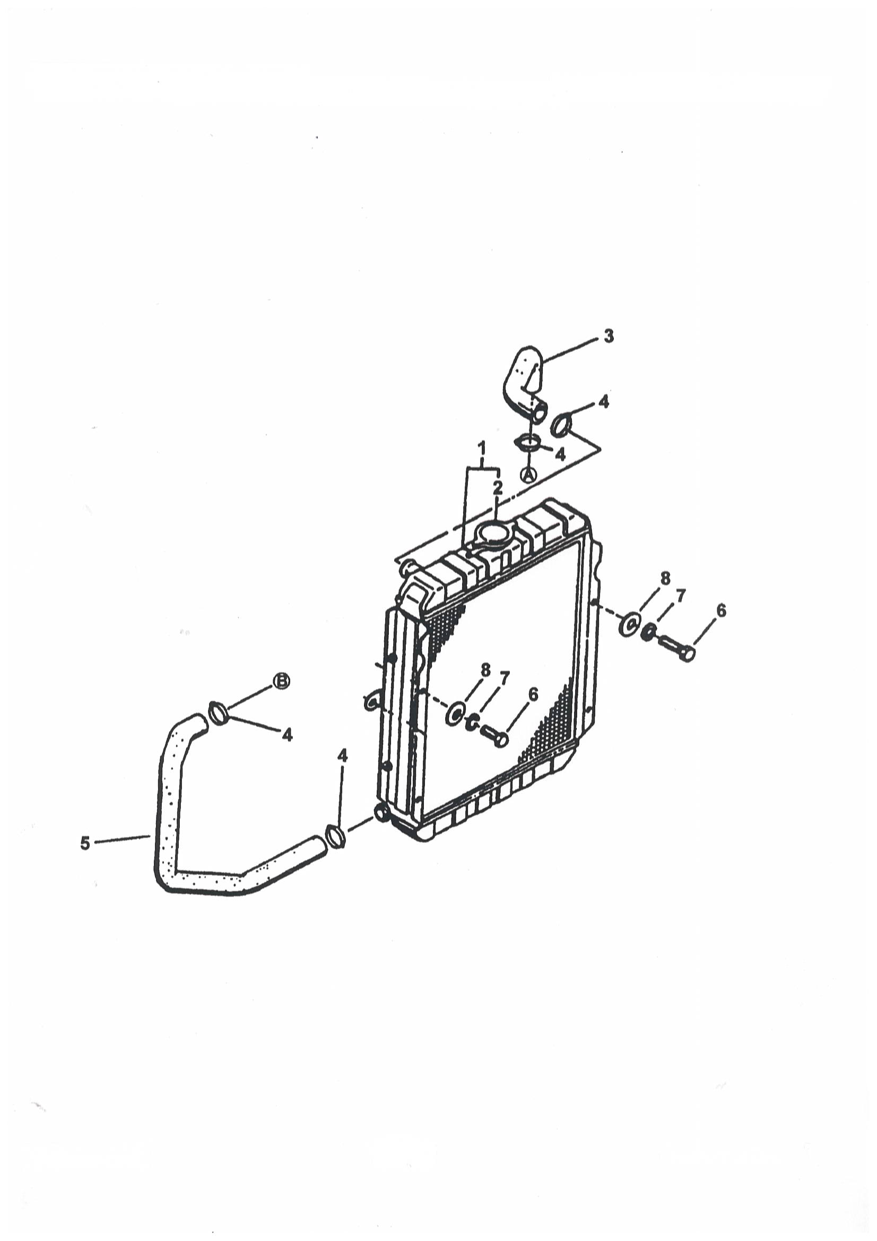
COOLER WATER SYSTEM
REF | PART NUMBER | DESCRIPTION | QTY
1 | 5335 | RADIATOR | 1
2 | 5336 | CAP | 1
6 | 5337 | SCREW/CAP M8-1.25 X 20 MM | 4
7 | 5338 | WASHER/LOCK 5/16 | 5
8 | 5339 | WASHER/FLAT 5/16 | 4

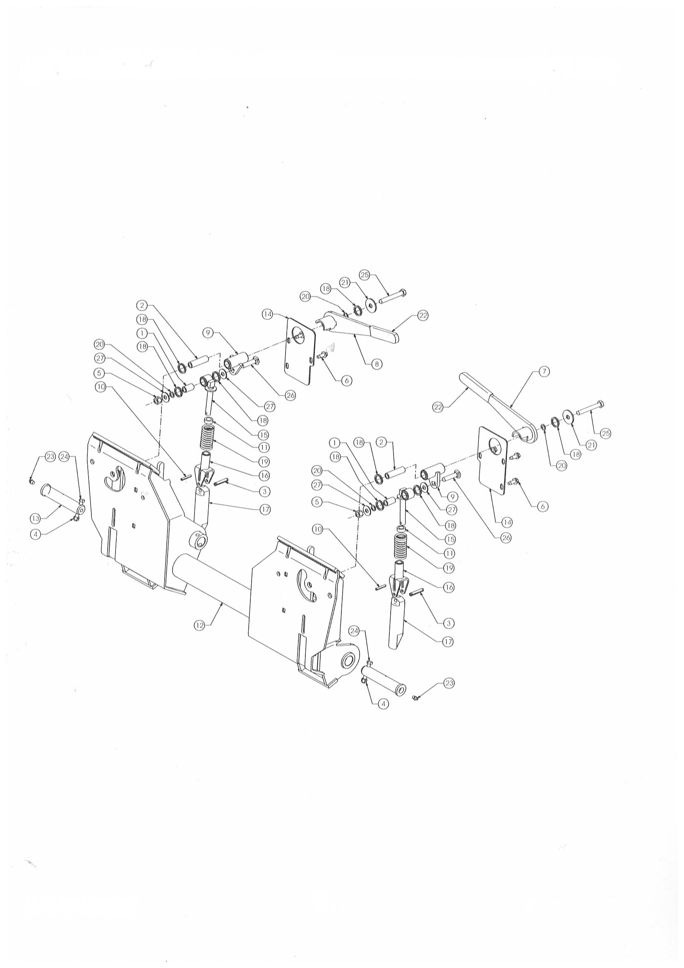
ATTACHMENT SYSTEM
REF | PART NUMBER | DESCRIPTION | QTY
 | 5400 | MULTI-TACH™ COMPLETE | 1
1 | 5401 | BUSHING/OILITE | 2
2 | 5402 | BUSHING/OILITE | 2
3 | 5403 | PIN/SPRING 3/8 X 2 | 2
4 | 5404 | NUT/LOCK 3/8 | 2
5 | 5405 | NUT/HEX CENTERLOCK 12-13NC | 2
6 | 5406 | SCREW/TAPPING THWH TF USL 3/8 X 1 | 6
7 | 5407 | HANDLE/LEFT | 1
8 | 5408 | HANDLE/RIGHT | 1
9 | 5409 | LEVER | 2
10 | 5410 | PIN/ROLL 1/4 X 1-1/2 | 2
11 | 5411 | BUSHING/SPACER | 2
12 | 5412 | WELDMENT/TWO-PIN ATTACHMENT | 1
13 | 5413 | PIN/PIVOT | 2
14 | 5414 | COVER/LATCH | 2
15 | 5415 | ROD/LINK | 2
16 | 5416 | CLEVIS | 2
17 | 5417 | PIN/LATCH | 2
18 | 5418 | RING/QUAD | 8
19 | 5419 | SPRING/COMPRESSION | 2
20 | 5420 | WASHER/SPECIAL | 4
21 | 5421 | WASHER/SPECIAL | 2
22 | 5422 | GRIP/HANDLE | 2
23 | 5423 | ZERK/GREASE | 2
24 | 5424 | SCREW/CAP 3/8 X 2-1/2 | 2
25 | 5425 | SCREW/CAP 1/2-13NC X 3-1/2 | 2
26 | 5426 | BOLT/CARRIAGE 1/2-13NC X 2-1/4 | 2
27 | 5427 | WASHER/FLAT 7/16 | 4

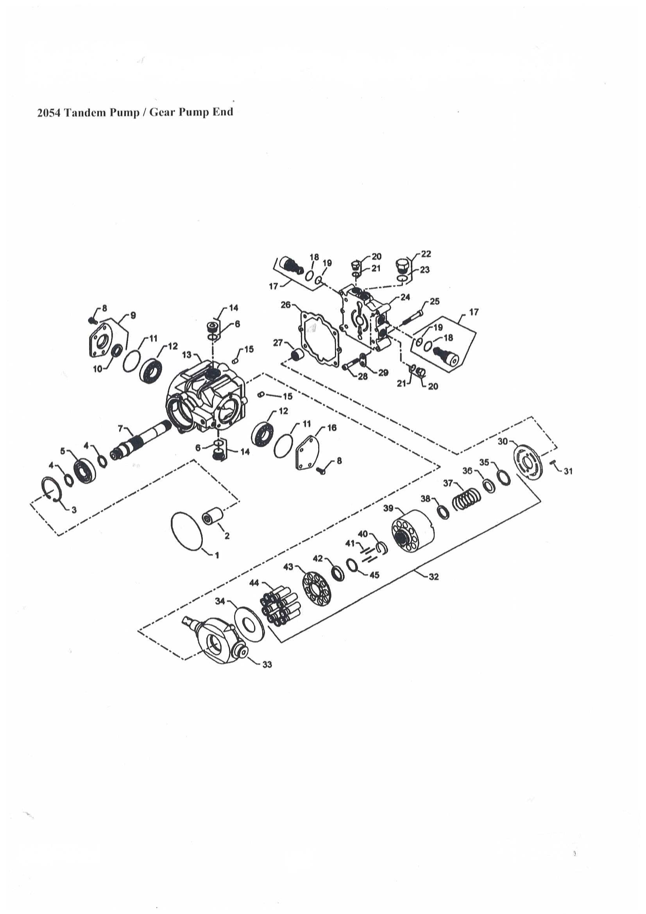
TANDEM PUMP
REF | PART NUMBER | DESCRIPTION | QTY
1 | 5500 | O-RING | 1
2 | 5501 | COUPLING | 1
3 | 5502 | RING/RETAINING | 1
4 | 5503 | RING/RETAINING | 2
5 | 5504 | BEARING/BALL | 1
6 | 5505 | O-RING | 2
7 | 5506 | SHAFT | 1
8 | 5507 | SCREW | 8
9 | 5508 | COVER/TRUNNION | 1
10 | 5509 | SEAL/LIP | 1
11 | 5510 | O-RING | 2
12 | 5511 | BEARING | 2
13 | 5512 | HOUSING | 1
14 | 5513 | PLUG | 2
15 | 5514 | PIN | 2
16 | 5515 | COVER/TRUNNION | 1
17 | 5516 | VALVE/SCR | 2
18 | 5517 | O-RING | 2
19 | 5518 | O-RING | 2
20 | 5519 | PLUG | 2
21 | 5520 | O-RING | 2
22 | 5521 | PLUG | 1
23 | 5522 | O-RING | 1
24 | 5523 | CAP/END | 1
25 | 5524 | SCREW/SOCKET HEAD | 4
26 | 5525 | GASKET/END CAP | 1
27 | 5526 | BEARING/NEEDLE | 1
28 | 5527 | SCREW/SOCKET HEAD | 4
29 |  | EAR/LIFTING | 1
30 | 5528 | PLATE/VALVE REAR | 1
31 | 5529 | PIN/SPRING | 1
32 | 5530 | KIT/CYLINDER BLOCK | 1
33 | 5531 | SWASH PLATE | 1
34 | 5532 | PLATE/THRUST | 1
35 |  | RING/RETAINING | 1
36 |  | WASHER | 1
37 |  | SPRING | 1
38 |  | WASHER | 1
39 |  | BLOCK/CYLINDER | 1
40 |  | PIN/HOLD DOWN RETAINER | 1
41 |  | PIN/HOLD DOWN SLIPPER | 4
42 |  | GUIDE/RETAINING SLIPPER | 1
43 |  | RETAINER/SLIPPER | 1
44 |  |  | 9
45 |  | WASHER/THRUST | 1
 | 5533 | KIT/SEAL OVERHAUL (INCLUDES 1, 6, 10, 11, 18, 19, 21, 26) | 1

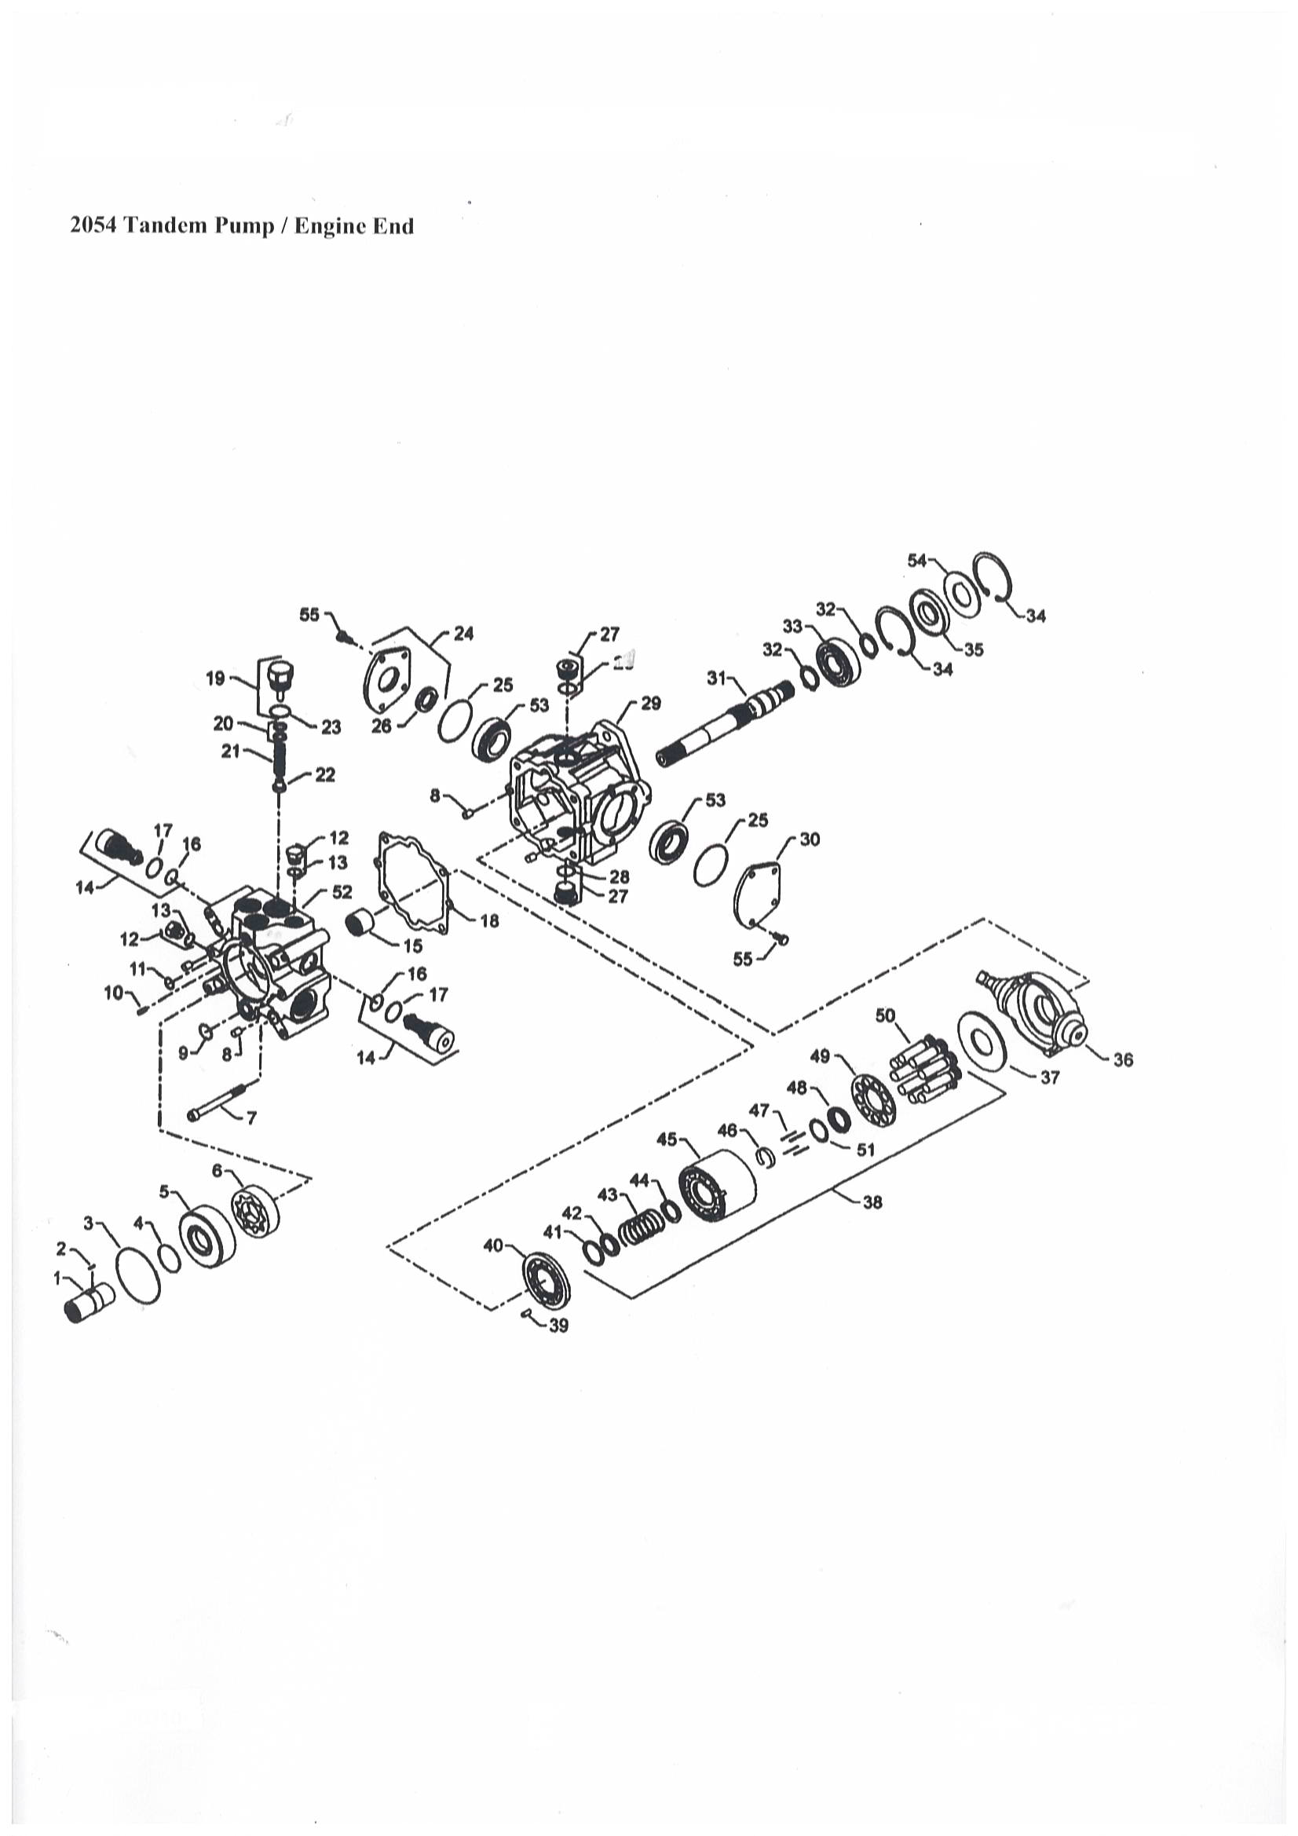
TANDEM PUMP
REF | PART NUMBER | DESCRIPTION | QTY
 | 5534 | PUMP/TANDEM M44 | 1
1 | 5535 | COUPLING | 1
2 | 5536 | PIN | 1
3 | 5537 | O-RING | 1
4 | 5538 | O-RING | 1
5 | 5539 | SPACER | 1
6 | 5540 | GEROTOR | 1
7 | 5541 | SCREW/SOCKET HEAD | 4
8 | 5514 | PIN | 2
9 | 5543 | O-RING | 1
10 | 5544 | PIN | 1
11 | 5545 | O-RING | 1
12 | 5519 | PLUG | 1
13 | 5547 | O-RING | 1
14 | 5516 | VALVE/SCR | 2
15 | 5526 | NEEDLE/BEARING | 1
16 | 5518 | O-RING | 2
17 | 5517 | O-RING | 2
18 | 5525 | GASKET/END CAP | 1
19 | 5553 | PLUG/CHARGE RELIEF | 1
20 | 5554 | SHIM KIT/CHARGE RELIEF | 1
21 | 5555 | SPRING/COMPRESSION | 1
22 | 5556 | POPPET/CHARGE RELIEF | 1
23 | 5557 | SHIM/CHARGE RELIEF | 3
24 | 5508 | COVER/TRUNNION | 1
25 | 5510 | O-RING | 1
26 | 5509 | SEAL/LIP | 2
27 | 5513 | PLUG | 2
28 | 555 | O-RING | 2
29 | 5563 | HOUSING/FRONT PUMP | 1
30 | 5515 | COVER/TRUNNION | 1
31 | 5565 | SHAFT/PUMP | 1
32 | 5503 | RING/RETAINING | 2
33 | 5504 | BEARING/BALL | 1
34 | 5502 | RING/RETAINING | 2
35 | 5569 | SEAL/LIP | 1
36 | 5531 | SWASH PLATE/VARIABLE | 1
37 | 5571 | PLATE/THRUST | 1
38 | 5530 | KIT/CYLINDER BLOCK | 1
39 | 5529 | PIN/SPRING | 1
40 | 5574 | VALVE PLATE/FRONT | 1
41 |  | RING/RETAINING | 1
42 |  | WASHER | 2
43 |  | SPRING | 1
44 |  | WASHER | 1
45 |  | BLOCK/CYLINDER | 1
46 |  | RETAINER/PIN | 1

CRANKCASE

Ref No | Part No | Description | Qty
010 | 6000 | COMP. CRANKCASE | 1
010 | 6001 | COMP. CRANKCASE | 1
010 | 6002 | COMP. CRANKCASE | 1
010 | 6003 | COMP. CRANKCASE | 1
020 | 6004 | PLUG | 6
030 | 6005 | PLUG | 2
040 | 6006 | PLUG, EXPANSION | 3
050 | 6007 | PLUG, EXPANSION | 1
060 | 6008 | CAP, SEALING | 6
070 | 6009 | CAP, SEALING | 2
080 | 6010 | PIN, STRAIGHT | 2
090 | 6011 | PIN, STRAIGHT | 3
100 | 6012 | PIN, STRAIGHT | 2
110 | 6013 | PIN, STRAIGHT | 1
120 | 6014 | PIN, PIPE | 1
140 | 6015 | PLUG | 1
140 | 6016 | PLUG | 1
150 | 6017 | GASKET | 1
160 | 6018 | COCK, DRAIN | 1
170 | 6019 | JOINT, DRAIN COCK | 1

OIL PAN
REF NO | PART NO | DESCRIPTION | QTY
010 | 6100 | COMP.OIL PAN | 1
010 | 6101 | COMP.OIL PAN | 1
020 | 6102 | GASKET, OIL PAN | 1
030 | 6103 | BOLT, FLANGE | 24
040 | 6104 | PLUG, DRAIN | 2
050 | 6105 | GASKET | 2
060 | 6106 | FILTER OIL | 1
070 | 6107 | BOLT, FLANGE | 1
080 | 6108 | O RING | 1

CYLINDER HEAD
REF NO | PART NO | DESCRIPTION | QTY
010 | 6200 | HOOK, ENGINE | 2
020 | 6201 | BOLT | 1
030 | 6202 | STUD | 2
040 | 6203 | HEX.NUT | 1
050 | 6204 | WASHER SPRING | 1
060 | 6205 | WASHER, PLAIN | 1
070 | 6206 | COMP.CYLINDER HEAD | 1
080 | 6207 | CAP, SEALING | 12
090 | 6208 | CAP, SEALING | 1
100 | 6209 | PLUG | 2
110 | 6210 | GUIDE, INLET VALVE | 4
110 | 6211 | GUIDE, INLET VALVE | 4
120 | 6212 | GUIDE, EXHAUST VALVE | 4
130 | 6213 | BOLT, CYLINDER HEAD | 18
140 | 6214 | GASKET, CYL.HEAD | 1
140 | 6215 | GASKET, CYL.HEAD | 1
140 | 6216 | GASKET, CYL.HEAD | 1
140 | 6217 | GASKET, CYL.HEAD | 1
140 | 6218 | GASKET, CYL.HEAD | 1
150 | 6219 | SEAL, INLET VALVE | 4
160 | 6220 | SEAL, EXHAUST VALVE | 4

GEAR CASE
REF NO | PART NO | DESCRIPTION | QTY
010 | 6300 | COMP. CASE, GEAR | 1
010 | 6301 | COMP. CASE, GEAR | 1
020 | 6302 | PLUG | 2
030 | 6303 | O RING | 1
040 | 6304 | O RING | 2
050 | 6305 | O RING | 1
060 | 6306 | PIN, STRAIGHT | 2
070 | 6307 | CAP, SEALING | 1
080 | 6308 | GASKET, GEAR CASE | 1
080 | 6309 | GASKET, GEAR CASE | 1
090 | 6310 | BOLT, FLANGE | 1
100 | 6311 | BOLT, FLANGE | 7
110 | 6312 | BOLT, FLANGE | 1
120 | 6313 | BOLT, FLANGE | 2
130 | 6314 | BOLT, FLANGE | 4
150 | 6315 | SPRING | 1
160 | 6316 | SEAT, VALVE | 1
170 | 6317 | BALL | 1
180 | 6318 | FLANGE, WATER RETURN | 1
190 | 6319 | GASKET, RETURN FLANGE | 1
200 | 6320 | BOLT | 3
210 | 6321 | COVER | 1
220 | 6322 | GASKET, HOUR METRE | 1
230 | 6323 | STUD | 4
240 | 6324 | NUT | 4
250 | 6325 | WASHER, SPRING | 4
260 | 6326 | JOINT, PIPE | 1
270 | 6327 | COLLAR, VALVE SEAT | 1

HEAD COVER
REF NO | PART NO | DESCRIPTION | QTY
010 | 6400 | TUBE BREATHER | 1
010 | 6401 | TUBE BREATHER | 1
020 | 6402 | CLAMP, HOSE | 2
040 | 6403 | ASSY COVER, CYL. HEAD | 1
040 | 6404 | ASSY COVER, CYL. HEAD | 1
060 | 6405 | PIPE, WATER RETURN | 1
070 | 6406 | COVER, BREATHER | 1
080 | 6407 | COMP VALVE, BREATHER | 1
090 | 6408 | SCREW, SEMS (PAN HEAD) | 4
090 | 6409 | SCREW, PAN HEAD (PHILL) | 4
100 | 6410 | GASKET, HEAD COVER | 1
110 | 6411 | BOLT | 10
120 | 6412 | PLUG, OIL FILTER | 1
130 | 6413 | O RING | 1

OIL FILTER
REF NO | PART NO | DESCRIPTION | QTY
010 | 6500 | ENGINE OIL FILTER | 1

DIPSTICK & GUIDE
REF NO | PART NO | DESCRIPTION | QTY
010 | 6550 | GAUGE, OIL | 1
010 | 6551 | GAUGE, OIL | 1
020 | 6552 | GUIDE, OIL GAUGE | 1

OIL PUMP
REF NO | PART NO | DESCRIPTION | QTY
010 | 6600 | ASSY PUMP, OIL | 1
020 | 6601 | GASKET, OIL PUMP | 1
030 | 6602 | BOLT | 4
040 | 6603 | GEAR, OIL PUMP DRIVE | 1
040 | 6604 | GEAR, OIL PUMP DRIVE | 1
050 | 6605 | KET, FEATHER | 1
060 | 6606 | NUT | 1

MAIN BEARING CASE
REF NO | PART NO | DESCRIPTION | QTY
010 | 6700 | ASSY BRG. CASE, WHEEL | 1
010 | 6701 | ASSY BRG. CASE, WHEEL | 1
020 | 6702 | BOLT, BEARING CASE | 2
030 | 6703 | METAL, CRANKSHAFT | 1
030 | 6704 | METAL, CRANKSHAFT | 1
030 | 6705 | METAL, CRANKSHAFT | 1
030 | 6706 | METAL, CRANKSHAFT | 1
040 | 6707 | GASKET, BEARING CASE | 1
050 | 6708 | COVER, BEARING CASE | 1
060 | 6709 | GASKET, CASE COVER | 1
070 | 6710 | BOLT, SEMS | 8
080 | 6711 | BOLT, SEMS | 8
090 | 6712 | SEAL, OIL | 1
090 | 6713 | SEAL, OIL | 1
100 | 6714 | ASSY BRG. CASE, MAIN | 1
100 | 6715 | ASSY BRG. CASE, MAIN | 1
110 | 6702 | BOLT, BEARING CASE | 2
120 | 6703 | METAL CRANKSHAFT | 1
120 | 6704 | METAL CRANKSHAFT | 1
120 | 6705 | METAL CRANKSHAFT | 1
120 | 6706 | METAL CRANKSHAFT | 1
130 | 6721 | ASSY BRG. CASE, MAIN | 1
130 | 6722 | ASSY BRG. CASE, MAIN | 1
140 | 6702 | BOLT, BEARING CASE | 2
150 | 6724 | METAL, CRANKSHAFT | 1
150 | 6704 | METAL, CRANKSHAFT | 1
150 | 6705 | METAL, CRANKSHAFT | 1
150 | 6706 | METAL, CRANKSHAFT | 1
160 | 6728 | ASS BRG. CASE, MAIN | 1
160 | 6729 | ASS BRG. CASE, MAIN | 1
170 | 6702 | BOLT, BEARING CASE | 2
180 | 6703 | METAL, CRANKSHAFT | 1
180 | 6704 | METAL, CRANKSHAFT | 1
180 | 6705 | METAL, CRANKSHAFT | 1
180 | 6706 | METAL, CRANKSHAFT | 1
190 | 6735 | BOLT, BEARING CASE | 3

CAMSHAFT & IDLE GEAR SHAFT
REF NO | PART NO | DESCRIPTION | QTY
010 | 6800 | TAPPET | 8
010 | 6801 | TAPPET | 8
020 | 6802 | PUSH ROD | 8
030 | 6803 | ASSY CAMSHAFT | 1
050 | 6804 | BALL 1/4 | 1
060 | 6805 | GEAR, CAMSHAFT | 1
070 | 6806 | KEY, FEATHER | 1
080 | 6807 | STOPPER, CAMSHAFT | 1
090 | 6808 | BOLT, SEMS | 2
100 | 6809 | COMP. GEAR, DILE | 1
100 | 6810 | COMP. GEAR, DILE | 1
110 | 6811 | BUSH. IDLE GEAR | 1
110 | 6812 | BUSH, IDLE GEAR | 1
120 | 6813 | COLLAR | 1
120 | 6814 | COLLAR, IDLE GEAR | 1
130 | 6815 | CIR CLIP, EXTERNAL | 1
130 | 6816 | BOLT, FLANGE | 2
140 | 6817 | SHAFT, IDLE GEAR | 1
140 | 6818 | SHAFT, IDLE GEAR | 1
150 | 6808 | BOLT, SEMS | 3

PISTON & CRANKSHAFT
REF NO | PART NO | DESCRIPTION | QTY
010 | 6900 | PISTON | 4
010 | 6901 | PISTON | 4
020 | 6902 | ASSY PISTON RING | 4
020 | 6903 | ASSY PISTON RING | 4
030 | 6904 | PIN, PISTON | 4
040 | 6905 | CIR CLIP, INTERNAL | 8
050 | 6906 | ASSY CONNECTING ROD | 4
050 | 6907 | ASSY ROD, CONNECTING | 4
050 | 6908 | ASSY ROD, CONNECTING | 4
050 | 6909 | ROD, CONNECTUBG, ASSY | 4
060 | 6910 | BUSH, PISTON PIN | 4
060 | 6911 | BUSH, PISTON PIN | 4
070 | 6912 | BOLT, CONNECTING ROD | 8
070 | 6913 | BOLT, CONNECTING ROD | 8
080 | 6914 | METAL, CRANKPIN | 4
080 | 6915 | METAL, CRANKPIN | 4
080 | 6916 | METAL, CRANKPIN | 4
080 | 6917 | METAL, CRANKPIN | 4
090 | 6918 | COMP. CRANKSHAFT | 1
090 | 6919 | COMP. CRANKSHAFT | 1
090 | 6920 | COMP. CRANKSHAFT | 1
100 | 6921 | BALL 1/4 | 4
110 | 6922 | BUSH, CRANKSHAFT | 1
115 | 6923 | PIN, STRAIGHT | 1
115 | 6924 | PIN, STRAIGHT | 1
120 | 6925 | GEAR, CRANKSHAFT | 1
130 | 6926 | FEATHER KEY | 1
140 | 6927 | OIL SLINGER | 1
150 | 6928 | COLLAR, CRANKSHAFT | 1
160 | 6929 | O RING | 1
170 | 6930 | NUT, CRANKSHAFT | 1
180 | 6931 | METAL,CRANKSHAFT | 1
180 | 6932 | METAL CRANKSHAFT | 1
180 | 6933 | METAL CRANKSHAFT | 1
180 | 6934 | METAL CRANKSHAFT | 1
200 | 6935 | METAL, SIDE | 2
200 | 6936 | METAL, SIDE | 2
200 | 6937 | METAL, SIDE | 2
200 | 6938 | METAL, SIDE | 2
210 | 6939 | METAL, SIDE | 2
210 | 6940 | METAL, SIDE | 2
210 | 6941 | METAL, SIDE | 2
210 | 6942 | METAL, SIDE | 2
220 | 6943 | SEAL, OIL | 1
220 | 6944 | SEAL, OIL | 1
230 | 6945 | KIT METAL, ENGINE | 1
230 | 6946 | KIT METAL, ENGINE | 1
230 | 6947 | KIT METAL, ENGINE | 1
230 | 6948 | KIT METAL, ENGINE | 1
240 | 6949 | KIT PISTON | 4
240 | 6950 | KIT PISTON | 4
240 | 6951 | KIT PISTON | 4
240 | 6952 | KIT PISTON | 4
240 | 6953 | KIT PISTON | 4

This page was intentionally left blank

FLYWHEEL
REF NO | PART NO | DESCRIPTION | QTY
010 | 7000 | COMP. FLYWHEEL | 1
020 | 7001 | GEAR RING | 1
030 | 7002 | BOLT FLYWHEEL | 6
030 | 7003 | BOLT FLYWHEEL | 6
040 | 7004 | HOUSING, FLYWHEEL | 1
040 | 7005 | HOUSING | 1
050 | 7006 | COVER | 1
060 | 7007 | HEX. BOLT | 1
070 | 7008 | WASHER SPRING | 1
080 | 7009 | BOLT | 11

FUEL CAMSHAFT & GOVERNOR SHAFT
REF NO | PART NO | DESCRIPTION | QTY
010 | 7050 | ASSY CAMSHAFT, FUEL | 1
010 | 7051 | ASSY CAMSHAFT, FUEL | 1
020 | 7052 | BEARING, BALL | 1
020 | 7053 | BEARING, BALL | 1
030 | 7054 | GEAR, INJECTION PUMP | 1
040 | 7055 | FEATHER KEY | 1
060 | 7056 | SLEEV, GOVERNOR | 1
070 | 7057 | CIR-CLIP, GOV. SLEEVE | 1
080 | 7058 | CASE, GOVERNOR BALL | 1
090 | 7059 | BALL 5/32 | 39
100 | 7060 | CIR-CLIP | 1
110 | 7061 | BALL | 7
120 | 7062 | BEARING, BALL | 1
130 | 7063 | STOPPER, FUEL C/SHAFT | 1
140 | 7064 | BOLT | 2
150 | 7065 | COVER, FUEL CAMSHAFT | 1
160 | 7066 | COLLAR | 1
170 | 7067 | GASKET | 1
180 | 7068 | CIR-CLIP, EXTERNAL | 1
190 | 7069 | BOLT, SEMS | 4

IDLE APPARATUS
REF NO | PART NO | DESCRIPTION | QTY
010 | 7100 | APPARATUS. IDLING | 1
020 | 7101 | ASSY BOLT. ADJUSTMENT | 1
040 | 7102 | NUT. SPRING | 1
050 | 7103 | O RING | 1
060 | 7104 | GASKET | 1
070 | 7105 | CAP | 1

ENGINE STOP LEVER – S.NO BKZ999
REF NO | PART NO | DESCRIPTION | QTY
010 | 7150 | ASSY LEVER, ENG. STOP | 1
010 | 7151 | ASSY LEVER, ENG. STOP | 1
020 | 7152 | COMP. LEVER, STOP | 1
030 | 7153 | LEVER, ENGINE STOP | 1
040 | 7154 | SEAL, OIL | 1
050 | 7155 | PIN, SPRING | 1
060 | 7156 | SPRING, RETURN | 1
070 | 7157 | GASKET, PLATE | 1
080 | 7158 | BOLT, SEMS | 2
090 | 7159 | STUD | 2
100 | 7160 | NUT, FLANGE | 2

ENGINE STOP LEVER – S.NO BL0001
REF NO | PART NO | DESCRIPTION | QTY
010 | 7200 | ASSY LEVER, ENG. STOP | 1
020 | 7201 | COMP. LEVER, STOP | 1
030 | 7202 | LEVER, ENGINGEN STOP | 1
040 | 7203 | GASKET | 2
050 | 7204 | PIN, SPRING | 1
060 | 7205 | SPRING, RETURN | 1
070 | 7206 | GASKET, PLATE | 1
080 | 7207 | BOLT, SEMS | 2
090 | 7208 | STUD | 2
100 | 7209 | NUT, FLANGE | 2

INJECTION PUMP
REF NO | PART NO | DESCRIPTION | QTY
010 | 7300 | ASSY PUMP, INJECTION | 1
010 | 7301 | ASSY PUMP, INJECTION | 1
020 | 7302 | SHIM, INJECTION | 1
020 | 7303 | SHIM, INJECTION | 1
020 | 7304 | SHIM, INJECTION | 1
020 | 7305 | SHIM, INJECTION | 1
020 | 7306 | SHIM, INJECTION | 1
030 | 7307 | BOLT, FLANGE | 4
050 | 7308 | STUD | 2
060 | 7309 | NUT, FLANGE | 2
070 | 7310 | JOINT, EYE | 1
080 | 7311 | ASSY COCK, JET START | 1
090 | 7312 | GASKET | 2
100 | 7313 | SCREW, AIR BLEEDER | 2
110 | 7314 | GASKET | 2
110 | 7315 | GASKET | 2
120 | 7316 | BOLT, JOINT | 1
120 | 7317 | BOLT, EYE JOINT | 1
130 | 7318 | ASSY PIPE, FUEL | 1
140 | 7319 | CLIP, PIPE | 2

GOVERNOR
REF NO | PART NO | DESCRIPTION | QTY
010 | 7400 | ASSY LEVER, FORK | 1
030 | 7401 | LEVER, FORK | 1
040 | 7402 | SHAFT, FORK LEVER | 1
050 | 7403 | HOLDER, FORK LEVER | 1
060 | 7404 | BOLT, FLANGE | 1
070 | 7405 | BOLT | 1
080 | 7406 | WASHER, SPRING | 1
090 | 7407 | BOLT, FLANGE | 2
100 | 7408 | BOLT | 1
110 | 7409 | SPRING (GOVERNOR,1) | 1
120 | 7410 | SPRING, GOVERNOR | 1

SPEED CONTROL PLATE
REF NO | PART NO | DESCRIPTION | QTY
010 | 7500 | ASSY BOLT, ADJUSTMENT | 1
015 | 7501 | BOLT, ADJUSTING | 1
020 | 7502 | NUT | 1
030 | 7503 | GASKET | 2
040 | 7504 | NUT | 1
060 | 7505 | ASSY PLATE, CONTROL | 1
070 | 7506 | COMP. LEVER, GOVERNOR | 1
080 | 7507 | LEVER, SPEEN CONTROL | 1
090 | 7508 | SEAL OIL | 1
100 | 7509 | PIN, SPRING | 1
110 | 7510 | SPRING, RETURN | 1
120 | 7511 | GASKET, PLATE | 1
130 | 7512 | BOLT | 2
140 | 7513 | STUD | 2
150 | 7514 | NUT, FLANGE | 2

NOZZLE HOLDER AND GLOW PLUG
REF NO | PART NO | DESCRIPTION | QTY
010 | 7600 | ASSY PIPE, OVER FLOW | 1
020 | 7601 | ASSY PIPE, OVER FLOW | 1
020 | 7602 | ASSY TUBE, FUEL | 1
030 | 7603 | CLIP, PIPE | 1
030 | 7603 | CLIP, PIPE | 2
035 | 7605 | CLIP, PIPE | 1
040 | 7606 | ASSY HOLDDER, NOZZLE | 4
040 | 7607 | ASSY HOLDDER, NOZZLE | 4
045 | 7608 | BOLT, EYE | 4
045 | 7609 | BOLT, EYE JOINT | 4
050 | 7610 | O RING | 4
060 | 7611 | GASKET | 4
070 | 7612 | CLAMP, NOZZLE | 4
070 | 7613 | CLAMP, NOZZLE | 4
080 | 7614 | BOLT, CLAMP | 4
090 | 7615 | GASKET | 4
100 | 7616 | PIPE, INJECTION | 1
110 | 7617 | PIPE, INJECTION | 1
120 | 7618 | PIPE, INJECTION | 1
130 | 7619 | PIPE, INJECTION | 1
140 | 7620 | CLAMP, PIPE | 2
150 | 7621 | CLAMP, PIPE | 2
160 | 7622 | SCREW, SEMS (PAN HEAD) | 2
170 | 7623 | GLOW PLUG | 4
170 | 7624 | GLOW PLUG | 4
180 | 7625 | CORD, GLOW PLUG | 1
190 | 7626 | NUT, FLANGE | 4
200 | 7627 | CLAMP, CORD | 1

FUEL PUMP (MECHANICAL)
REF NO | PART NO | DESCRIPTION | QTY
010 | 7700 | ASSY PUMP, FUEL | 1
020 | 7701 | COMP DIAPHRAGM | 1
030 | 7702 | GASKET, FUEL PUMP | 1
040 | 7703 | BOLT | 2

COVER
REF NO | PART NO | DESCRIPTION | QTY
010 | 7800 | COVER, INJ. PUMP | 1
020 | 7801 | GASKET, PUMP COVER | 1
030 | 7802 | BOLT | 2
040 | 7803 | BRACKET, ACCEL. CABLE | 1
050 | 7804 | BOLT | 2

ALTERNATOR PULLEY
REF NO | PART NO | DESCRIPTION | QTY
090 | 7850 | PULLEY, FAN DRIVE | 1
110 | N/A | N/A | -

STARTER
REF NO | PART NO | DESCRIPTION | QTY
010 | 7900 | ASSY STARTER | 1
020 | 7901 | STUD | 1
030 | 7902 | BOLT | 1
040 | 7903 | NUT, FLANGE | 1
060 | 7904 | NUT, FLANGE | 1
070 | 7905 | WASHER, SPRING | 1

WATER PUMP
REF NO | PART NO | DESCRIPTION | QTY
010 | 8000 | ASSY PUMP, WATER | 1
020 | 8001 | BODY, WATER PUMP | 1
030 | 8002 | BEARING | 1
030 | 8003 | BEARING | 1
040 | 8004 | IMPELLER, WATER PUMP | 1
050 | 8005 | ASSY SEAL, MECHANICAL | 1
060 | 8006 | FLANGE, W/PUMP SHAFT | 1
070 | 8007 | GASKET, WATER PUMP | 1
080 | 8008 | BOLT, SEMS | 2
090 | 8009 | BOLT, STUD | 1
100 | 8010 | BOLT, SEMS | 6
110 | 8011 | WASHER SPRING | 1
120 | 8012 | HEX. NUT | 1

FAN
REF NO | PART NO | DESCRIPTION | QTY
010 | 8100 | FAN | 1
0220 | 8101 | BOLT. FLANGE | 4
040 | 8102 | COLLAR, FAN | 1
050 | 8103 | POLEA, VENTILADOR | 1

VALVE & ROCKER ARM
REF NO | PART NO | DESCRIPTION | QTY
010 | 8200 | VALVE, INLET | 4
010 | 8201 | VALVE, INLET | 4
020 | 8202 | VALVE, EXHAUST | 4
020 | 8203 | VALVE, EXHAUST | 4
030 | 8204 | SPRING, VALVE | 8
030 | 8205 | SPRING, VALVE | 8
040 | 8206 | RETAINER, VALVE SP | 8
050 | 8207 | COLLET, VALVE SPRING | 8
060 | 8208 | SEAL (VALVE STEM) | 8
070 | 8209 | CAP, VALVE | 8
080 | 8210 | SHAFT, ROCKER ARM | 1
090 | 8211 | BRACKET, ROCKER ARM | 4
100 | 8212 | SPRING, ROCKER ARM | 3
110 | 8213 | BOLT, FLANGER | 4
120 | 8214 | SPRING PIN | 1
130 | 8215 | WASHER, R-ARM. SHAFT | 2
140 | 8216 | WASHER, PLAIN | 2
150 | 8217 | WASHER SPRING | 2
160 | 8218 | HEX. BOLT | 2
170 | 8219 | ASSY ROCKER ARM | 8
180 | 8220 | SCREW, ADJUSTING | 8
190 | 8221 | NUT | 8

INLET MANIFOLD
REF NO | PART NO | DESCRIPTION | QTY
010 | 8300 | ASS MANIFOLD, INLET | 1
020 | 8301 | PIPE, WATER RETURN | 1
030 | 8302 | GASKET, IN-MANIFOLD | 1
040 | 8303 | BOLT, SEMS | 7

GASKET KIT
REF NO | PART NO | DESCRIPTION | QTY
010 | 8400 | KIT GASKET, UPPER | 1
020 | 8401 | GASKET | 4
030 | 8402 | GASKET, IN-MANIFOLD | 1
040 | 8403 | SEAL, VALVE STEM | 8
050 | 8404 | GASKET, HEAD COVER | 1
060 | 8405 | O RING | 1
070 | 8406 | GASKET | 4
080 | 8407 | O RING | 4
090 | 8408 | WASHER WITH RUBBER | 1
100 | 8409 | GASKET, WATER FLANGE | 1
110 | 8410 | GASKET, THERMOSTAT | 1

LOWER GASKET KIT
REF NO | PART NO | DESCRIPTION | QTY
010 | 8500 | KIT GASKET, LOWER | 1
010 | 8501 | KIT GASKET, LOWER | 1
010 | 8502 | KIT GASKET, LOWER | 1
010 | 8503 | KIT GASKET, LOWER | 1
010 | 8504 | KIT GASKET, LOWER | 1
020 | 8505 | GASKET | 1
030 | 8506 | GASKET, OIL PAN | 1
040 | 8507 | PACKING | 1
045 | 8508 | GASKET | 2
050 | 8509 | O RING | 1
060 | 8510 | O RING | 2
070 | 8511 | O RING | 1
080 | 8512 | GASKET, GEAR CASE | 1
080 | 8513 | GASKET, GEAR CASE | 1
090 | 8514 | GASKET, RETURN FLANGE | 1
100 | 8515 | GASKET, FUEL PUMP | 1
110 | 8516 | GASKET, BEARING CASE | 1
120 | 8517 | GASKET, CASE COVER | 1
130 | 8518 | SEAL, OIL | 1
130 | 8519 | SEAL, OIL | 1
140 | 8520 | SEAL, OIL | 1
140 | 8521 | SEAL, OIL | 1
150 | 8522 | O RING | 1
160 | 8523 | O RING | 1
170 | 8524 | GASKET, PUMP COVER | 1
180 | 8525 | GASKET, OIL PUMP | 1
190 | 8526 | GASKET | 2
200 | 8527 | GASKET | 2
210 | 8528 | GASKET | 1
220 | 8529 | SEAL, OIL | 2
230 | 8530 | GASKET, PALTE | 2
240 | 8531 | O RING | 1
250 | 8532 | GASKET, WATER PUMP | 1
260 | 8533 | GASKET, HOUR METRE | 1
270 | 8534 | O RING | 1
280 | 8535 | RING | 1
290 | 8536 | GASKET | 1
300 | 8537 | GASKET | 1
310 | 8538 | GASKET | 2
310 | 8539 | GASKET | 2
320 | 8540 | GASKET | 2

